

2005

NORTHWESTERN

ALASKA PENINSULA/BRISTOL BAY

BIOSTRATIGRAPHY STUDY

NORTH ALEUTIAN BASIN

BERING SEA, ALASKA

Interpreted by:

Hideyo Haga - Palynomorphs

Michael B. Mickey - Foraminifera

Richard S. Boettcher - Foraminifera

Stanley A. Kling - Siliceous Microfossils

Stanley A. Kling - Calcareous Nannoplankton

M.C. Job No. 25-104 June, 2005

TABLE OF CONTENTS

INTRODUCTION 2

AMOCO BECHAROF NO. 1 9

Integrated Biostratigraphy Summary 10

Palynology Report 12

Kerogen Maturation Report 20

Foraminifera Report 39

AMOCO CATHEDRAL RIVER UNIT NO. 1 47

Integrated Biostratigraphy Summary 48

Palynology Report 49

Kerogen Maturation Report 55

Foraminifera Report 60

ARCO NORTH ALEUTIAN COST NO. 1 68

Integrated Biostratigraphy Summary 69

PAN AM DAVID RIVER NO. 1/1A 72

Integrated Biostratigraphy Summary 73

Palynology Report 75

Foraminifera Report 84

MOBIL (GP) GREAT BASINS NO. 1 90

Integrated Biostratigraphy Summary 91

Palynology Report 93

Foraminifera Report 100

MOBIL (GP) GREAT BASINS NO. 2 106

Integrated Biostratigraphy Summary 107

Palynology Report 109

Foraminifera Report 116

PAN AM HOODOO LAKE UNIT NO. 1 121

Integrated Biostratigraphy Summary 122

Palynology Report 124

Foraminifera Report 133

Siliceous Microfossil and Calcareous Nannoplankton Report 139

PAN AM HOODOO LAKE UNIT NO. 2 148

Integrated Biostratigraphy Summary 149

Palynology Report 151

Foraminifera Report 160

Calcareous Nannoplankton Report 170

GULF PORT HEIDEN UNIT NO. 1 179

Integrated Biostratigraphy Summary 180

Palynology Report 182

Foraminifera Report 191

Siliceous Microfossil Report 193

GULF SANDY RIVER FEDERAL NO. 1 202

Integrated Biostratigraphy Summary 203

Palynology Report 205

Foraminifera Report 212

Siliceous Microfossil and Calcareous Nannoplankton Report 220

GREAT BASINS UGASHIK NO. 1 230

Integrated Biostratigraphy Summary 231

Palynology Report 233

Foraminifera Report 239

REFERENCES 245

LIST OF TEXT ILLUSTRATIONS

TEXT FIGURES

Text Figure 1 Study Well Location Map 3

Text Figure 2 Biostratigraphy Correlation Section Location Map 4

Text Figure 3 Basin Profile Showing Paleoenvironments vs.
Water Depth Relationships 6

Text Figure M-1 Correlation of Thermal Alteration Index (T.A.I.) and
Vitrinite Reflectance (V.R.) values to hydrocarbon
Generation 22 & 57

Text Figure M-2 Plot of average R_{o} (%) versus depth,
AMOCO Becharof No. 1 well 25

Text Figure S-1 West Coast and Alaskan
Microfossil Zone Correlations 142, 196 & 224

Text Figure C-1 Bukry Calcareous Nannofossil Zonation 172 & 223

TEXT TABLES

Text Table 1 North Aleutian Shelf Biostratigraphy Project
List of Samples and Reports 5

Text Table KM-1 AMOCO Becharof No. 1 Thermal Alteration Index
(T.A.I.), percent of kerogen types, and Vitrinite
Reflectance (V.R.) 23

Text Table KM-2 AMOCO Cathedral River Unit No. 1 Thermal
Alteration Index (T.A.I.), percent of dominant
kerogen types 58-59

LIST OF PHOTOMICROGRAPHY PLATES

PALYNOMORPH PLATES 1-10 249

Pan Am David River No. 1/1A (Plate 1) 250-251

Pan Am Hoodoo Lake Unit No. 1 (Plates 2 & 3) 252-255

Pan Am Hoodoo Lake Unit No. 2 (Plates 4 - 6) 256-261

Gulf Port Heiden Unit No. 1 (Plates 7 - 9) 262-267

Gulf Sandy River Federal No. 1 (Plate 10) 268-269

SILICEOUS MICROFOSSIL AND
CALCAREOUS NANNOPLANKTON PLATES 1-3 270

Pan Am Hoodoo Lake Unit No. 1 (Plate 1) 271-272

Pan Am Hoodoo Lake Unit No. 2 (Plate 1) 271-272

Gulf Port Heiden Unit No. 1 (Plates 2 & 3) 273-276

Gulf Sandy River Federal No. 1 (Plate 1) 271-272

FORAMINIFERA PLATES 1-5 277

Pan Am Hoodoo Lake Unit No. 1 (Plate 1) 278-279

Pan Am Hoodoo Lake Unit No. 2 (Plates 2 - 4) 280-285

Gulf Sandy River Federal No. 1 (Plate 5) 286-287

LIST OF PLATES AND FIGURES

(In Expandable Wallet Folder)

Plate B-1 Biostratigraphy Correlation Section
North Aleutian COST No. 1 (A) – David River No. 1/1A (C)

Plate B-2 Biostratigraphy Correlation Section
North Aleutian COST No. 1 (A) – Sandy River Federal No. 1 (D)

Plate B-3 Biostratigraphy Correlation Section
Cathedral River Unit No. 1 (B) – Port Heiden Unit No. 1 (E)

Plate B-4 Biostratigraphy Correlation Section
Port Heiden Unit No. 1 (E) – Great Basins No. 2 (F)

AMOCO BECHAROF NO. 1

Figure I-1 Integrated Paleo Summary Log

Figure P-1 Palynomorph Distribution Chart

Figure F-1 Foraminifera Distribution Chart

AMOCO CATHEDRAL RIVER UNIT NO. 1

Figure I-2 Integrated Paleo Summary Log

Figure P-2 Palynomorph Distribution Chart

Figure F-2 Foraminifera Distribution Chart

PAN AM DAVID RIVER NO. 1/1A

Figure I-3 Integrated Paleo Summary Log

Figure P-3 Palynomorph Distribution Chart

Figure F-3 Foraminifera Distribution Chart

MOBIL (GP) GREAT BASINS NO. 1

Figure I-4 Integrated Paleo Summary Log

Figure P-4 Palynomorph Distribution Chart

Figure F-4 Foraminifera Distribution Chart

MOBIL (GP) GREAT BASINS NO. 2

Figure I-5 Integrated Paleo Summary Log

Figure P-5 Palynomorph Distribution Chart

Figure F-5 Foraminifera Distribution Chart

PAN AM HOODOO LAKE UNIT NO. 1

Figure I-6 Integrated Paleo Summary Log

Figure P-6 Palynomorph Distribution Chart

Figure F-6 Foraminifera Distribution Chart

PAN AM HOODOO LAKE UNIT NO. 2

Figure I-7 Integrated Paleo Summary Log

Figure P-7 Palynomorph Distribution Chart

Figure F-7 Foraminifera Distribution Chart

GULF PORT HEIDEN UNIT NO. 1

Figure I-8 Integrated Paleo Summary Log

Figure P-8 Palynomorph Distribution Chart

Figure S-1 Siliceous Microfossil Distribution Chart

GULF SANDY RIVER FEDERAL NO. 1

Figure I-9 Integrated Paleo Summary Log

Figure P-9 Palynomorph Distribution Chart

Figure F-8 Foraminifera Distribution Chart

GREAT BASINS UGASHIK NO. 1

Figure I-10 Integrated Paleo Summary Log

Figure P-10 Palynomorph Distribution Chart

Figure F-9 Foraminifera Distribution Chart

LISTING OF DIGITAL FILES

(On DVD-ROM Located in Expandable Wallet Folder)

Complete Report (MSWord)
Miscellaneous Text Figures

Photomicrograph Plates (TIF)

Palynomorph Plates 1 – 10
Siliceous Microfossil & Calcareous Nannoplankton Plates 1 –3
Foraminifera Plates 1 – 5

Biostratigraphy Correlation Sections (PDF)
Plate B-1 North Aleutian COST No.1 (A) – David River No. 1/1A (C)
Plate B-2 North Aleutian COST No.1 (A) – Sandy River Federal No. 1 (D)
Plate B-3 Cathedral River Unit No.1 (B) – Port Heiden Unit No. 1(E)
Plate B-4 Port Heiden Unit No.1 (E) – Great Basins No.2 (F)

Distribution Charts & Integrated Summary Logs (PDF)

 |  |  | Distribution Charts
 | Well | Integrated Paleo Summary Log | Palynomorph | Foraminifera | Siliceous Microfossils
 | Becharof #1 |  |  |  | ---
 | Cathedral River #1 |  |  |  | ---
 | David River #1/1A |  |  |  | ---
 | Great Basins #1 |  |  |  | ---
 | Great Basins #2 |  |  |  | ---
 | Hoodoo Lake Unit #1 |  |  |  | ---
 | Hoodoo Lake Unit #2 |  |  |  | ---
 | Port Heiden #1 |  |  | --- | 
 | Sandy River #1 |  |  |  | ---
 | Ugashik #1 |  |  |  | ---

INTRODUCTION

Micropaleo Consultants prepared biostratigraphic analyses on 11 wells from the Northwestern Alaska Peninsula and adjacent North Aleutian Shelf (Text Figure 1). Four (4) Biostratigraphy Correlation Sections (Plates B-1 through B-4) are in the front of the expandable wallet folder accompanying this report. The location of these four sections is shown on Text Figure 2.

The 11 wells studied were:

AMOCO Becharof No. 1 PAN AM Hoodoo Lake Unit No. 1
AMOCO Cathedral River Unit No. 1 PAN AM Hoodoo Lake Unit No. 2
ARCO North Aleutian COST No. 1 GULF Port Heiden Unit No. 1
PAN AM David River No. 1/1A GULF Sandy River Federal No. 1
MOBIL (GP) Great Basins No. 1 GREAT BASINS Ugashik No. 1
MOBIL (GP) Great Basins No. 2

Micropaleo Consultants examined various microfossil disciplines in each well from both previously prepared material available from the State of Alaska as well as processing and analyzing samples from available raw materials. The North Aleutian COST No. 1 well data came from the publicly available Biostratigraphics' Biostratigraphy Report (1983) available as an Open File Report from the MMS. Text Table 1 shows the disciplines examined, numbers of samples and types of reports (Summary and/or Full Report) presented for each of the wells.

This report package contains biostratigraphic reports for 10 onshore wells consisting of a written report on each of the disciplines studied, an Integrated Paleo Summary Log (1" = 500'), and floral and/or faunal distribution charts when applicable. Water depths associated with reported paleoenvironments can be found on Text Figure 3.

The altered nature of the sedimentary rocks depositionally associated with intrusive and extrusive igneous rocks characteristic of the Alaska Peninsula magmatic arc resulted in patchy preservation and extraction of microfossils and laterally variable lithologic facies related to proximity to the igneous activity. This is probably a result of both heat and ionic migrations associated with magmatic gases and fluids.

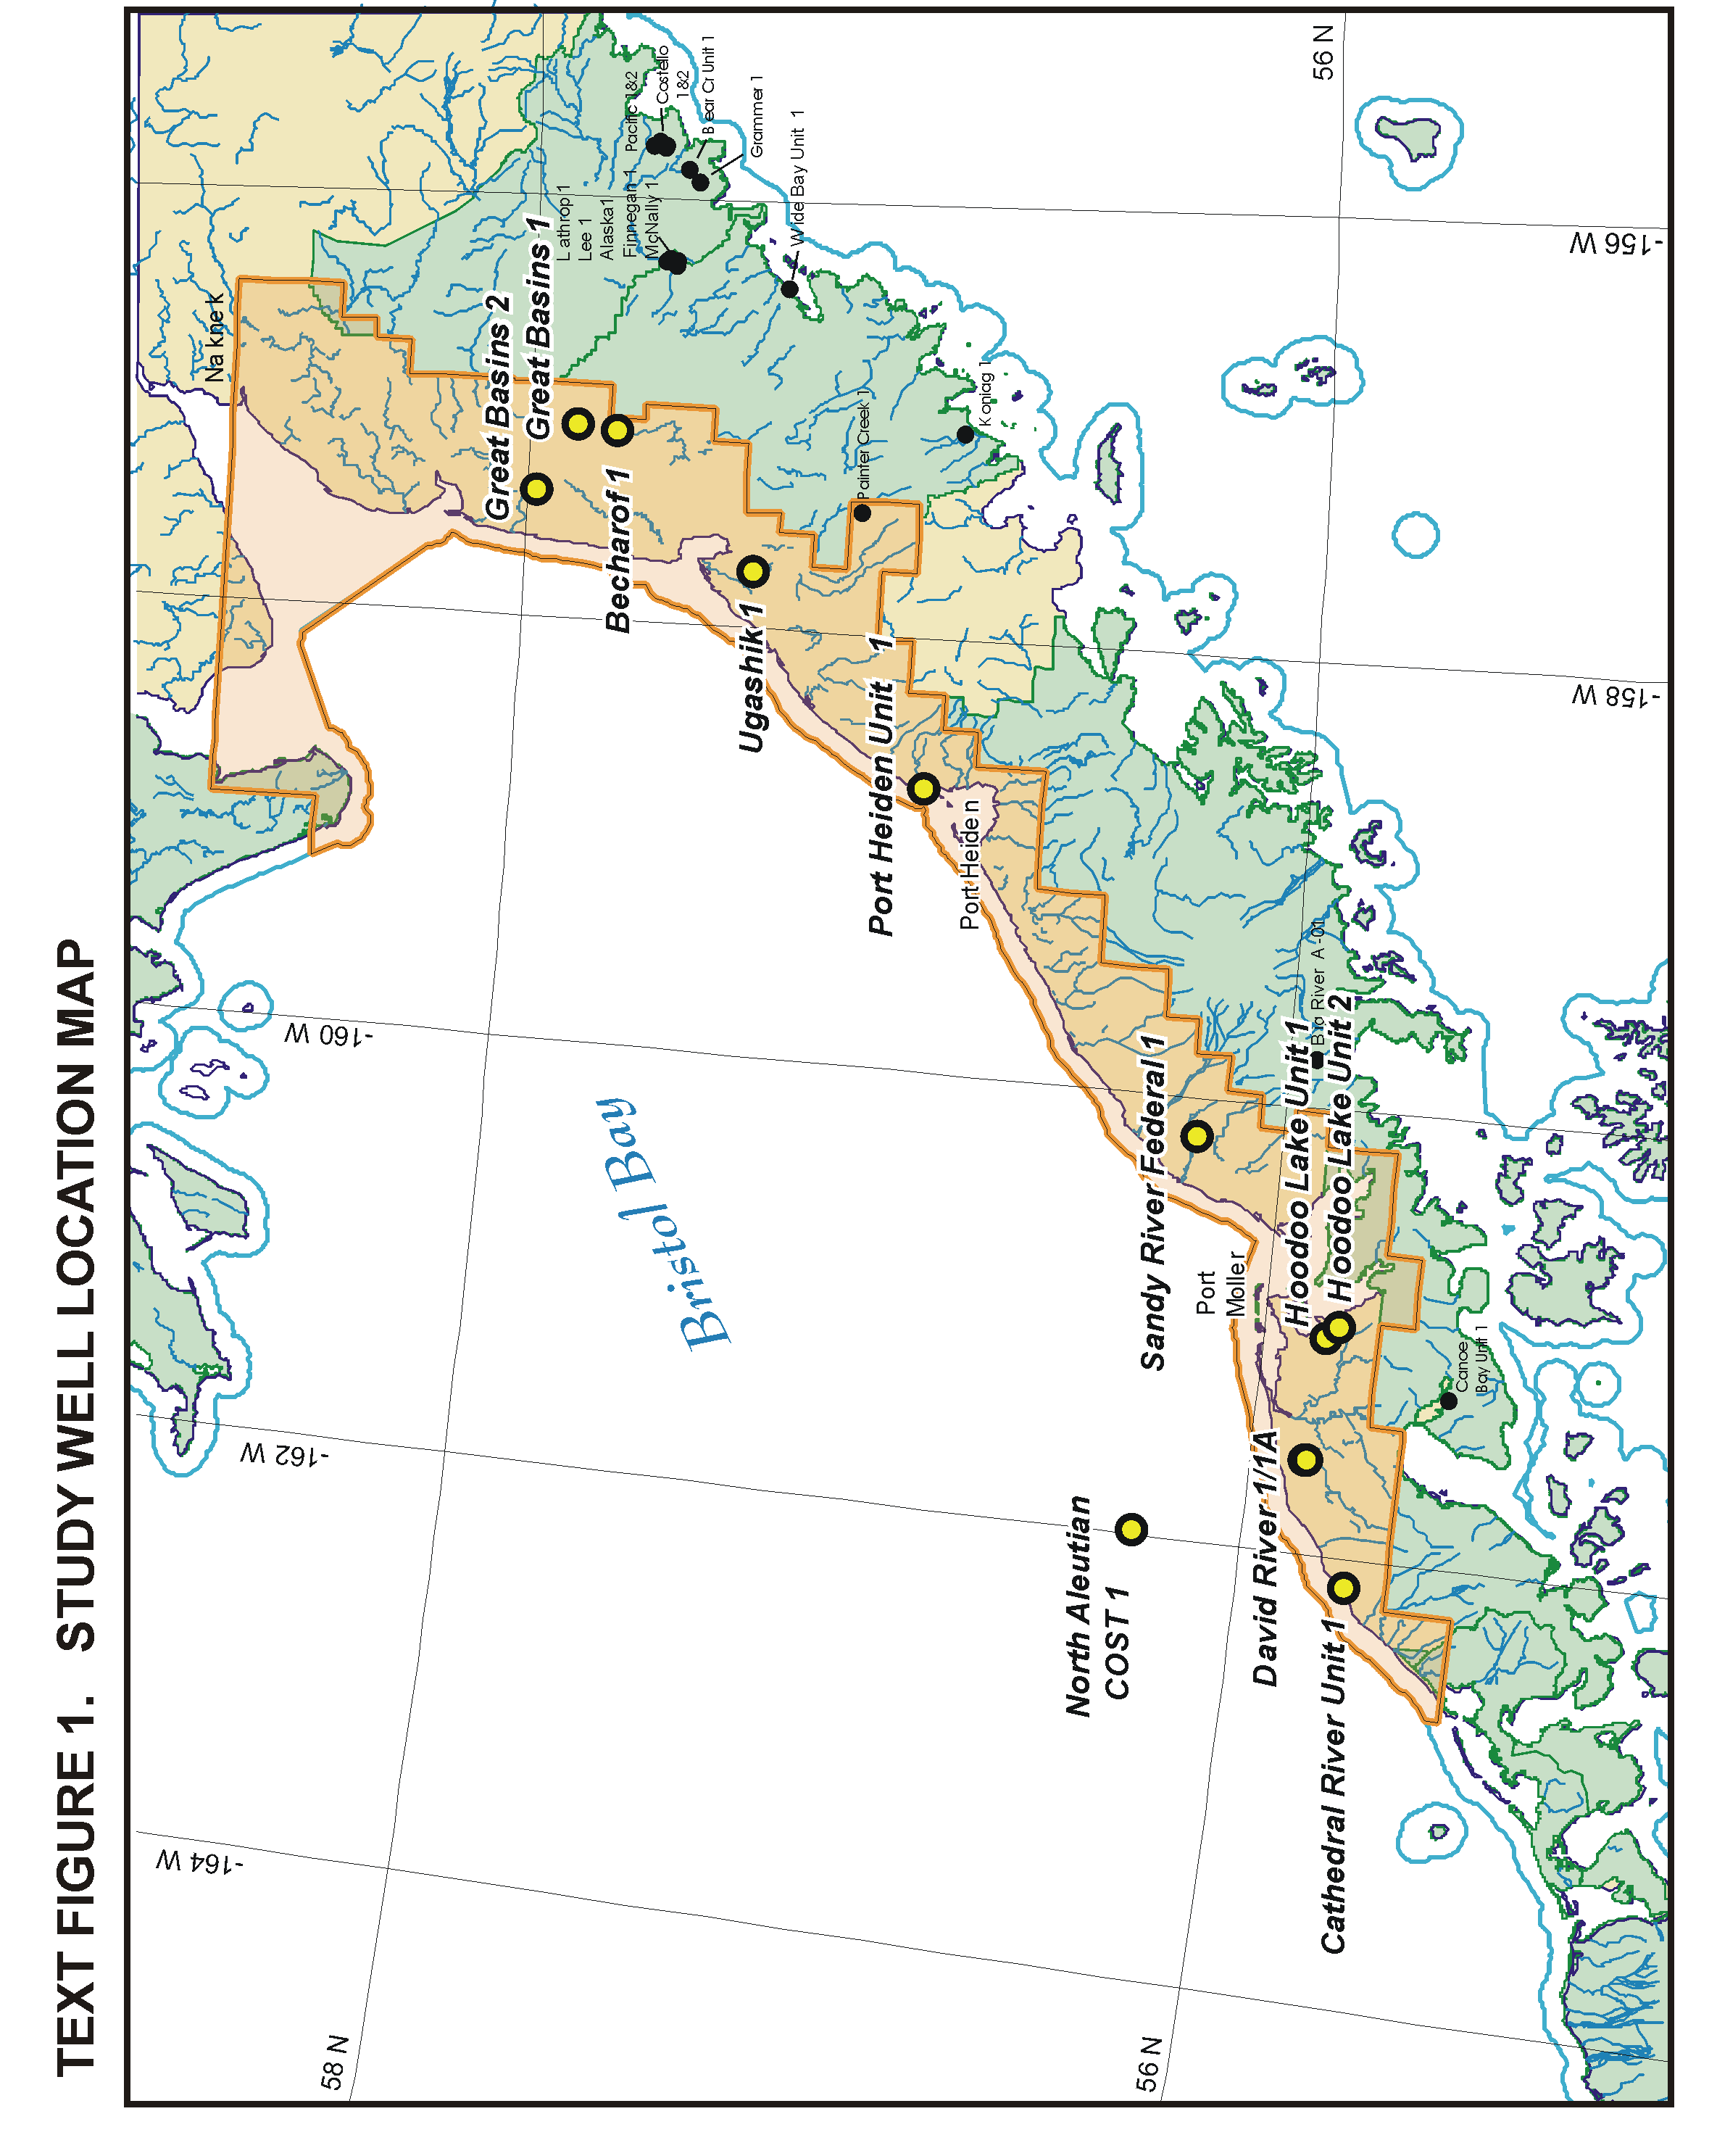
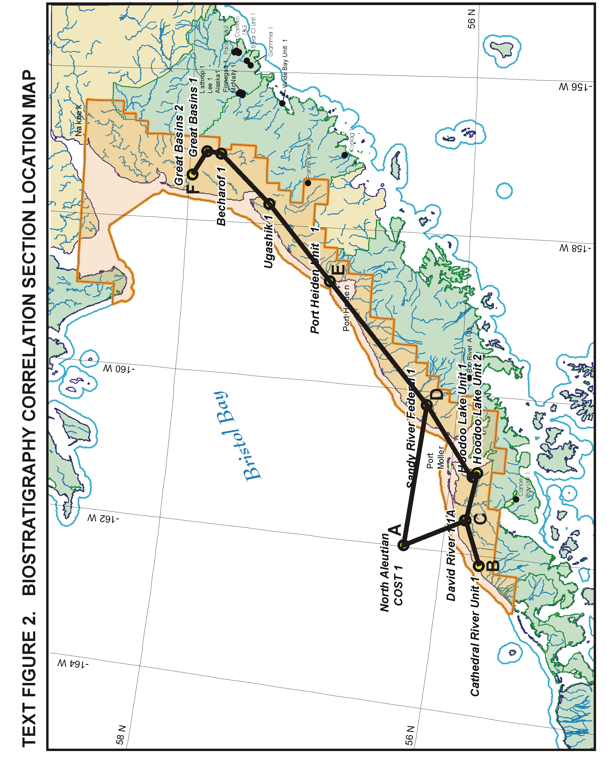
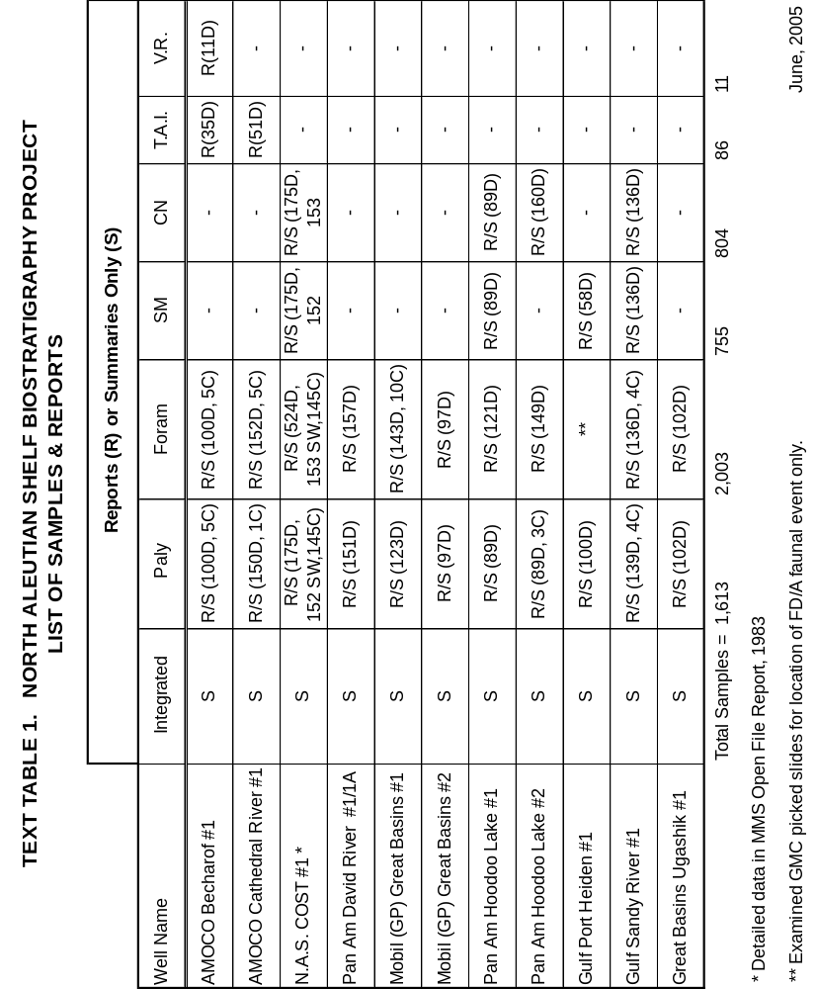

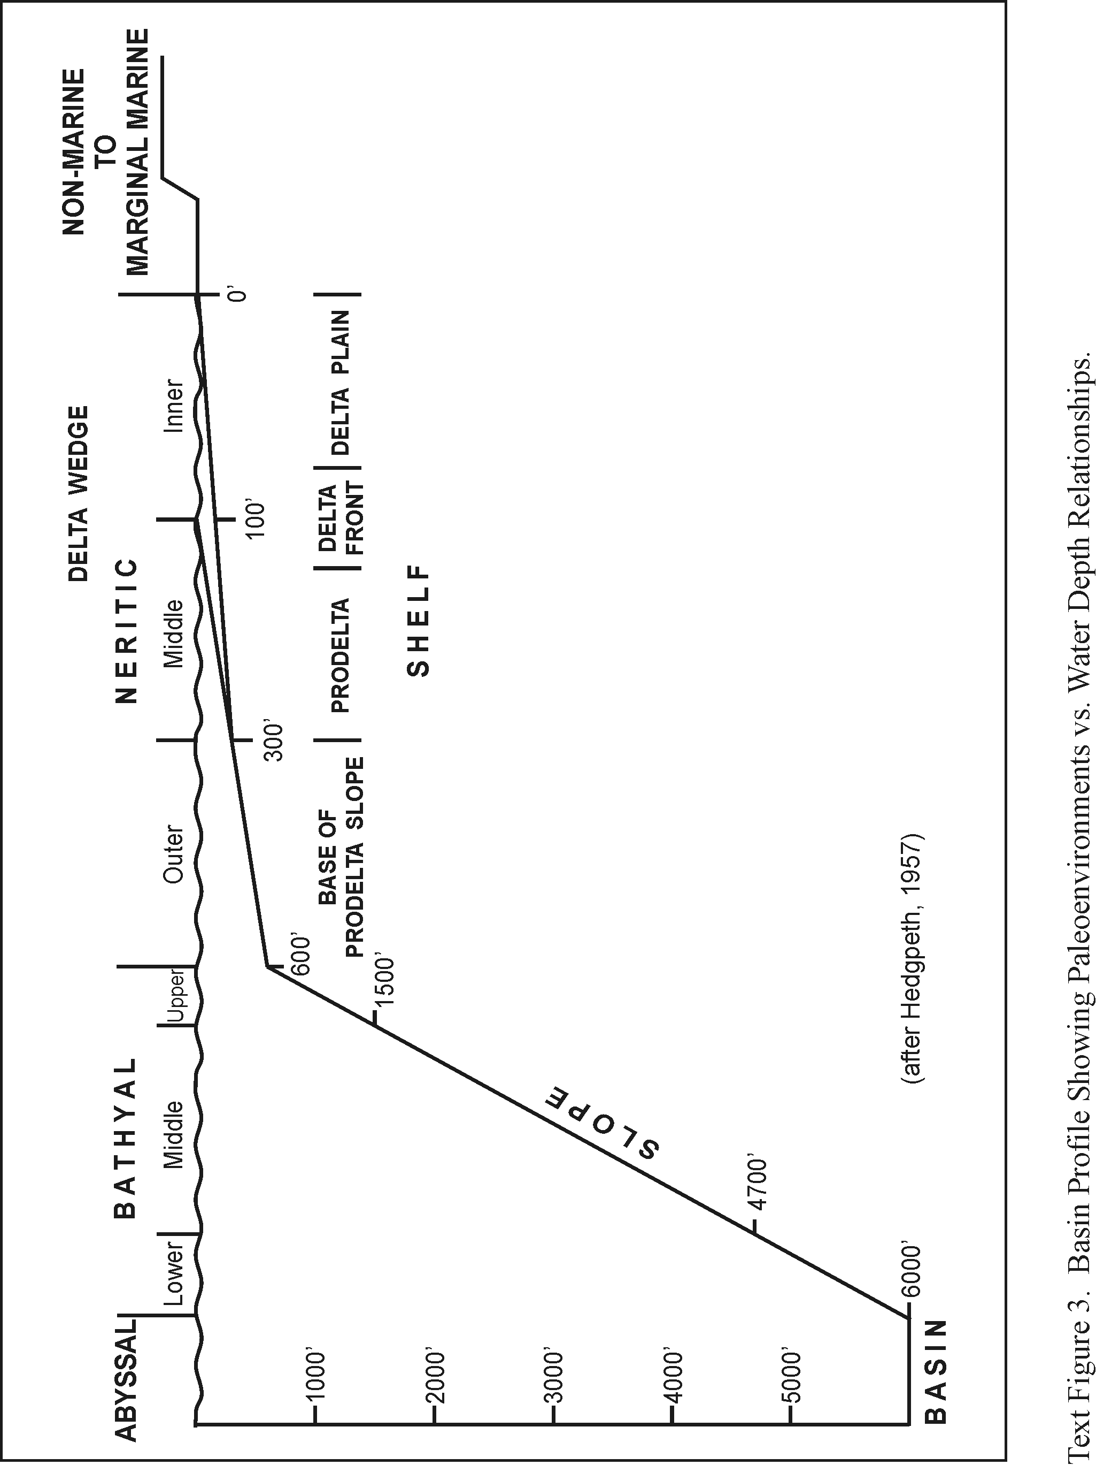

With the above cautions fully noted, we can make some general observations and conclusions based on the biostratigraphic analysis of the study wells.

1) Two (2) wells, the Great Basins No. 1 and Great Basins No. 2, encountered probable Jurassic age metamorphic and granitic rocks at or near the bottom of each well.

- Three (3) of the study wells encountered Mesozoic sedimentary rocks. The David River No. 1/1A and Hoodoo Lake Unit No. 2 wells drilled Valanginian to Hauterivian age Herendeen Limestone and Staniukovich Fm. strata. It is possible, based on a lack of biostratigraphic evidence to the contrary, that the Hoodoo Lake Unit No. 2 might have even penetrated rocks as old as Late Jurassic? (Oxfordian? or Kimmeridgian?). The oldest Mesozoic sedimentary rocks were penetrated in the Cathedral River Unit No. 1 well which drilled a relatively thick sequence of Early Jurassic to Late Jurassic (or possibly Earliest Neocomian) age sedimentary strata which exhibited Thermal Alteration Index (TAI) values of 2.5 to 3.0 down to a depth of 8100 to 8350 feet. In general, amorphous kerogen comprised 20% to 50% of the organics down to a depth of 5770 to 6020 feet. Most of this section was within the 2.5 to 3.0 TAI oil and condensate generation window.

3) A slightly coarser interval can be recognized in three (3) of the wells which appears to represent a basal coarse unit of probable Eocene age overlying the Mesozoic Herendeen Limestone in the David River 1/1A and Hoodoo Lake Unit No. 2 wells. It is also present in the bottom of the North Aleutian COST No. 1 well.

4) Three (3) of the wells, the Port Heiden Unit No. 1, Ugashik No. 1 and Becharof No. 1, encountered probable Oligocene age Meshik Fm., consisting of volcanic conglomerates and sandstones, volcanic breccias and andesitic - basaltic extrusive volcanics with local siltstones and shales. The Becharof No. 1 well also contains approximately 1,000 feet of Tolstoi Fm. clastics characterized by mostly herbaceous and woody-fusinitic organics within the TAI range of 2.5 to 3.0 and the Vitrinite Reflectance (VR) range of .53 to .57 which puts these strata just into the oil generation window.

- A regional unconformity appears present at the Oligocene/Miocene boundary as well as the Mesozoic/Tertiary (Paleogene) boundary.

- The reader should be aware that the recognition and subdivision of the Early and Late Pliocene (especially the Early Pliocene subzones) is based on siliceous microfossil analysis which was lacking in several of the wells on the Port Heiden Unit No. 1 - Great Basins No. 2 Biostratigraphy Correlation Section (Plate B-4) where these subdivisions were tentatively placed (dashed) into most wells on the basis of relationship with paly units and e-log correlations.

In summary, analysis of the wells in this Study suggest that there are areas where Mesozoic units with oil-prone amorphous kerogen have not been "over cooked." There are also thick gas-prone to marginally oil-prone Tertiary strata that may be present in areas thermally mature enough to produce thermogenic gas or oil?, as well as, thermally immature areas that could produce biogenic gas. The missing part of the equation has to do with the quality and distribution of reservoir rock, a subject not addressed within the confines of this Study. Oil plays in this area, as in the Cook Inlet area, may depend on having a Mesozoic source rock in the "correct" proximity to an overlying Tertiary reservoir rock so that the reservoir can be charged via direct contact, fractures or faulting. However, based on proximity to thermal activity associated with this island arc system, this area may also have the added advantage of producing gas and possibly even oil from Tertiary source rocks.

AMOCO

BECHAROF NO. 1

API #50-285-20001

SEC. 10, T28S/R48W SM

NORTHWESTERN ALASKA PENINSULA, ALASKA

Interpreted by:

Hideyo Haga - Palynomorphs

Michael B. Mickey - Foraminifera

Richard S. Boettcher - Foraminifera

INTEGRATED BIOSTRATIGRAPHY SUMMARY

0-1480'

Tertiary/Quaternary
Pleistocene
Undifferentiated

1480-2300'?

Tertiary
Late Pliocene

2300?-2900'?

Tertiary
Possible Early Pliocene
C?

2900?-3600'?

Tertiary
Possible Early Pliocene
B?

3600?-7480'

Tertiary
Miocene
Undifferentiated

Discussion. Paly floral event (PD/A) occurs at 4100 feet and foram faunal event (FD/A) occurs at 5530 feet.

7480-8410'

Tertiary
Probable Oligocene
Undifferentiated

8410-9023'T.D.

Tertiary
Probable Oligocene
Undifferentiated

Discussion. Probable Oligocene age Meshik Fm. volcanic conglomerates, sandstones, volcanic breccias, andesitic - basaltic extrusive volcanics or local siltstones and shales.

PALYNOLOGY REPORT

Interpreted by:

Hideyo Haga

PALYNOLOGY SUMMARY

0-2260'

Age. Tertiary
Pleistocene

Environment. Nonmarine?

2260-5800'?

Age. Tertiary
Late Miocene - Pliocene

Environment. Nonmarine to Marginal Marine

5800?-6880'

Age. Tertiary
Middle? - Miocene

Environment. Nonmarine to Marginal Marine

6880-8410'

Age. Tertiary
Undifferentiated

Environment. Nonmarine to Marginal Marine

8410-9023'T.D.

Age. Probable Tertiary
Undifferentiated

Environment. Nonmarine
Remarks. Volcanics and volcaniclastic lithology.

INTRODUCTION

Scope

Palynological analyses were completed on 105 samples from the AMOCO Becharof No. 1 well. The samples consisted of ditch and core composites taken between zero feet and the total depth of 9023 feet.

Based on the palynomorph assemblages observed, an age and generalized environment of deposition were interpreted for each palynostratigraphic subdivision. The environments, as interpreted from the palynological preparations, are simply categorized as nonmarine, marginal marine or marine. These categories are based on the absence or the presence and diversity of microplankton cysts.

The observed data were input to a microcomputer. These data form the basic elements of the species distribution chart.

Report Format

The following Results section gives the age, environment of deposition and significant palynomorphs for the palynological subdivisions. This is an expansion of the preceding brief Summary. Some generalized interpretations are outlined in the Conclusions section.

A Palynomorph Distribution Chart (Figure P-1) is included in a wallet folder accompanying this report. This chart records the presence and abundance of individual taxa in the samples. Included on this chart are the diversity and abundance curves for the nonmarine (spore-pollen) and marine (microplankton cysts) components. The abundance estimates used in the chart represent the following quantities: very rare = single specimen, rare = 2 - 5 specimens, frequent = 6 - 15 specimens, common = 16 - 30 specimens and abundant = greater than 30 specimens.

An Integrated Paleo Summary Log (Figure I-1) is also provided. Additional palynology parameters are shown in the form of a cumulative plot that illustrates the relative abundance of nonmarine, marine and miscellaneous palynomorph constituents.

RESULTS

The well begins in Pleistocene strata and bottoms in metamorphic rocks. The oldest fossiliferous unit is of undifferentiated Tertiary age.

0-2260'

Age. Tertiary
Pleistocene

Environment. Nonmarine?

Palynomorphs. The Pleistocene interval is dominated by reworked Late Jurassic dinocysts. The assemblage includes Gonyaulacysta jurassica, G. spp., Pareodinia ceratophora and Sirmiodinium grossi. The indigenous palynomorphs are sparse and consisted of a few spore-pollen taxa.

2260-5800'?

Age. Tertiary
Late Miocene - Pliocene

Environment. Nonmarine to Marginal Marine

Palynomorphs. This interval recovered a diverse spore-pollen assemblage. This assemblage included Alnipollenites, Betulaceae, Juglanspollenites, Osmundacidites, Sphagnumsporites, Tsugaepollenites, Taxodiaceae and Ulmipollenites.

The dinocysts species are limited to a few forms and include Lejeunecysta and Spiniferites.

Discussion. The frequent Lejeunecysta datum that occurs in sample 4090-4180 feet may be equivalent to the Lejeunecysta hyalina/fallax datum seen in other nearby wells.

5800?-6880'

Age. Tertiary
Middle? Miocene

Environment. Nonmarine to Marginal Marine

Palynomorphs. The Middle? Miocene interval is separated due to the consistent occurrence of Ulmipollenites associated with Caryapollenites and Tiliaepollenites.

Discussion. The assemblage suggests a warm temperate climatic interval; however, it is not very well developed.

6880-8410'

Age. Tertiary
Undifferentiated

Environment. Nonmarine to Marginal Marine

Palynomorphs. The palynomorph recoveries decrease in this section. Most of the forms seen above continue sporadically in this interval.

8410-9023'T.D.

Age. Probable Tertiary
Undifferentiated

Environment. Nonmarine

Palynomorphs. Lithologies are of volcanic origin. Several of the spore-pollen species recorded above are present in this section. Included are the forms Tiliaepollenites and Ulmipollenites. Also, the spore Cicatricosisporites makes its first appearance.

Discussion. The appearance of Cicatricosisporites and an increase in numbers of Tiliaepollenites might be a hint for an older Tertiary (possibly Eocene) age. Considering the lithologic make-up of this section, whether these forms are indigenous or sloughed from above is open to question.

CONCLUSIONS

Palynological analysis of the AMOCO Becharof No. 1 well provides the following generalized palynostratigraphic succession:

- Pleistocene age strata of nonmarine? origin are present from zero feet to 2260 feet. Reworked dinocysts from the Late Jurassic are consistent throughout this section.

- Late Miocene to Pliocene age strata of nonmarine to marginal marine origin makes up the section from 2260 feet to 5800? feet. A datum, possibly equivalent to the Lejeunecysta hyalina/fallax datum, is seen at 4090 feet to 4180 feet.

- Nonmarine to marginal marine strata of undifferentiated Tertiary age occur between 6880 feet and 8410 feet.

- The bottom interval from 8410 feet to the total depth of 9023 feet is probably of Tertiary age. It remains questionable whether the palynomorphs are indigenous to this section based on the volcanic origins of the dominant lithologies.

KEROGEN MATURATION REPORT

Interpreted by:

Hideyo Haga

KEROGEN MATURATION
(T.A.I. - VITRINITE REFLECTANCE)

Maturation levels of the kerogen residues from the AMOCO Becharof No. 1 well were determined by visual estimates (Thermal Alteration Index or T.A.I.) and by Vitrinite Reflectance (V.R.) measurements. A chart correlating the two analytical techniques and their relationship to hydrocarbon generation is given in Text Figure M-1.

Thermal Alteration Index

Thirty-five (35) T.A.I. samples were analyzed. The ditch composites were at 270-foot intervals.

The T.A.I. and percentage estimates for the major organic constituents are presented in Text Table KM-1. The organic classification used is very generalized, but the terminology may be referred to the following categories:

- Amorphous = Alginite = Type I
- Herbaceous = Exinite = Type II
- Woody = Vitrinite = Type III
- Fusinitic = Inertnite = Type IV

The T.A.I. estimates indicate that the well is in the Immature/Mature Transition facies for hydrocarbon generation down to about 6700 feet. From 6700 feet to about 8000 feet, Mature organic facies are encountered. Below 8000 feet, the organic facies is entering the Supramature range.

The organic constituents are mostly herbaceous from 2400 feet to 6800 feet. Below 6800 feet, woody-fusinitic materials are dominant.

Text Figure M-1. Correlation of Thermal Alteration Index (TAI) and Vitrinite Reflectance (VR) values to hydrocarbon generation. Modified from Heroux, Y., Chagnou, A. and Bertrand, R., (1979).
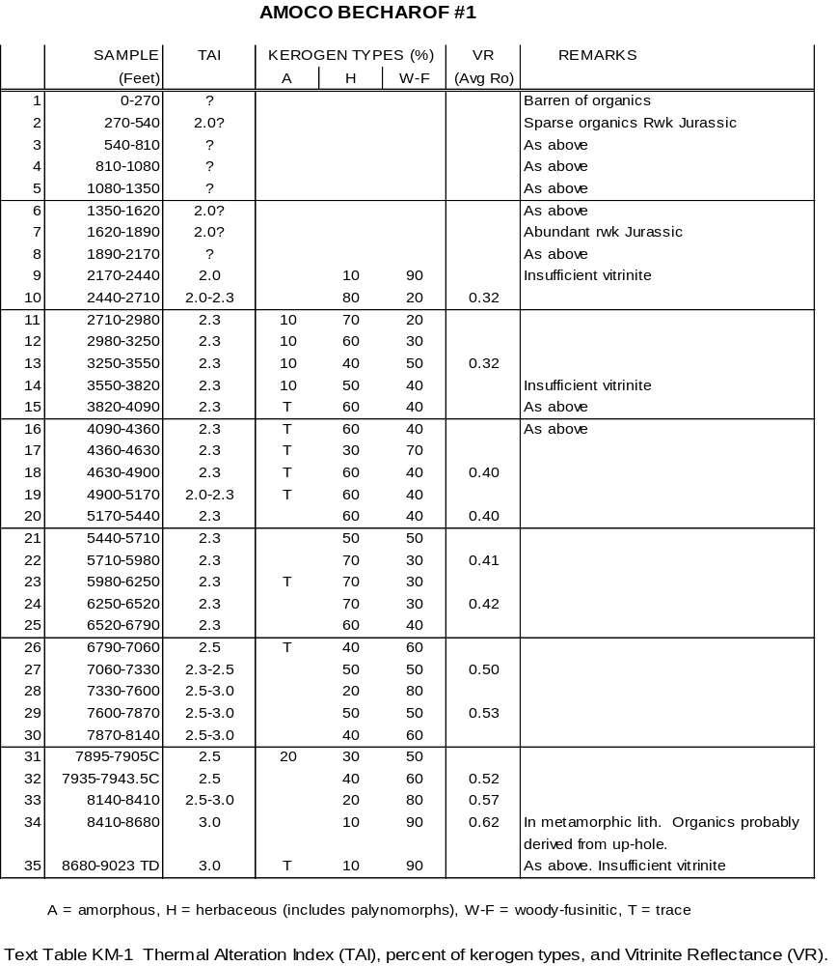

Vitrinite Reflectance

Eleven (11) samples were analyzed for V.R. The V.R. sample plugs were made from material below 2400 feet, which is below the reworked Jurassic interval.

The average V.R. values of the measured samples are included in Text Table KM-1. The individual measurements and histogram plots are presented in the Appendix. Text Figure M-2 displays the reflectance average for each sample on a semi-log plot.

The V.R. measurements indicate that maturation levels are in the Immature/ Mature Transition facies down to at least 6500 feet. This is in agreement with the T.A.I. estimates.

Below 7000 feet, the organic maturation is in the Mature stage. No V.R. averages suggest that the sedimentary strata are in the Supramature range.

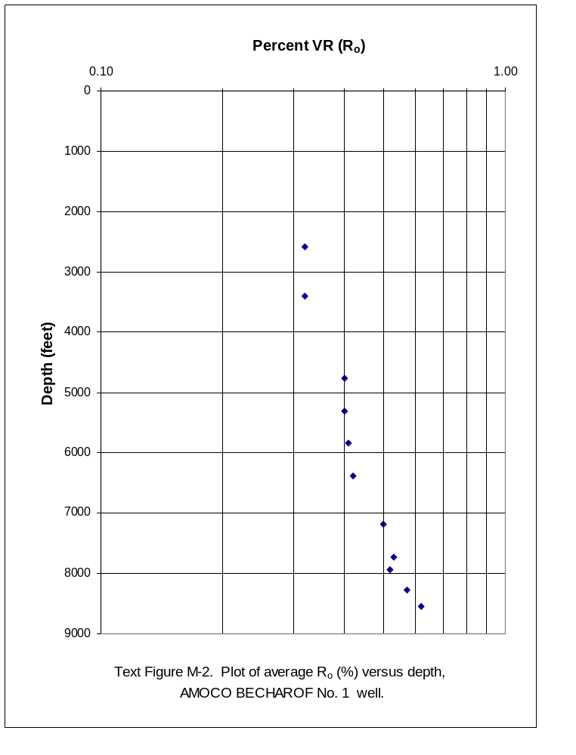

REFERENCE

Heroux, Y., Chagnou, A. and Bertrand, R., 1979. Compilation and correlation of major thermal maturation indicators: Bull. Am. Assoc. Petr. Geol., 63: pp. 2128-2144.

APPENDIX

VITRINITE REFLECTANCE DATA

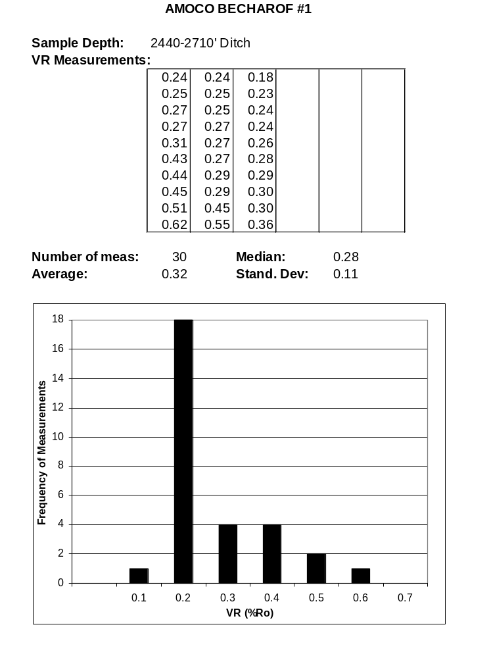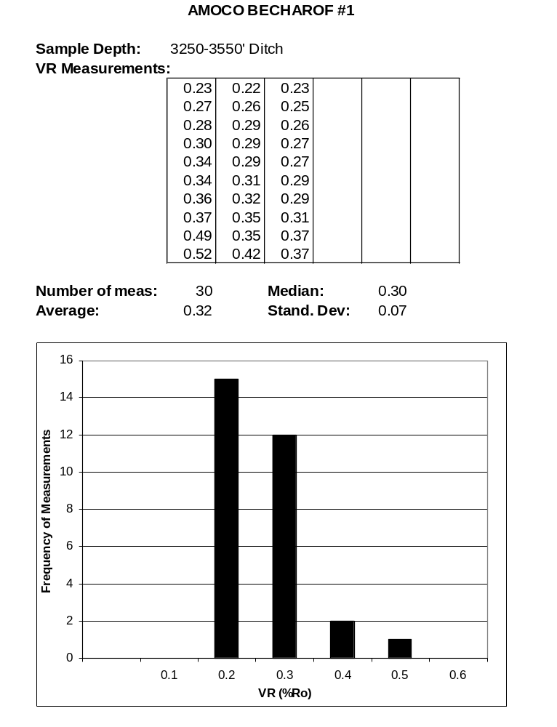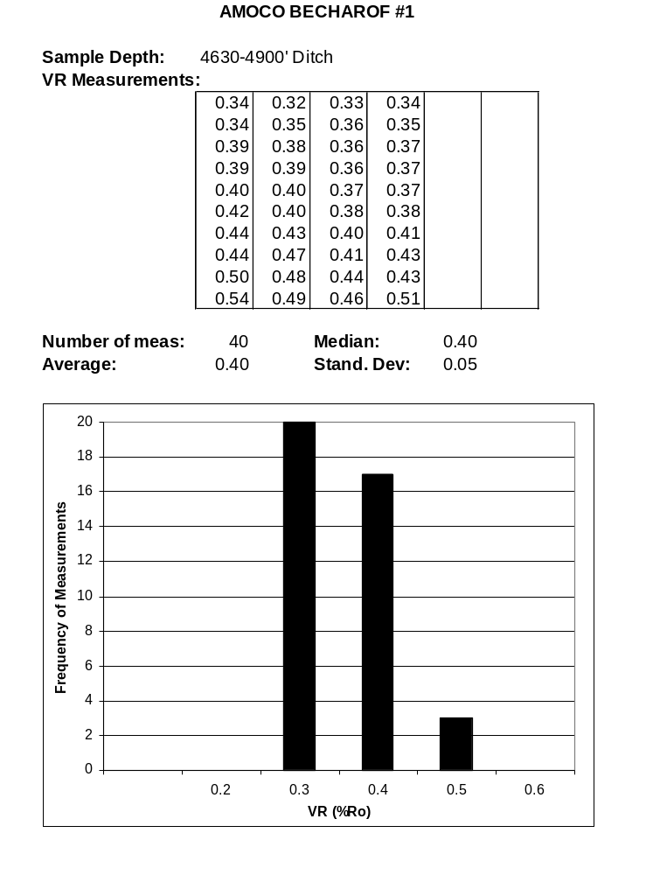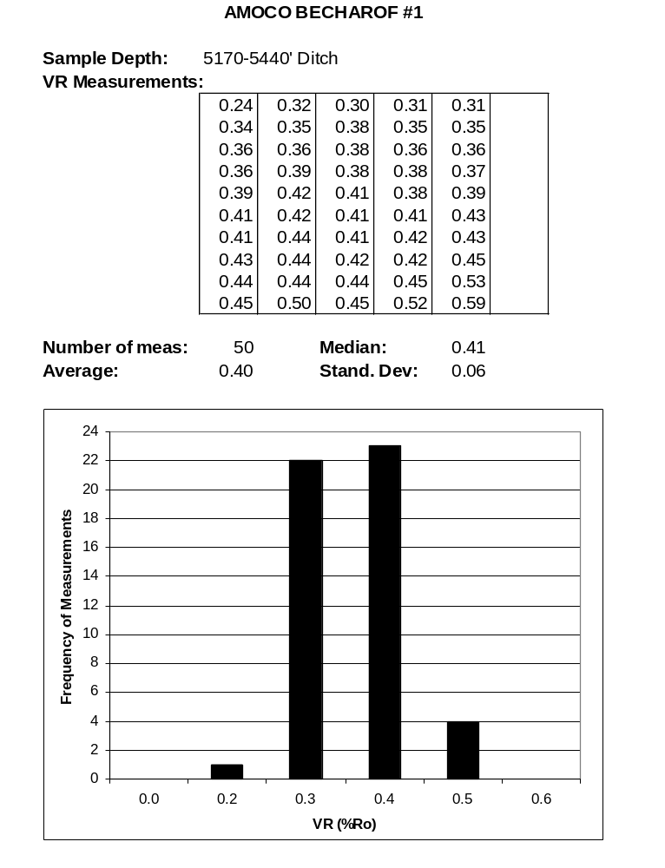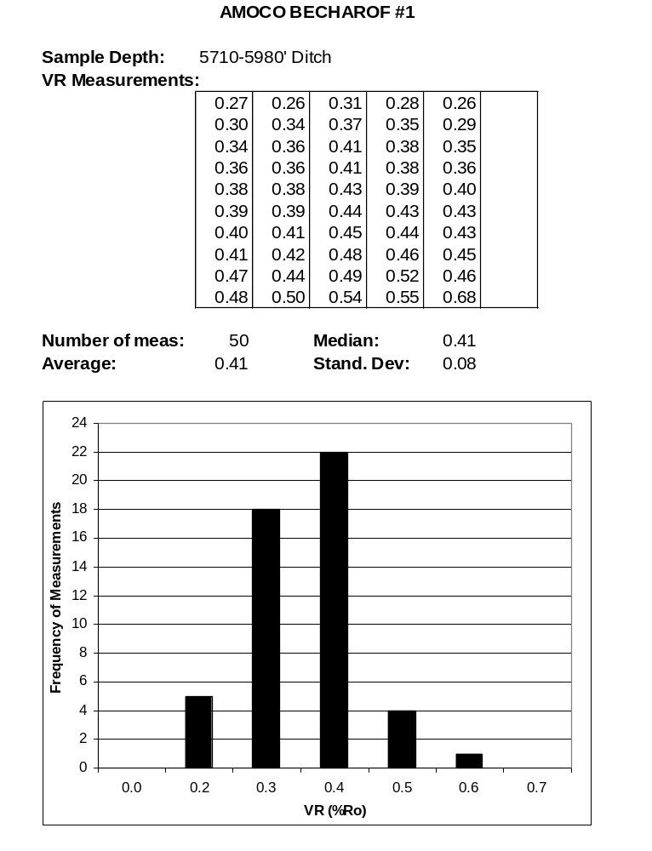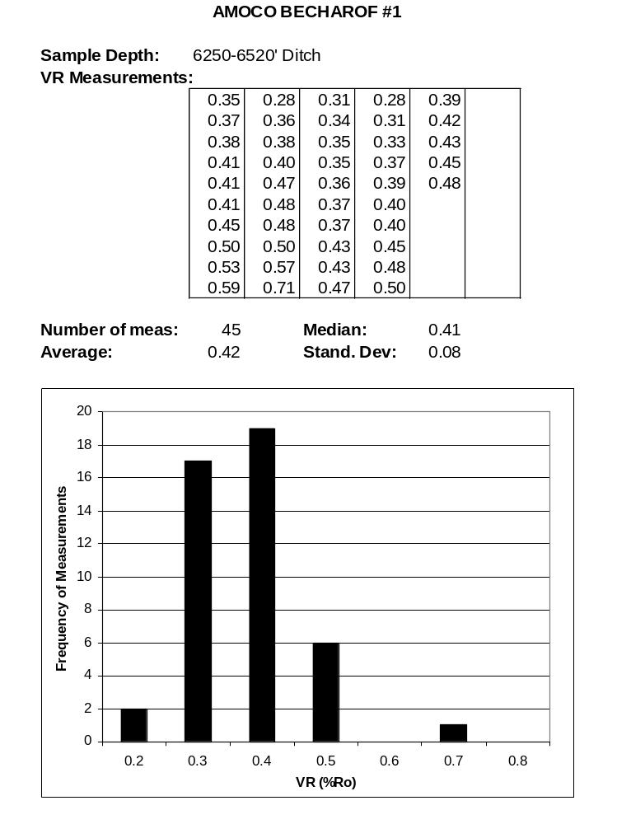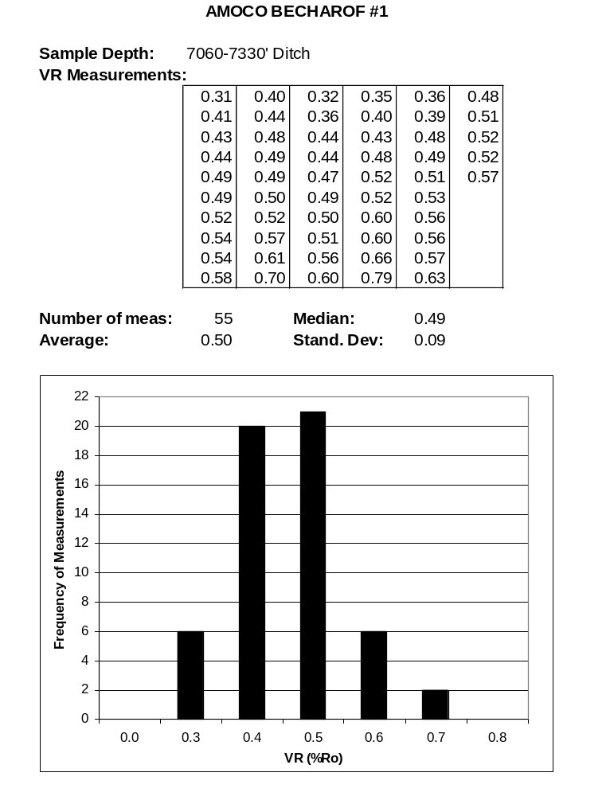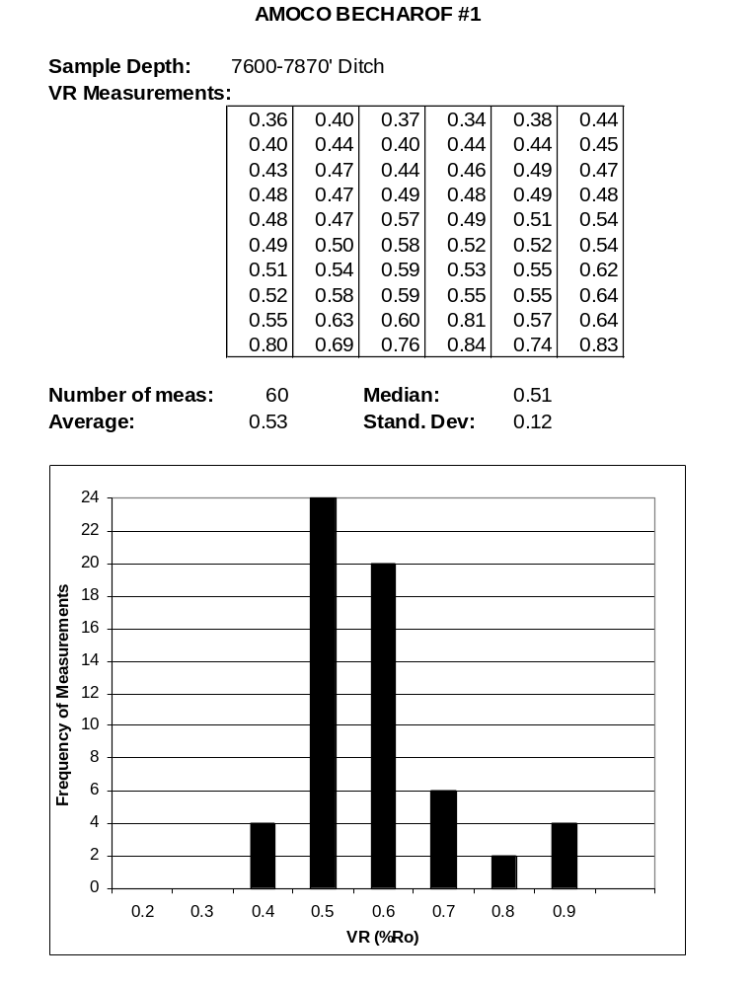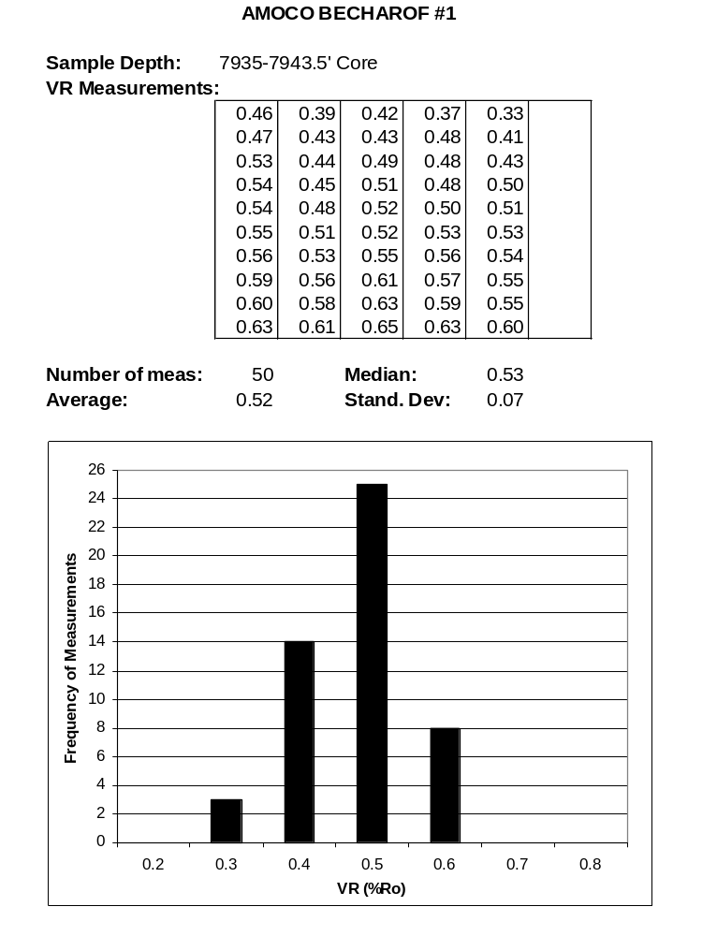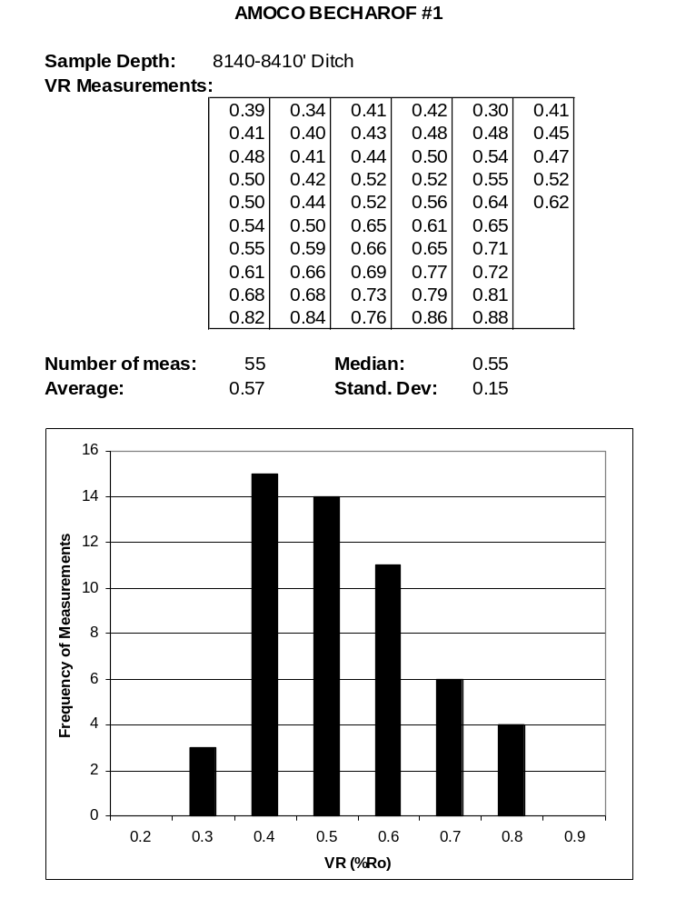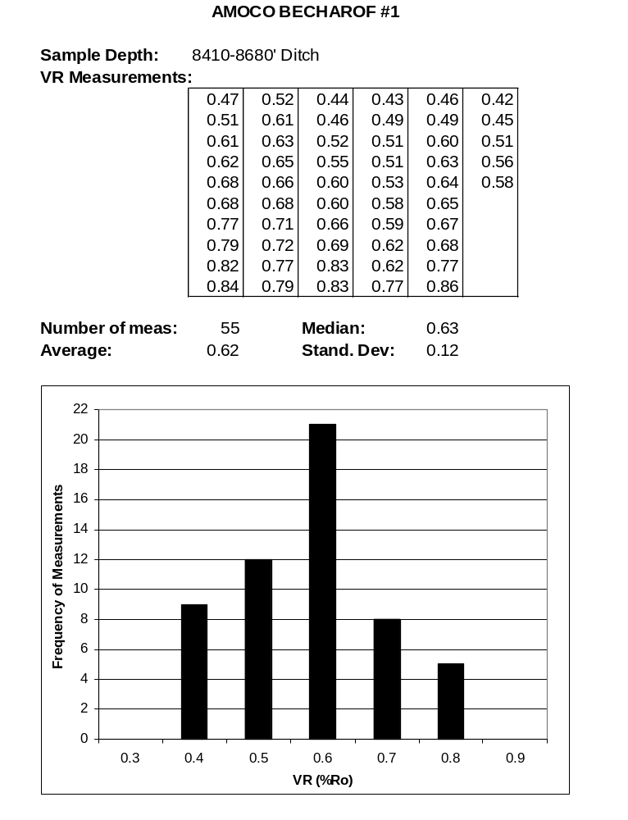

FORAMINIFERA REPORT

Interpreted by:

Michael B. Mickey
and
Richard S. Boettcher

FORAMINIFERA SUMMARY

0-1440'?

Age. Tertiary/Quaternary
Probable Pleistocene
Undifferentiated

Environment. 0-810': Nonmarine
(Alluvial Plain)
810-1440'?: Nonmarine to Marginal Marine
(Alluvial Plain to Transitional)

1440?-4360'

Age. Indeterminate

Environment. Probable Nonmarine
(Probable Alluvial Plain)

4360-7240'?

Age. Tertiary
Miocene
Undifferentiated

Environment. 4360-5440': Nonmarine to Marginal Marine
(Alluvial Plain to Transitional)
5440-7240'?: Marginal Marine to Inner Neritic
(Transitional to Inner Shelf)

7240?-8050'?

Age. Indeterminate

Environment. Probable Nonmarine
(Probable Alluvial Plain)

8050?-8410'

Age. Tertiary
Possible Oligocene
Undifferentiated

Environment. Nonmarine to Marginal Marine
(Alluvial Plain to Transitional)

8410-9023'T.D.

Age. Probable Tertiary
Probable Oligocene
Undifferentiated

Environment. Probable Nonmarine
(Probable Alluvial Plain)

Discussion. Probable Oligocene age Meshik Fm. volcanic conglomerates, sandstones, volcanic breccias, andesitic - basaltic extrusive volcanics or local siltstones and shales.

INTRODUCTION

Scope

Micropaleo Consultants analyzed 100 ditch and five (5) conventional core samples from the AMOCO Becharof No. 1 well for Foraminifera. These were all 90-foot composited ditch samples collected over the interval zero feet to the total depth of 9023 feet. Conventional cores covered the interval 7895 to 7943.5 feet.

The samples used in this study were obtained from a private industry source.

Procedures

All samples were examined from previously prepared, picked Foraminifera slides. Frequency symbols correspond to the following numerical values: V = very rare (1), R = rare (2 - 4), F = few (5 - 25), C = common (26 - 100), A = abundant (101 - 1000) and P = prolific (1001 - 5000).

An age and depositional environment based on the foraminiferal assemblage present were interpreted for each biostratigraphic interval. A generalized washed lithology description was also done for each sample. These washed lithology descriptions can be found on the Foraminifera Distribution Chart (Figure F-1) in a wallet folder accompanying this report.

Format

A listing of the age, environment and fauna for each biostratigraphic interval follows. A generalized summary of the well is presented in the Conclusions section at the end of the Foraminifera Report. A Foraminifera Distribution Chart (Figure F-1) and an Integrated Paleo Summary Log (Figure I-1) are in the wallet folder accompanying this report.

RESULTS

0-1440'?

Age. Tertiary/Quaternary
Probable Pleistocene
Undifferentiated

Environment. 0-810': Nonmarine
(Alluvial Plain)
810-1440'?: Nonmarine to Marginal Marine
(Alluvial Plain to Transitional)

Fauna. Two single specimen occurrences of Buccella frigida, shell fragments, coal and volcanic glass shards characterize this interval.

1440?-4360'

Age. Indeterminate

Environment. Probable Nonmarine
(Probable Alluvial Plain)

Fauna. This interval is barren of forams and is characterized by occurrences of plant debris, pyrite and rare to abundant coal.

4360-7240'?

Age. Tertiary
Miocene
Undifferentiated

Environment. 4360-5440': Nonmarine to Marginal Marine
(Alluvial Plain to Transitional)
5440-7240'?: Marginal Marine to Inner Neritic
(Transitional to Inner Shelf)

Fauna. This interval contains occurrences of Elphidium clavatum, E. cf. bartletti, Ammosphaeroidina sp., Elphidiella cf. hannai, Cibicides cf. fletcheri, Rotalia sp., Haplophragmoides spp., Saccammina sp., Bathysiphon sp., Oolina aff. borealis and arenaceous spp.

7240?-8050'?

Age. Indeterminate

Environment. Probable Nonmarine
(Probable Alluvial Plain)

Fauna. Barren of Foraminifera. Frequent to abundant coal.

8050?-8410'

Age. Tertiary
Possible Oligocene
Undifferentiated

Environment. Nonmarine to Marginal Marine
(Alluvial Plain to Transitional)

Fauna. One specimen of Ammosphaeroidina? sp. is all that faunally occurs in this interval, together with a dark brownish-gray to gray medium to coarse grained lithic sandstone containing common to abundant metamorphic rock fragments.

8410-9023'T.D.

Age. Probable Tertiary
Probable Oligocene
Undifferentiated

Environment. Probable Nonmarine
(Probable Alluvial Plain)

Fauna. Barren of Foraminifera.

Discussion. Probable Oligocene age Meshik Fm. volcanic conglomerates, sandstones, volcanic breccias, andesitic - basaltic extrusive volcanics or local siltstones and shales.

CONCLUSIONS

The AMOCO Becharof No. 1 well penetrated the following biostratigraphic sequence based on foraminiferal analysis:

- 1440+ feet (0-1440'?) of probable Pleistocene age nonmarine to marginal marine fine to medium grained lithic sandstones.

- 2920 feet (1440?-4360') of indeterminate age probable nonmarine clastics.

- 2880 feet (4360-7240'?) of Miocene age nonmarine to inner shelf coaly sandstones and siltstones or silty shales.

- 810 feet (7240?-8050'?) of indeterminate age nonmarine coaly and organic-rich silty to sandy shales and siltstones.

- 360 feet (8050?-8410') of possible Oligocene age nonmarine to marginal marine medium to coarse grained lithic sandstones.

- 613+ feet (8410-9023'T.D.) of probable Oligocene age probable nonmarine Meshik Fm. equivalent volcanics and volcaniclastics.

AMOCO

CATHEDRAL RIVER UNIT NO. 1

API #50-093-20001

SEC. 29, T51S/R83W SM

NORTHWESTERN ALASKA PENINSULA, ALASKA

Interpreted by:

Hideyo Haga - Palynomorphs

Michael B. Mickey - Foraminifera (Radiolaria)

INTEGRATED BIOSTRATIGRAPHY SUMMARY

100-5720'?

Late Jurassic
Oxfordian to Tithonian
Rad Zonule 1

5720?-8190'

Middle? to Late Jurassic
Callovian? to Oxfordian
Rad Zonule 1 to Rad Zonule 2?

Discussion. Possible Chisik Cgl. Mbr. equivalent.

8190-13,390'

Early to Middle Jurassic
Pliensbachian to Callovian
Rad Zonule 2

13,390-14,280'

Possible Early Jurassic
Sinemurian? to Pliensbachian?
Rad Zonule 3?

PALYNOLOGY REPORT

Interpreted by:

Hideyo Haga

PALYNOLOGY SUMMARY

100-5720'

Age. Late Jurassic
Oxfordian - Kimmeridgian?

Zones. P-M22 to P-M21?

Environment. Marine

5770-8630'

Age. Middle? - Late Jurassic
Callovian? – Oxfordian

Zones. P-M22a? to P-M22

Environment. Marine

8640-14,280'

Age. Indeterminate

Environment. Nonmarine? to Marginal Marine

INTRODUCTION

Scope

Palynological analyses were completed on 151 samples from the AMOCO Cathedral River Unit No. 1 well. The samples consisted of ditch composites and one (1) conventional core taken between 100 feet and 14,280 feet.

Based on the palynomorph assemblages observed, an age and generalized environment of deposition were interpreted for each palynostratigraphic subdivision. The environments, as interpreted from the palynological preparations, are simply categorized as nonmarine, marginal marine or marine. These categories are based on the absence or the presence and diversity of microplankton cysts.

The observed data were input to a microcomputer. These data form the basic elements of the species distribution chart.

Report Format

The following Results section gives the age, environment of deposition and significant palynomorphs for the palynological subdivisions. This is an expansion of the preceding brief Summary. Some generalized interpretations are outlined in the Conclusions section.

A Palynomorph Distribution Chart (Figure P-2) is included in a wallet folder accompanying this report. This chart records the presence and abundance of individual taxa in the samples. Included on this chart are the diversity and abundance curves for the nonmarine (spore-pollen) and marine (microplankton cysts) components. The abundance estimates used in the chart represent the following quantities: very rare = single specimen, rare = 2 - 5 specimens, frequent = 6 - 15 specimens, common = 16 - 30 specimens and abundant = greater than 30 specimens.

An Integrated Paleo Summary Log (Figure I-2) is also provided. Additional palynology parameters are shown in the form of a cumulative plot that illustrates the relative abundance of nonmarine, marine and miscellaneous palynomorph constituents.

RESULTS

The top sample indicates that the youngest strata are of Late Jurassic age. The oldest identifiable assemblage ranges into the Middle Jurassic.

100-5720'

Age. Late Jurassic
Oxfordian - Kimmeridgian?

Zones. P-M22 to P-M21?

Environment. Marine

Palynomorphs. The uppermost interval carries a diverse marine palynomorph assemblage overall. The forms recorded included Acanthaulax senta, Endoscrinium galeritum, Gonyaulacysta cladophora, G. jurassica, Pareodinia osmingtonensis, Scriniodinium crystallinum and Sirmiodinium grossi.

Discussion. Between 2300 feet and 3800 feet, relatively poor palynomorph recoveries were encountered. The poor recoveries can be attributed to the coarse-grained lithologies of the interval.

5770-8630'

Age. Middle? - Late Jurassic
Callovian? - Oxfordian

Zones. P-M22a? to P-M22

Environment. Marine

Palynomorphs. This interval continues with a fairly diverse dinocyst assemblage. Some of the species seen above have dropped off. The assemblage here consists mainly of Gonyaulacysta cladophora, Meiourogonyaulax and numerous species of Pareodinia.

8640-14,280'

Age. Indeterminate

Environment. Nonmarine? to Marginal Marine

Palynomorphs. The palynomorph recoveries decrease dramatically. The main constituents are the nonmarine forms Vitreisporites pallidus and indeterminate spores or spore fragments. Some rare occurrences of Micrhystridium were recorded below 12,000 feet.

Discussion. The interval from 12,100 feet to 13,040 feet may be equivalent to the Micrhystridium - Tasmanaceae assemblage zone seen in other wells of the Alaska Peninsula region. This zone appears in the Early Jurassic section of these other wells.

CONCLUSIONS

Palynological analysis of the AMOCO Cathedral River Unit No. 1 well provides the following generalized palynostratigraphic succession:

- The uppermost interval, from 100 feet to 5720 feet, consists of marine Oxfordian to possibly Kimmeridgian age strata.

- Marine strata of Callovian? to Oxfordian age occur between 5770 feet and 8630 feet.

- The interval from 8640 feet to 14,280 feet had poor palynomorph recoveries. The age is given as indeterminate, although there is weak suggestion of an Early Jurassic age.

KEROGEN MATURATION REPORT

Interpreted by:

Hideyo Haga

KEROGEN MATURATION
(T.A.I.)

Maturation levels of the kerogen residues from the AMOCO Cathedral River Unit No. 1 well were determined by visual estimates (Thermal Alteration Index or T.A.I.). A chart correlating the T.A.I. with Vitrinite Reflectance (V.R.) values and their relationship to hydrocarbon generation is given in Text Figure M-1.

A total of 51 samples were processed and analyzed to determine the T.A.I. in the organic residues. The samples consisted of 270-foot ditch composites plus one (1) conventional core. The sample coverage was from the top to the bottom of the well.

The T.A.I. and percentage estimates for the major organic constituents are presented in Text Table KM-2. The organic classification used is very generalized, but the terminology may be referred to the following categories:

- Amorphous = Alginite = Type I
- Herbaceous = Exinite = Type II
- Woody = Vitrinite = Type III
- Fusinitic = Inertnite = Type IV

The T.A.I. estimates indicate that the well is in the mature facies for hydrocarbon generation down to about 8400 feet. Between 8400 feet and 10,000 feet, the maturation in the condensate range. Below 10,000 feet, the maturation progresses into the gas only range.

The organic constituents above 7300 feet are mostly amorphous and herbaceous materials. The herbaceous material is mainly spore-pollen and dinocysts down to about 6000 feet. Woody-fusinitic material dominates most of the samples below 7300 feet, although amorphous material appears to be abundant below 13,000 feet.

Text Figure M-1. Correlation of Thermal Alteration Index (TAI) and Vitrinite Reflectance (VR) values to hydrocarbon generation. Modified from Heroux, Y., Chagnou, A. and Bertrand, R., (1979).
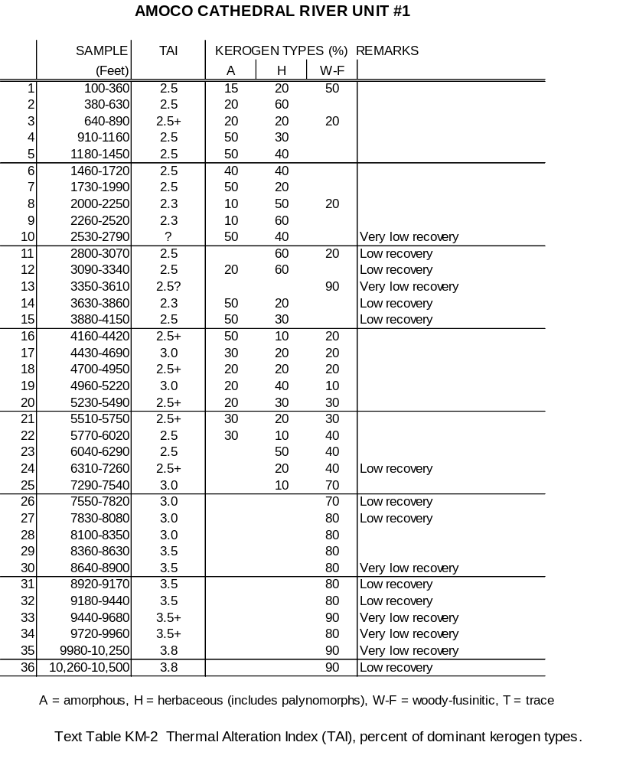
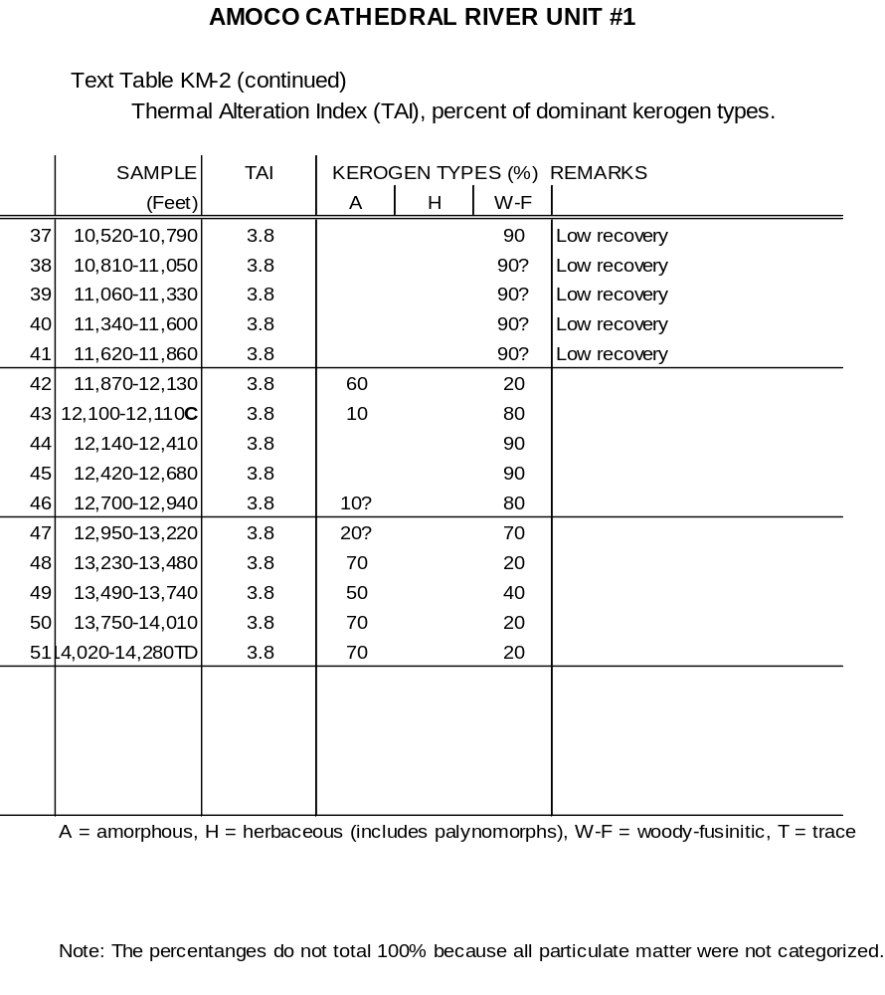

FORAMINIFERA REPORT

Interpreted by:

Michael B. Mickey

FORAMINIFERA SUMMARY

100-5420'?

Age. Late Jurassic
Oxfordian to Tithonian
Rad Zonule 1

Environment. 100-2000': Inner to Middle Neritic
(Inner to Middle Shelf)
2000-3630': Nonmarine to Marginal Marine
(Alluvial Plain to Transitional)
3630-5420'?: Inner to Middle Neritic
(Inner to Middle Shelf)

5420?-8190'?

Age. Indeterminate

Environment. Nonmarine to Marginal Marine
(Alluvial Plain to Transitional)

Discussion. Possible Chisik Cgl. Mbr. equivalent. Some oil staining.

8190?-13,390'?

Age. Early to Middle Jurassic
Pliensbachian to Callovian
Rad Zonule 2

Environment. Middle Neritic to Upper Bathyal
(Middle Shelf to Upper Slope)
13,390?-14,280'

Age. Possible Early Jurassic
Possible Sinemurian to Pliensbachian
Rad Zonule 3?

Environment. Middle to Outer Neritic
(Middle to Outer Shelf)

Discussion. Based on negative evidence, this basal interval could still represent Rad Zonule 2.

INTRODUCTION

Scope

Micropaleo Consultants analyzed 152 ditch and five (5) conventional core samples from the AMOCO Cathedral River Unit No. 1 well for Foraminifera. These were generally 70 to 90-foot composited ditch samples collected over the interval 100 feet to 14,280 feet. Four (4) conventional core samples from the interval 7405 to 7425 feet and one (1) from 12,100 to 12,110 feet were also analyzed.

The samples used in this study were obtained from a private industry source.

Procedures

All samples were examined from previously prepared, picked Foraminifera slides. Frequency symbols correspond to the following numerical values: V = very rare (1), R = rare (2 - 4), F = few (5 - 25), C = common (26 - 100), A = abundant (101 - 1000) and P = prolific (1001 - 5000).

An age and depositional environment based on the foraminiferal assemblage present were interpreted for each biostratigraphic interval. A generalized washed lithology description was also done for each sample. These washed lithology descriptions can be found on the Foraminifera Distribution Chart (Figure F-2) in a wallet folder accompanying this report.

Format

A listing of the age, environment and fauna for each biostratigraphic interval follows. A generalized summary of the well is presented in the Conclusions section at the end of the Foraminifera Report. A Foraminifera Distribution Chart (Figure F-2) and an Integrated Paleo Summary Log (Figure I-2) are in the wallet folder accompanying this report.
RESULTS

100-5420'?

Age. Late Jurassic
Oxfordian to Tithonian
Rad Zonule 1

Environment. 100-2000': Inner to Middle Neritic
(Inner to Middle Shelf)
2000-3630': Nonmarine to Marginal Marine
(Alluvial Plain to Transitional)
3630-5420'?: Inner to Middle Neritic
(Inner to Middle Shelf)

Fauna. Saracenaria cf. projectura, Haplophragmoides spp., Trochammina instowensis, T. cf. gryci, Vaginulina? cf. sp. A (of Wall), Lenticulina audax, L. (Darbyella) cf. erviei, Ammobaculites cobbani, Trochamminoides sp. (small, thin), Astacolus cf. agalmatus, Reinholdella? (Conorboides) cf. hofkeri, Dictyomitra sp. A, D. spp., D. sp. B, Cenosphaera spp., C. sp. A, Spongodiscus spp., Spongurus spp., Lithocampe cf. sp. A, L. spp., Rhopalastrum sp. A and frequent pyrite.

5420?-8190'?

Age. Indeterminate

Environment. Nonmarine to Marginal Marine
(Alluvial Plain to Transitional)

Fauna. This sandy faunally poorer interval contains only one newly? occurring foram, Epistomina? sp., which could have sloughed into the ditch sample from the overlying interval.

Discussion. Possible Chisik Cgl. Mbr. equivalent. Some oil staining.

8190?-13,390'?

Age. Early to Middle Jurassic
Pliensbachian to Callovian
Rad Zonule 2

Environment. Middle Neritic to Upper Bathyal
(Middle Shelf to Upper Slope)

Fauna. Lenticulina audax, L. quenstedti, Trochammina instowensis, T. topagorukensis, T. canningensis, Marginulinopsis phragmites, Bathysiphon anomalocoelia, Trochamminoides sp. (medium, thin), T. cf. proteus, T. sp. (small, thin), Astacolus cf. dubius, A. petalus, Ammobaculites vetusta, Ammodiscus siliceus, Gaudryina dyscrita, Textularia areoplecta, Spongurus spp., Dictyomitra sp. B, D. sp. A, D. spp., Lithocampe spp., Cenosphaera spp., Spongodiscus spp., Cyrtocapsa cf. sp. C, C. sp. B, C. sp. A, Crucella cf. sp. B, C. sp. B, C. sp. A, Rhopalastrum sp. A, R. sp. B, Stichomitra spp., Darwinula oblonga, pyrite and rare to abundant Inoceramus prisms.
13,390?-14,280'

Age. Possible Early Jurassic
Possible Sinemurian to Pliensbachian
Rad Zonule 3?

Environment. Middle to Outer Neritic
(Middle to Outer Shelf)

Fauna. Faunal decrease characterized by no newly occurring forams and rare newly occurring forms of the following radiolaria: Patulibracchium sp. A, Cyrtocapsa sp. C, Lithocampe sp. A and Stichomitra sp. A.

Discussion. Based on negative evidence, this basal interval could still represent Rad Zonule 2.

CONCLUSIONS

The AMOCO Cathedral River Unit No. 1 well penetrated the following biostratigraphic sequence based on foraminiferal analysis:

- 5320+ feet (100-5420'?) of Oxfordian to Tithonian age nonmarine to middle shelf fine grained sandstones and siliceous shales.

- 2770 feet (5420?-8190'?) of indeterminate age nonmarine to marginal marine predominantly dark gray to black very fine to fine grained sandstones (some oil stained).

- 5200 feet (8190?-13,390'?) of Pliensbachian to Callovian age middle shelf to upper slope siliceous Inoceramus prism shale.

- 890+ feet (13,390?-14,280') of possible Sinemurian to Pliensbachian age middle to outer shelf tarry siliceous Inoceramus prism shale.

ARCO

NORTH ALEUTIAN COST NO. 1
(OCS-Y-8218)

BLOCK 666

API #55-307-00001

BRISTOL BAY - BERING SEA, ALASKA

Interpreted by:

Hideyo Haga - Palynomorphs

Michael B. Mickey - Foraminifera

Richard S. Boettcher - Foraminifera

Stanley A. Kling - Siliceous Microfossils

Stanley A. Kling - Calcareous Nannoplankton

* INTEGRATED BIOSTRATIGRAPHY SUMMARY

1380-1560'

In Tertiary/Quaternary
In Early Pleistocene

1560-2350'

Tertiary
Late Pliocene

2350-3210'

Tertiary
Early Pliocene
B

Discussion. Denticulopsis kamtschatica Zone
Subzone b

3210-4870'

Tertiary
Miocene (Undiff.)

* Modified by OCS Report MMS 88-0089.
4870-9570'

Tertiary
Oligocene (Undiff.)

9570-10,080'

Tertiary
Early Oligocene

10,080-10,300'

Tertiary
Late Eocene to Early Oligocene

10,300-11,059'

Tertiary
Late Eocene

11,059-17,150'T.D.

Tertiary
Eocene (Undiff.)

Discussion. Basal coarse facies tops at 15,622 feet.

Individual Discipline Reports Available from MMS

MMS OPEN FILE REPORT

From Biostratigraphics Consulting (a division of McClelland Engineers), 1983 Biostratigraphy Report ARCO North Aleutian COST No. 1 well, Bering Sea, Alaska: 6 parts, 139 p.

This report is based on the preparation, examination and analysis of: 472 palynomorph; 822 foram; 473 calcareous nannoplankton and 472 siliceous microfossil ditch, conventional core and sidewall core samples from this well.

REFERENCES

Biostratigraphics Consulting Micropaleontology, 1983, ARCO North Aleutian Shelf COST No. 1 well, Bering Sea, Alaska: San Diego, California, Biostratigraphics, a unit of McClelland Engineers, 6 parts, 139 p.

Turner, R. F., McCarthy, C. M., Lynch, M. B., Hoose, P. J., Martin, G. C., Larson, J. A., Flett, T. O., Sherwood, K. W. and Adams, A. J., 1988, Geological and operational summary, ARCO North Aleutian Shelf COST No. 1 well, Bering Sea, Alaska: U. S. Minerals Management Service, OCS Report MMS 88-0089, 256 p.

PAN AMERICAN PETROLEUM COMPANY

DAVID RIVER NO. 1/1A

API #50-211-20001 NO. 1

API #50-211-20002 NO. 1A

SEC. 12, T50S/R80W SM

NORTHWESTERN ALASKA PENINSULA, ALASKA

Interpreted by:

Hideyo Haga - Palynomorphs

Michael B. Mickey - Foraminifera

Richard S. Boettcher - Foraminifera

INTEGRATED BIOSTRATIGRAPHY SUMMARY

0-380'

Tertiary
Probable Late Pliocene

380-1490'?

Tertiary
Miocene to Early Pliocene

1490?-2420'

Tertiary
Oligocene (Undiff.)

2420-2600'

Tertiary
Probable Late Eocene

2600-11,900'

Tertiary
Eocene (Undiff.)

Discussion. Basal coarse facies tops at 10,510 feet.

11,900-12,040'

Probable Early Cretaceous
Probable Hauterivian

12,040-13,769'T.D.

Early Cretaceous
Neocomian (Undiff.)

PALYNOLOGY REPORT

Interpreted by:

Hideyo Haga

PALYNOLOGY SUMMARY

0-380'

Age. Tertiary
Pliocene? - Pleistocene

Environment. Nonmarine

380-1490'?

Age. Tertiary
Miocene - Pliocene

Environment. Marine

Discussion. Possibly no older than Late Miocene.

1490?-2420'

Age. Tertiary
Oligocene - Miocene

Environment. Nonmarine to Marginal Marine?

2600-10,510'?

Age. Tertiary
Eocene

Environment. Nonmarine
10,600-13,769'T.D.

Age. Indeterminate

Environment. Indeterminate

INTRODUCTION

Scope

Micropaleo Consultants analyzed a total of 151 samples from the PAN AM David River No. 1/1A well. These consisted of ditch samples taken between zero feet and the total depth of 13,769 feet.

All materials were examined, or obtained from the Alaska Oil and Gas Conservation Commission sample library in Anchorage, or the Geologic Materials Center in Eagle River, Alaska.

Through the observed palynomorph assemblages, an age and generalized depositional environment were interpreted for each palynostratigraphic subdivision.

The depositional environments are merely categorized as nonmarine, marginal marine or marine. These categories are based essentially on the absence or presence and diversity of dinocysts and acritarchs.

Procedures

As each sample was examined, an estimate of abundance for each taxon was recorded. These data were then entered into a microcomputer which produced the basic elements for a species distribution chart.

Report Format

In the following Results section the age, environment of deposition and significant palynomorphs are reported for each palynostratigraphic subdivision. This is an expansion of the brief Palynology Summary.

Following the Results are some general remarks in the Conclusions.

A Palynomorph Distribution Chart (Figure P-3) is included in a wallet folder accompanying this report. This chart records the presence and abundance of individual taxa in the samples. Included on this chart are the diversity and abundance curves for the nonmarine (spore-pollen) and marine (microplankton cysts) components. The abundance estimates used in the chart represent the following quantities: very rare = single specimen, rare = 2 - 5 specimens, frequent = 6 - 15 specimens, common = 16 - 30 specimens and abundant = greater than 30 specimens.

An Integrated Paleo Summary Log (Figure I-3) is also provided. Additional palynology parameters are shown in the form of a cumulative plot that illustrates the relative abundance of nonmarine, marine and miscellaneous palynomorph constituents.

Photomicrographs of selected palynomorphs recorded in this well are included on Palynomorph Plate 1.

RESULTS

0-380'

Age. Tertiary
Pliocene? to Pleistocene

Environment. Nonmarine

Palynomorphs. This interval carries a nondescript spore-pollen assemblage. The base of the interval appears to be in the Tertiary with the presence of Pterocaryapollenites.

380-1490'?

Age. Tertiary
Miocene to Pliocene

Environment. Marine

Palynomorphs. The spore-pollen assemblage increases slightly in diversity. An important Miocene - Pliocene pollen Rugaepollis was recorded at 1040 feet.

The dinocysts, although sparse, make their appearance in this interval. Single specimens of Xandarodinium variabile mark the top and bottom of this section.

Discussion. If the two specimens of Xandarodinium variabile are truly representing the limits of occurrence in this well, then this interval may be considered Late Miocene to Pliocene in age.

1490?-2420'

Age. Tertiary
Oligocene to Miocene

Environment. Nonmarine to Marginal Marine?

Palynomorphs. This interval contains a very poor assemblage of palynomorphs. The age assignment is made principally on the lack of any definitive forms and the superposition of these strata.

2600-10,510'?

Age. Tertiary
Eocene

Environment. Nonmarine

Palynomorphs. A significant increase in palynomorph diversity and abundance occurs through this interval. The pollen Caryapollenites, Tiliaepollenites and Alnipollenites occur quite consistently.

The fungal spore assemblage is very well developed. The important Eocene forms present are Pesavis tagluensis and Ctenosporites wolfei.

Discussion. The base of this interval is tentatively placed at the depth where the palynomorph occurrences show a marked decrease.

10,600-13,769'T.D.

Age. Indeterminate

Environment. Indeterminate

Palynomorphs. This interval is separated only on the basis of the sparse palynomorph recoveries. It is possible that the scattered occurrences of spore-pollen and fungal spores are all derived from uphole.

CONCLUSIONS

The palynological analysis of the PAN AM David River No. 1/1A well can be summarized into the following generalized subdivisions:

- Tertiary (Neogene age) strata extend to a depth of at least 1490 feet.

- Possible Oligocene to Late? Miocene age strata occur between 1490 feet and 2600 feet.

- Tertiary (Eocene) age strata occur between 2600 feet and 10,500 feet.

- Indeterminate age strata occur below 10,500 feet down to the total depth of 13,769 feet.

FORAMINIFERA REPORT

Interpreted by:

Michael B. Mickey
and
Richard S. Boettcher

FORAMINIFERA SUMMARY

0-11,950'?

Age. Tertiary
Undifferentiated

Environment. Nonmarine to Marginal Marine
(Alluvial Plain to Transitional)

Discussion. Basal coarse facies tops at 10,510 feet.

11,950?-12,660'?

Age. Probable Early Cretaceous
Possible Valanginian to Hauterivian

Environment. Indeterminate

Discussion. Possible Herendeen Ls. based on washed lithology and e-log correlation with PAN AM Hoodoo Lake Unit No. 2 well.

12,660?-13,769'T.D.

Age. Probable Early Cretaceous
Possible Neocomian (Undiff.)

Environment. Indeterminate

Discussion. Probably no older than Neocomian based on e-log correlation with PAN AM Hoodoo Lake Unit No. 2 well.

INTRODUCTION

Scope

Micropaleo Consultants analyzed 157 ditch samples from the PAN AM David River No. 1/1A well for Foraminifera. There were 150 90-foot composited ditch samples collected over the interval zero feet to the total depth of 13,769 feet. Seven (7) additional 20 to 50-foot ditch samples from the interval 11,970 to 13,220 feet were recently resampled and analyzed.

Some of the samples used in this study are reposited at the State of Alaska Geologic Materials Center in Eagle River, Alaska, while others were from a private industry source.

Procedures

All samples were examined from previously prepared, picked Foraminifera slides. Frequency symbols correspond to the following numerical values: V = very rare (1), R = rare (2 - 4), F = few (5 - 25), C = common (26 - 100), A = abundant (101 - 1000) and P = prolific (1001 - 5000).

An age and depositional environment based on the foraminiferal assemblage present were interpreted for each biostratigraphic interval. A generalized washed lithology description was also done for each sample. These washed lithology descriptions can be found on the Foraminifera Distribution Chart (Figure F-3) in a wallet folder accompanying this report.

Format

A listing of the age, environment and fauna for each biostratigraphic interval follows. A generalized summary of the well is presented in the Conclusions section at the end of the Foraminifera Report. A Foraminifera Distribution Chart (Figure F-3) and an Integrated Paleo Summary Log (Figure I-3) are in the wallet folder accompanying this report.

RESULTS

0-11,950'?

Age. Tertiary
Undifferentiated

Environment. Nonmarine to Marginal Marine
(Alluvial Plain to Transitional)

Fauna. This interval is generally barren of forams with a single questionable specimen of arenaceous sp.? occurring at 3260-3350 feet, and a single questionable specimen of the radiolarian genus Cenosphaera sp.? occurring at 10,560-10,650 feet. The section above 3260 feet contains rare to abundant plant debris, very rare to rare diatoms, rare scattered shell fragments and very rare megaspores.

Discussion. Basal coarse facies tops at 10,510 feet.

11,950?-12,660'?

Age. Probable Early Cretaceous
Possible Valanginian to Hauterivian

Environment. Indeterminate

Fauna. This interval is also barren of forams with rare spines or spicules, rare pyrite and rare rounded quartz grains.

Discussion. Possible Herendeen Ls. based on washed lithology and e-log correlation with PAN AM Hoodoo Lake Unit No. 2 well.

12,660?-13,769'T.D.

Age. Probable Early Cretaceous
Possible Neocomian (Undiff.)

Environment. Indeterminate

Fauna. Barren of forams, rare pyrite and rare rounded quartz grains.

Discussion. Probably no older than Neocomian based on e-log correlation with PAN AM Hoodoo Lake Unit No. 2 well.

CONCLUSIONS

The PAN AM David River No. 1/1A well penetrated the following biostratigraphic sequence based on foraminiferal analysis:

- 11,950+ feet (0-11,950'?) of undifferentiated Tertiary age nonmarine to marginal marine clastic sediments, rich in volcanic debris and devoid of organic remains.

- 710 feet (11,950?-12,660'?) of probable Early Cretaceous (Valanginian to Hauterivian) age calcareous (Herendeen Ls.) equivalent.

- 1109+ feet (12,660?-13,769'T.D.) of undifferentiated possible Neocomian age clastics.

MOBIL (GP)

GREAT BASINS NO. 1

API #50-285-10007

SEC. 2, T27S/R48W SM

NORTHWESTERN ALASKA PENINSULA, ALASKA

Interpreted by:

Hideyo Haga - Palynomorphs

Michael B. Mickey - Foraminifera

INTEGRATED BIOSTRATIGRAPHY SUMMARY

20-1350'

Tertiary/Quaternary
Pleistocene
Undifferentiated

1350-2230'?

Tertiary
Late Pliocene

2230?-2930'?

Tertiary
Possible Early Pliocene
C?

2930?-3700'?

Tertiary
Possible Early Pliocene
B?

3700?-10,320'

Tertiary
Miocene
Undifferentiated

Discussion. Paly floral event (PD/A) occurs at 3900 feet and foram faunal event (FD/A) occurs at 8200 feet.

10,320-10,510'

Tertiary
Oligocene
Undifferentiated

10,510-11,080'T.D.

Probable Jurassic
Undifferentiated

Discussion. Granite and metamorphics.

PALYNOLOGY REPORT

Interpreted by:

Hideyo Haga

PALYNOLOGY SUMMARY

20-1950'

Age. Tertiary
Pleistocene

Environment. Marginal Marine

1950-7000'

Age. Tertiary
Late Miocene - Pliocene

Environment. Marginal Marine

7000-9700'?

Age. Tertiary
Middle? Miocene

Environment. Marginal Marine to Marine

9700?-11,080'T.D.

Age. Tertiary
Oligocene? - Miocene

Environment. Nonmarine? to Marginal Marine

INTRODUCTION

Scope

Palynological analyses were completed on 123 samples from the MOBIL (GP) Great Basins No. 1 well. The samples consisted of ditch composites taken between 20 feet and the total depth of 11,080 feet.

Based on the palynomorph assemblages observed, an age and generalized environment of deposition were interpreted for each palynostratigraphic subdivision. The environments, as interpreted from the palynological preparations, are simply categorized as nonmarine, marginal marine or marine. These categories are based on the absence or the presence and diversity of microplankton cysts.

The observed data were input to a microcomputer. These data form the basic elements of the species distribution chart.

Report Format

The following Results section gives the age, environment of deposition and significant palynomorphs for the palynological subdivisions. This is an expansion of the preceding brief Summary. Some generalized interpretations are outlined in the Conclusions section.

A Palynomorph Distribution Chart (Figure P-4) is included in a wallet folder accompanying this report. This chart records the presence and abundance of individual taxa in the samples. Included on this chart are the diversity and abundance curves for the nonmarine (spore-pollen) and marine (microplankton cysts) components. The abundance estimates used in the chart represent the following quantities: very rare = single specimen, rare = 2 - 5 specimens, frequent = 6 - 15 specimens, common = 16 - 30 specimens and abundant = greater than 30 specimens.

An Integrated Paleo Summary Log (Figure I-4) is also provided. Additional palynology parameters are shown in the form of a cumulative plot that illustrates the relative abundance of nonmarine, marine and miscellaneous palynomorph constituents.

RESULTS

The samples begin in Pleistocene age strata. The oldest section is assigned an Oligocene - Miocene age.

20-1950'

Age. Tertiary
Pleistocene

Environment. Marginal Marine

Palynomorphs. The Pleistocene interval is dominated by reworked Late Jurassic dinocysts. These forms are Gonyaulacysta cladophora, G. jurassica and Sirmiodinium grossi. The indigenous palynomorphs are sparse, but includes the marine forms Selenopemphix and Xandarodinium variabile.

Discussion. The presence of Xandarodinium variabile suggests that perhaps the bottom part of the interval, between 1340 feet and 1950 feet, is Early Pleistocene or possibly Pliocene in age.

1950-7000'

Age. Tertiary
Late Miocene - Pliocene

Environment. Marginal Marine

Palynomorphs. This section recovered a diverse spore-pollen assemblage. The assemblage included Alnipollenites, Betulaceae, Sphagnumsporites, Tsugaepollenites, Taxodiaceae and Ulmipollenites.

The dinocysts were very rare, but included Lejeunecysta hyalina/fallax and Xandarodinium variabile.

Discussion. The Lejeunecysta hyalina/fallax occurrences top at the sample 3850-3940 feet. This datum is seen in other wells of the region and may provide a correlative horizon.

7000-9700'?

Age. Tertiary
Middle? Miocene

Environment. Marginal Marine to Marine

Palynomorphs. The Middle? Miocene interval is not well defined. The key forms are Caryapollenites, Tiliaepollenites and Ulmipollenites. In many Tertiary sections of southern and western Alaska, this correlative warm temperate assemblage is very useful when it is well developed.

The dinocyst assemblage shows an increase in diversity.

9700?-11,080'T.D.

Age. Tertiary
Oligocene? - Miocene

Environment. Nonmarine? to Marginal Marine

Palynomorphs. The bottom interval has a drop-off of the warmer climate pollen forms as well as the dinocyst species.

Discussion. The age assignment of Oligocene - Miocene is largely based on the absence of a diverse assemblage and indications of a cooler temperate climate relative to the above interval.

CONCLUSIONS

Palynological analysis of the MOBIL (GP) Great Basins No. 1 well provides the following generalized palynostratigraphic succession:

- Pleistocene age strata of marginal marine origin occur in the interval from 100 feet to 1950 feet. Reworked dinocysts from the Late Jurassic are consistent throughout this section. Very rare evidence is recorded that suggests a possible Early Pleistocene or Pliocene age at the bottom of this interval.

- The interval from 1950 feet to 7000 feet consists of Late Miocene to Pliocene age strata. These were deposited in a marginal marine environment.

- Marginal marine to marine strata of possible Middle Miocene age occur between 7000 feet and 9700? feet.

- The bottom section of the well is assigned an Oligocene? to Miocene age. The palynomorph assemblage is weakly developed. A nonmarine? to marginal marine environment of deposition is indicated.

FORAMINIFERA REPORT

Interpreted by:

Michael B. Mickey

FORAMINIFERA SUMMARY

20-4190'?

Age. Tertiary/Quaternary
Undifferentiated

Environment. Nonmarine to Inner Neritic
(Alluvial Plain to Inner Shelf)

4190?-10,420'

Age. Tertiary
Oligocene? to Miocene
Undifferentiated

Environment. 4190?-8215'C: Nonmarine to Marginal Marine
(Alluvial Plain to Transitional)
8215C-9430': Marginal Marine to Inner Neritic
(Transitional to Inner Shelf)
9430-10,420': Nonmarine to Marginal Marine
(Alluvial Plain to Transitional)

10,420-11,080'T.D.

Age. Indeterminate

Environment. Indeterminate

Discussion. Granite and metamorphics.

INTRODUCTION

Scope

Micropaleo Consultants analyzed 143 ditch and ten (10) conventional core samples from the MOBIL (GP) Great Basins No. 1 well for Foraminifera. These were generally 80 to 100-foot composited ditch samples collected over the interval 20 feet to the total depth of 11,080 feet.

The samples used in this study are reposited at the State of Alaska Geologic Materials Center in Eagle River, Alaska.

Procedures

All samples were examined from previously prepared, picked Foraminifera slides. Frequency symbols correspond to the following numerical values: V = very rare (1), R = rare (2 - 4), F = few (5 - 25), C = common (26 - 100), A = abundant (101 - 1000) and P = prolific (1001 - 5000).

An age and depositional environment based on the foraminiferal assemblage present were interpreted for each biostratigraphic interval. A generalized washed lithology description was also done for each sample. These washed lithology descriptions can be found on the Foraminifera Distribution Chart (Figure F-4) in a wallet folder accompanying this report.

Format

A listing of the age, environment and fauna for each biostratigraphic interval follows. A generalized summary of the well is presented in the Conclusions section at the end of the Foraminifera Report. A Foraminifera Distribution Chart (Figure F-4) and an Integrated Paleo Summary Log (Figure I-4) are in the wallet folder accompanying this report.
RESULTS

20-4190'?

Age. Tertiary/Quaternary
Undifferentiated

Environment. Nonmarine to Inner Neritic
(Alluvial Plain to Inner Shelf)

Fauna. This interval is generally barren of forams with a single specimen of Elphidiella acutum in a core sample from 831-832 feet, rare Elphidium clavatum occurring in a core sample at 3900 feet, frequent to abundant shell fragments between 700 and 1860 feet, and rare to abundant coal below 2220 feet.

4190?-10,420'

Age. Tertiary
Oligocene? to Miocene
Undifferentiated

Environment. 4190?-8215'C: Nonmarine to Marginal Marine
(Alluvial Plain to Transitional)
8215C-9430': Marginal Marine to Inner Neritic
(Transitional to Inner Shelf)
9430-10,420': Nonmarine to Marginal Marine
(Alluvial Plain to Transitional)

Fauna. Very rare to rare scattered occurrences of Elphidium clavatum, Cibicides lobatulus, Saccammina? sp. and Buccella frigida, along with common to prolific coal, characterize the upper portion of this interval down to 8215C feet. Somewhat more marine assemblages, characterized by Elphidium clavatum, E. incertum, E. bartletti, Buccella frigida, B. tenerrima, Cibicides fletcheri, Ammosphaeroidina sp., Saccammina sp., S. lathrami, Oolina aff. borealis, Haplophragmoides excavatus, H. spp., Gaudryina sp. (small), Lenticulina sp., Elphidiella hannai and Spiroplectammina sp., along with common to abundant interbedded coal, occur below 9070 feet.

10,420-11,080'T.D.

Age. Indeterminate

Environment. Indeterminate

Fauna. This interval is probably barren of indigenous microfossils.

Discussion. Granite and metamorphics.
CONCLUSIONS

The MOBIL (GP) Great Basins No. 1 well penetrated the following biostratigraphic sequence based on foraminiferal analysis:

- 4170+ feet (20-4190'?) of undifferentiated Tertiary/Quaternary age fine to medium grained nonmarine to inner shelf sandstones that become organic-rich below 2220 feet.

- 6230 feet (4190?-10,420') of Oligocene? to Miocene age nonmarine to inner shelf coal seams, coaly sandstones and organic-rich shales.

- 660+ feet (10,420-11,080'T.D.) of indeterminate age granitic and metamorphic rocks.

MOBIL (GP)

GREAT BASINS NO. 2

API #50-285-10008

SEC. 35, T25S/R50W SM

NORTHWESTERN ALASKA PENINSULA, ALASKA

Interpreted by:

Hideyo Haga - Palynomorphs

Michael B. Mickey - Foraminifera

INTEGRATED BIOSTRATIGRAPHY SUMMARY

15-2170'?

Tertiary/Quaternary
Late Pliocene to Pleistocene
Undifferentiated

2170?-2850'?

Tertiary
Possible Early Pliocene
C?

2850?-3780'?

Tertiary
Possible Early Pliocene
B?

3780?-8820'

Tertiary
Miocene
Undifferentiated

Discussion. Paly floral event (PD/A) occurs at 3970 feet, while foram faunal event (FD/A) is not encountered in this well.

8820-8865'T.D.

Probable Jurassic
Undifferentiated

Discussion. Granite and metamorphics.

PALYNOLOGY REPORT

Interpreted by:

Hideyo Haga

PALYNOLOGY SUMMARY

15-1880'

Age. Tertiary
Pleistocene

Environment. Nonmarine?

1880-5150'

Age. Tertiary
Late Miocene - Pliocene

Environment. Nonmarine? to Marginal Marine

5150-7600'?

Age. Tertiary
Middle? Miocene

Environment. Nonmarine? to Marginal Marine

7600?-8865'T.D.

Age. Tertiary
Oligocene? - Miocene

Environment. Nonmarine? to Marginal Marine

INTRODUCTION

Scope

Palynological analyses were completed on 97 samples from the MOBIL (GP) Great Basins No. 2 well. The samples consisted of ditch composites taken between 215 feet and the total depth of 8865 feet.

Based on the palynomorph assemblages observed, an age and generalized environment of deposition were interpreted for each palynostratigraphic subdivision. The environments, as interpreted from the palynological preparations, are simply categorized as nonmarine, marginal marine or marine. These categories are based on the absence or the presence and diversity of microplankton cysts.

The observed data were input to a microcomputer. These data form the basic elements of the species distribution chart.

Report Format

The following Results section gives the age, environment of deposition and significant palynomorphs for the palynological subdivisions. This is an expansion of the preceding brief Summary. Some generalized interpretations are outlined in the Conclusions section.

A Palynomorph Distribution Chart (Figure P-5) is included in a wallet folder accompanying this report. This chart records the presence and abundance of individual taxa in the samples. Included on this chart are the diversity and abundance curves for the nonmarine (spore-pollen) and marine (microplankton cysts) components. The abundance estimates used in the chart represent the following quantities: very rare = single specimen, rare = 2 - 5 specimens, frequent = 6 - 15 specimens, common = 16 - 30 specimens and abundant = greater than 30 specimens.

An Integrated Paleo Summary Log (Figure I-5) is also provided. Additional palynology parameters are shown in the form of a cumulative plot that illustrates the relative abundance of nonmarine, marine and miscellaneous palynomorph constituents.

RESULTS

The samples begin in Pleistocene age strata. The oldest section is assigned an Oligocene? - Miocene age.

15-1880'

Age. Tertiary
Pleistocene

Environment. Nonmarine?

Palynomorphs. The Pleistocene interval is dominated by reworked Late Jurassic dinocysts. The assemblage includes Gonyaulacysta cladophora, G. jurassica, Pareodinia osmingtonensis and Sirmiodinium grossi. The indigenous palynomorphs are relatively sparse and consisted only of spore-pollen.

1880-5150'

Age. Tertiary
Late Miocene - Pliocene

Environment. Nonmarine? to Marginal Marine

Palynomorphs. This spore-pollen assemblage is diverse through this interval. The assemblage includes Alnipollenites, Betulaceae, Juglanspollenites, Sphagnumsporites, Tsugaepollenites, Taxodiaceae and Ulmipollenites.

The dinocysts are rare, but include Lejeunecysta hyalina/fallax and Selenopemphix.

Discussion. The Lejeunecysta hyalina/fallax occurrences top at the sample 3870-3960 feet. This datum is seen in other wells of the region and may provide a correlative horizon.

5150-7600'?

Age. Tertiary
Middle? Miocene

Environment. Nonmarine? to Marginal Marine

Palynomorphs. The Middle? Miocene interval is poorly defined and similar to the Great Basins No. 1 well. The key forms in this well are Tiliaepollenites and Ulmipollenites. In many Tertiary sections of southern and western Alaska, this correlative warm temperate assemblage is very useful when it is well developed.

The dinocyst assemblage is meager.

7600?-8865'T.D.

Age. Tertiary
Oligocene? - Miocene

Environment. Nonmarine? to Marginal Marine

Palynomorphs. The separation of this bottom interval is tentative and based merely on the decreased occurrences of the warmer climate pollen.

Discussion. In sections with abundant and consistent palynomorph recoveries, the oscillations of the warm temperate pollen suites can be used in subdividing the late Tertiary. The recoveries here provide only weak evidence for the separations.

CONCLUSIONS

Palynological analysis of the MOBIL (GP) Great Basins No. 2 well provides the following generalized palynostratigraphic succession:

- Pleistocene age strata of nonmarine? origin are present from 15 feet to 1880 feet. Reworked dinocysts from the Late Jurassic are consistent throughout this section.

- Late Miocene to Pliocene age strata of nonmarine? to marginal marine origin occur from 1880 feet to 5150 feet.

- Nonmarine? to marginal marine strata of Middle? Miocene age is designated between 5150 feet and 7600? feet.

- The bottom interval is assigned an Oligocene? to Miocene age. A nonmarine? to marginal marine environment of deposition is indicated.

FORAMINIFERA REPORT

Interpreted by:

Michael B. Mickey

FORAMINIFERA SUMMARY

15-8770'

Age. Tertiary to Quaternary
Undifferentiated

Environment. 15?-1500': Nonmarine to Marginal Marine
(Alluvial Plain to Transitional)
1500-3960': Nonmarine
(Alluvial Plain)
3960-4700': Nonmarine to Marginal Marine
(Alluvial Plain to Transitional)
4700-8770': Nonmarine
(Alluvial Plain)

8770-8865'T.D.

Age. Indeterminate

Environment. Indeterminate

Discussion. Granite and metamorphics.

INTRODUCTION

Scope

Micropaleo Consultants analyzed 97 ditch samples from the MOBIL (GP) Great Basins No. 2 well for Foraminifera. These were generally all 90-foot composited ditch samples collected over the interval 15 feet to the total depth of 8865 feet.

The samples used in this study are reposited at the State of Alaska Geologic Materials Center in Eagle River, Alaska.

Procedures

All samples were examined from previously prepared, picked Foraminifera slides. Frequency symbols correspond to the following numerical values: V = very rare (1), R = rare (2 - 4), F = few (5 - 25), C = common (26 - 100), A = abundant (101 - 1000) and P = prolific (1001 - 5000).

An age and depositional environment based on the foraminiferal assemblage present were interpreted for each biostratigraphic interval. A generalized washed lithology description was also done for each sample. These washed lithology descriptions can be found on the Foraminifera Distribution Chart (Figure F-5) in a wallet folder accompanying this report.

Format

A listing of the age, environment and fauna for each biostratigraphic interval follows. A generalized summary of the well is presented in the Conclusions section at the end of the Foraminifera Report. A Foraminifera Distribution Chart (Figure F-5) and an Integrated Paleo Summary Log (Figure I-5) are in the wallet folder accompanying this report.
RESULTS

15-8770'

Age. Tertiary to Quaternary
Undifferentiated

Environment. 15?-1500': Nonmarine to Marginal Marine
(Alluvial Plain to Transitional)
1500-3960': Nonmarine
(Alluvial Plain)
3960-4700': Nonmarine to Marginal Marine
(Alluvial Plain to Transitional)
4700-8770': Nonmarine
(Alluvial Plain)

Fauna. Barren of Foraminifera. Very rare to rare scattered diatoms and shell fragments. Common to prolific coal below 2420 feet.

8770-8865'T.D.

Age. Indeterminate

Environment. Indeterminate

Fauna. Barren of microfossils.

Discussion. Granite and metamorphics.

CONCLUSIONS

The MOBIL (GP) Great Basins No. 2 well penetrated the following biostratigraphic sequence based on foraminiferal analysis:

- 8755+ feet (15-8770') of undifferentiated Tertiary/Quaternary age nonmarine to marginal marine fine to coarse grained sandstones, coal seams and coaly clastics.

- 95+ feet (8770-8865'T.D.) of indeterminate age granitic and metamorphic rocks.

PAN AMERICAN PETROLEUM COMPANY

HOODOO LAKE UNIT NO. 1

API #50-211-20003

SEC. 21, T50S/R76W SM

NORTHWESTERN ALASKA PENINSULA, ALASKA

Interpreted by:

Hideyo Haga - Palynomorphs

Michael B. Mickey - Foraminifera

Richard S. Boettcher - Foraminifera

Stanley A. Kling - Siliceous Microfossils

Stanley A. Kling - Calcareous Nannoplankton

INTEGRATED BIOSTRATIGRAPHY SUMMARY

90-2060'

Tertiary
Early Pliocene
B

Discussion. Denticulopsis kamtschatica Zone
Subzone b

2060-3680'?

Tertiary
Miocene (Undiff.)

3680?-6310'

Tertiary
Oligocene (Undiff.)

6310-6780'?

Tertiary
Early Oligocene

6780?-7010'?

Tertiary
Late Eocene to Early Oligocene
7010?-7820'

Tertiary
Probable Late Eocene

7820-8041'T.D.

Tertiary
Probable Eocene (Undiff.)

PALYNOLOGY REPORT

Interpreted by:

Hideyo Haga

PALYNOLOGY SUMMARY

90-260'

Age. Tertiary - Quaternary
Pliocene to Pleistocene

Environment. Nonmarine

260-4400'?

Age. Neogene
Miocene to Pliocene

Environment. Nonmarine to Marine

4400?-4940'

Age. In Paleogene
In Oligocene

Environment. Marginal Marine

4940-7010'?

Age. Paleogene
Possible Eocene

Environment. Marginal Marine

7010?-7820'

Age. Probable Paleogene
Undifferentiated

Environment. Nonmarine?

7820-8041'T.D.

Age. Indeterminate

Environment. Indeterminate

INTRODUCTION

Scope

Micropaleo Consultants analyzed a total of 89 samples from the PAN AM Hoodoo Lake Unit No. 1 well. The total consisted of ditch samples taken between 90 feet and the total depth of 8041 feet.

All materials were examined, or obtained from the Alaska Oil and Gas Conservation Commission sample library in Anchorage, or the Geologic Materials Center in Eagle River, Alaska.

Through the observed palynomorph assemblages, an age and generalized depositional environment were interpreted for each palynostratigraphic subdivision.

The depositional environments are merely categorized as nonmarine, marginal marine or marine. These categories are based essentially on the absence or presence and diversity of dinocysts and acritarchs.

Procedures

As each sample was examined, an estimate of abundance for each taxon was recorded. These data were then entered into a microcomputer which produced the basic elements for a species distribution chart.

Report Format

In the following Results section the age, environment of deposition and significant palynomorphs are reported for each palynostratigraphic subdivision. This is an expansion of the brief Palynology Summary.

Following the Results are some general remarks in the Conclusions.

A Palynomorph Distribution Chart (Figure P-6) is included in a wallet folder accompanying this report. This chart records the presence and abundance of individual taxa in the samples. Included on this chart are the diversity and abundance curves for the nonmarine (spore-pollen) and marine (microplankton cysts) components. The abundance estimates used in the chart represent the following quantities: very rare = single specimen, rare = 2 - 5 specimens, frequent = 6 - 15 specimens, common = 16 - 30 specimens and abundant = greater than 30 specimens.

An Integrated Paleo Summary Log (Figure I-6) is also provided. Additional palynology parameters are shown in the form of a cumulative plot that illustrates the relative abundance of nonmarine, marine and miscellaneous palynomorph constituents.

Photomicrographs of selected palynomorphs recorded in this well are included on Palynomorph Plates 2 and 3.

RESULTS

90-260'

Age. Tertiary - Quaternary
Pliocene to Pleistocene

Environment. Nonmarine

Palynomorphs. The characteristic element of this interval is the presence of reworked Late Jurassic dinocysts. Very few indigenous forms were recorded.

260-4400'?

Age. Neogene
Miocene to Pliocene

Environment. Nonmarine to Marine

Palynomorphs. The spore-pollen assemblage is rather nondescript. This assemblage includes undifferentiated bisaccates, Tsugaepollenites, Alnipollenites and Betulaceae. Sporadic occurrences of Juglanspollenites and Compositae were also recorded.

The dinocysts occur sporadically below 1000 feet. The important Late Miocene to Pliocene species Xandarodinium variabile appears below 2700 feet.

4400?-4940'

Age. In Paleogene
In Oligocene

Environment. Marginal Marine

Palynomorphs. The top of this interval is tentatively placed at the sample wherein a single specimen of Nematosphaeropsis sp. was recorded. This form has been previously observed in the Oligocene section of some Bering Sea wells.

4940-7010'?

Age. Paleogene
Possible Eocene

Environment. Marginal Marine

Palynomorphs. The upper part of this interval is marked by scattered occurrences of a few Eocene marker palynomorphs. These species are Spinidinium saggitulum, Ctenosporites wolfei and Tiliaepollenites sp.

The base of the Eocene is questionably placed below the single specimen of Areosphaeridium diktyoplokus.

7010?-7820'

Age. Probable Paleogene
Undifferentiated

Environment. Nonmarine?

Palynomorphs. This interval contained relatively few palynomorphs. The main constituents are the general Tertiary pollen that were seen uphole

7820-8041'T.D.

Age. Indeterminate

Environment. Indeterminate

Palynomorphs. Only rare occurrences of Tsugaepollenites and bisaccate pollen were recorded.

CONCLUSIONS

The palynological analysis of the PAN AM Hoodoo Lake Unit No. 1 well can be summarized into the following generalized subdivisions:

- Neogene age strata extend to a depth of at least 4400 feet.

- Paleogene age strata occur between 4400 feet and 7010 feet.

- Questionable Paleogene age strata occur between 7010 feet and 7820 feet.

- Indeterminate age strata occur between 7820 feet and the total depth of 8041 feet.

FORAMINIFERA REPORT

Interpreted by:

Michael B. Mickey
and
Richard S. Boettcher

FORAMINIFERA SUMMARY

90-2240'?

Age. Tertiary
Possible Pliocene
Undifferentiated

Environment. Nonmarine to Marginal Marine
(Alluvial Plain to Transitional)

2240?-4250'?

Age. Tertiary
Oligocene to Miocene
Undifferentiated

Environment. Marginal Marine to Inner Neritic
(Transitional to Inner Shelf)

4250?-8041'T.D.

Age. Possible Tertiary
Undifferentiated

Environment. Indeterminate

INTRODUCTION

Scope

Micropaleo Consultants analyzed 121 samples from the PAN AM Hoodoo Lake Unit No. 1 well for Foraminifera. These were all generally 90-foot composited ditch samples collected over the interval 90 feet to the total depth of 8041 feet.

Some of the samples used in this study are reposited at the State of Alaska Geologic Materials Center in Eagle River, Alaska, while others were from a private industry source.

Procedures

All samples were examined from previously prepared, picked Foraminifera slides. Frequency symbols correspond to the following numerical values: V = very rare (1), R = rare (2 - 4), F = few (5 - 25), C = common (26 - 100), A = abundant (101 - 1000) and P = prolific (1001 - 5000).

An age and depositional environment based on the foraminiferal assemblage present were interpreted for each biostratigraphic interval. A generalized washed lithology description was also done for each sample. These washed lithology descriptions can be found on the Foraminifera Distribution Chart (Figure F-6) in a wallet folder accompanying this report. Photomicrographs of some of the species from the Hoodoo Lake Unit No. 1 well appear on Plate 1 in the Foraminifera Plates section at the end of this report.

Format

A listing of the age, environment and fauna for each biostratigraphic interval follows. A generalized summary of the well is presented in the Conclusions section at the end of the Foraminifera Report. A Foraminifera Distribution Chart (Figure F-6) and an Integrated Paleo Summary Log (Figure I-6) are in the wallet folder accompanying this report.
RESULTS

90-2240'?

Age. Tertiary
Possible Pliocene
Undifferentiated

Environment. Nonmarine to Marginal Marine
(Alluvial Plain to Transitional)

Fauna. Barren of Foraminifera. Frequent diatoms similar to the diatomaceous interval 2350 to 3210 feet in the ARCO North Aleutian COST No. 1 well.

2240?-4250'?

Age. Tertiary
Oligocene to Miocene
Undifferentiated

Environment. Marginal Marine to Inner Neritic
(Transitional to Inner Shelf)

Fauna. Elphidium aff. oregonense, E.? sp., Buccella tenerrima, B. frigida, Elphidiella cf. hannai and rare scattered diatoms.

4250?-8041'T.D.

Age. Possible Tertiary
Undifferentiated

Environment. Indeterminate

Fauna. Barren of Foraminifera or other age diagnostic forms.

CONCLUSIONS

The PAN AM Hoodoo Lake Unit No. 1 well penetrated the following biostratigraphic sequence based on foraminiferal analysis:

- 2150+ feet (90-2240'?) of possible Pliocene age nonmarine to marginal marine diatomaceous sediments.

- 2010 feet (2240?-4250'?) of Oligocene to Miocene age marginal marine to inner shelf deposition.

- 3791+ feet (4250?-8041'T.D.) of possible undifferentiated Tertiary age clastic sediments.

SILICEOUS MICROFOSSIL AND

CALCAREOUS NANNOPLANKTON REPORT

Interpreted by:

Stanley A. Kling

SUMMARY

The PAN AM Hoodoo Lake Unit No. 1 well is datable in the upper part on the basis of siliceous microfossils observed in the calcareous nannoplankton slides.

From 350 to 710 feet, the siliceous microfossils indicate an Early Pliocene age in the Denticulopsis kamtschatica Zone, Subzone b. The same assemblage continues through most of the well, and is probably in place down through 2060 feet. A single siliceous microfossil preparation from 2720 to 2810 feet yielded a possible Middle Miocene age, indicating the indigenous fossils reappear at or extend to that depth or deeper.

INTRODUCTION

Scope

Micropaleo Consultants examined 89 calcareous nannoplankton slides from the PAN AM Hoodoo Lake Unit No. 1 well. All materials were examined, or obtained from the Alaska Oil and Gas Conservation Commission sample library in Anchorage, or the Geologic Materials Center in Eagle River, Alaska. The slides had been prepared from ditch cutting samples composited at 90-foot intervals.

Some data from siliceous microfossil preparations analyzed independently by Micropaleo Consultants are included here where they augment information from the calcareous nannoplankton preparations.

Biostratigraphic Framework

Ages of samples are reported in terms of the European or international time scale as used in planktonic microfossil zonations in reports of the Deep Sea Drilling Project and elsewhere. Ages based on siliceous microfossils (observed in calcareous nannoplankton slides) are referred to the zonation of Barron (1988) shown in Text Figure S-1.

Text Figure S-1 West Coast and Alaskan Microfossil Zone Correlations
1. Berggren, H. A., Kent, D. V., Flynn, J. J., and Van Couvering, J. A., 1985. Cenozoic geochronology.
Geol. Soc. Amer., Bull., 95 (11), 1407-1418.
2. Blow, W. H., 1969. Late middle Eocene to Recent planktonic foraminiferal biostratigraphy. In: Bronnimann, R., and Renz, H. H., eds., Proceedings of the First International Conference on Planktonic Microfossils, Geneva, 1967,
Volume 1: Leiden, E. J. Brill, 199-421.
3. Kleinpell, R. M., 1938, Miocene stratigraphy of California, Tulsa, Oklahoma, Am. Assoc. Petrol,. Geol., 450 p.
4. Natland, M. W., 1952. Pleistocene and Pliocene stratigraphy of southern California. Univ. of California at Los
Angeles, Ph.D. thesis, 165 p., 50 pls.. 11 figs.
5. Warren, A. D., 1980. Calcareous nannoplankton biostratigraphy of Cenozoic marine stages in California. In: Kleinpell, R. M., and Others, The Miocene stratigraphy of California revisited. American Assoc. Petrol.
Geologists, Studies in Geology 11, 60-65.
6. Arends, R, G., and Blake, G. H., 1986. Biostratigraphy and Paleoecology of the Naples Bluff coastal section based on diatoms and benthic Foraminifera. In: Casey, R, E,, and Barron, J. A., eds., Siliceous microfossil and
microplankton of the Monterey Formation and modern analogs, Pacific Section S.E.P.M., 121-136.
7. Arnal, R. E., 1984. The Mohnian-Luisian boundary in the Coccolithus miopelagicus subzone, with new and related
species of foraminifera. Jour. Foram. Research, 14, 1-15.
8. Lagoe, M. B., and Thompson, P. R., In press. Chronostratigraphic significance of the late Cenozoic planktonic Foraminifera from the Ventura Basin, California Potential for improving tectonics and depositional
interpretation. Jour. Foram. Research.
9. Okada, H., and Bukry, D., 1980. Supplementary modification and introduction of code numbers to the lower latitude
coccolith biostratigraphic zonation (Bukry, 1973; 1975). Marine Micropaleontology, 5 (4), 321-325.
10. Barron, J. A., 1986a. Updated diatom biostratigraphy for the Monterey Formation of California, In: Casey, R. E., and Barron, J. A., Eds., Siliceous microfossils and microplankton studies of the Monterey Formation and modern analogs. Pacific Section, Soc. Econ. Paleontologists and Mineralogists, Special
Publications, Book 45, 105-119.
11. Barron, J. A., 1988. The Cenozoic stratigraphic record and hiatuses of the northeast Pacific: results from
the Deep Sea Drilling Project. In: Winterer, E. L., Hussong, D. M., and Decker, R, W., eds. The Eastern Pacific Ocean and Hawaii: Boulder, Colorado, Geological Society of America, The Geology
of North America, vol. N.
12. Koizumi, I., 1973. The late Cenozoic diatoms of Sites 183-193. In: Creager, J. S., and Scholl, D. H.,
eds., Initial Reports of the Deep Sea Drilling Project, Volume 19: Washington, D. C., U.S. Government
Printing Office, 805-855.
13. Riedel, W. R., and Sanfilippo, A., 1978. Stratigraphy and evolution of tropical Cenozoic radiolarians.
Micropaleontology, 24, (1), 61-96.
14. Hays, J. D., 1970. Stratigraphy and evolutionary trends of Radiolaria In North Pacific deep sea
sediments. In: Hays, J. D., ed., Geological investigations of the North Pacific. Geol. Soc. Amer.,
Memoir 126, 185- 218.
15. Foreman, H. P., 1975. Radiolaria from the North Pacific, Deep Sea Drilling Project, Leg 32. In:
Larson, R. L., and Moberly, R., eds., Init. Repts. DSDP, 32t Washington (U.S. Govt. Printing Office),
579-676.
16. Weaver, F. M., Casey, R. E., and Perez, A. M., 1981. Stratigraphic and paleoceanographic significance
of early Pliocene to middle Miocene radiolarian assemblages from northern to Baja California, In: Garrison, R. E., and Douglas, R. G., eds., The Monterey Formation and related siliceous rocks of
California. Pacific Section, Soc. Economic Paleontologists and Mineralogists, Spec. Publ., 71-86.
17. Bukry, D., 1981. Synthesis of silicoflagellate stratigraphy for Maestrichtian to Quaternary marine
sediment. Soc. Econ. Paleont. Mineral., Special Publication 32, 433-444.
18. Keller, Gerta, and Barron, J, A., 1987. Paleodepth distribution of' Neogene deep-sea hiatuses.
Paleoceanography, 2, 697-713.
19. Barron, J, A., 1987. Major Neogene cooling steps and their affect on paleoceanograpny and floral and
faunal distributions. In: R. Tsuchi, ed., Pacific Neogene Event Studies, Project IGCP-246. Shizuoka,
Japan, 3-5.
20. Haq, B. U., Hardenbol, J., and Vail., P. R., 1987. Chronology of fluctuating sea levels since the Triassic.
Science, 235, 1156-1167.

RESULTS

Results are presented for intervals over which no significant changes were noted. No calcareous nannoplankton was observed, but occurrences of some siliceous forms (usually diatom fragments) are used to determine ages. The species observed are few, and are listed here rather than in a species distribution chart.

Visual estimates of relative abundance are abbreviated as follows: V = very rare (1), R = rare (2 - 10), F = frequent (11 - 100), C = common (101 - 1000) and A = abundant (1001 - 5000).

Photomicrographs of selected key species are illustrated on Siliceous Microfossil and Calcareous Nannoplankton Plate 1.

90-710'

Age. Early Pliocene

Zone. Denticulopsis kamtschatica

Subzone. b

Species. Coscinodiscus marginatus f. fossilis (V-R), C. temperei (V-R), Cosmiodiscus insignis (V-R), Denticulopsis kamtschatica (V-R), Stephanopyxis sp. cf. S. dimorpha (V-R), Thalassiosira punctata (V-R), T. usatschevii (R), Ebriopsis antiqua antiqua (V)

710-980'

Age. Indeterminate

Remarks. Barren of calcareous nannoplankton and siliceous microfossils.
980-2060'

Age. Probable Early Pliocene

Zone. Probable Denticulopsis kamtschatica

Subzone. Probable b

Species. Coscinodiscus marginatus f. fossilis (V-R), C. temperei (V-R), Cosmiodiscus insignis (V-R), Denticulopsis kamtschatica (V-R), Stephanopyxis sp. cf. S. dimorpha (V-R), Thalassiosira punctata (V-R), T. usatschevii (R), Ebriopsis antiqua antiqua (V)

Remarks. Assemblages in this interval are sparser than above and may represent downhole contamination.

2060-2710'

Age. Indeterminate

Remarks. Barren of calcareous nannoplankton and essentially barren of siliceous microfossils.

2720-2810'

Age. Possible Middle Miocene

Zone. Possible Denticulopsis hustedtii - D. lauta

Subzone. Indeterminate

Species. Coscinodiscus temperei v. delicata (R), Delphineis sachalinensis (R), Denticulopsis hustedtii (R), Goniothecum tenue (R), Rhaphoneis sp. cf. R. fossilis (R), Stephanopyxis oamaruensis (R), S. sp. cf. S. megapora (R), S. schenckii (R), S. turris (thick-walled) (R), S. turris spp. cf. S. turris intermedia.

Remarks. These data are based on a single, isolated siliceous microfossil slide available in this section of the well. It also contains diatoms infilled with quartz, indicating either reworked older material or downhole working of the well-preserved material identified above.

Some taxa cited above, particularly the species of Stephanopyxis, other than Stephanopyxis turris (thick-walled), have normally been reported from Oligocene or Eocene - Oligocene assemblages. This suggests a possible admixture of older ages, or possibly an altogether older age than interpreted here.

2810-3230'

Age. Indeterminate

Remarks. Sparse assemblages in this interval are only in calcareous nannoplankton preparations and include only species encountered above.

3230-8041'T.D.

Age. Indeterminate

Remarks. Much of this interval is barren of calcareous nannoplankton and siliceous microfossils. Sporadic recovery of species cited above is considered to be downhole contamination.

DISCUSSION AND CONCLUSIONS

No calcareous nannoplankton were found in the PAN AM Hoodoo Lake Unit No. 1 well. Fragments of diatoms in the calcareous nannoplankton preparations can be used for approximate age assignments. Siliceous microfossil preparations being analyzed independently by Micropaleo Consultants confirm (and in some cases augment) the results from the calcareous nannoplankton slides.

The upper part of the well is earliest Pliocene in age. This age extends probably down to 2060 feet or deeper.

A single currently available sample from 2720 to 2810 feet yielded a tentative age of Middle Miocene. However, the coarse-pored species of Stephanopyxis are more characteristic of Eocene to Oligocene assemblages. Another indication of older material in this sample is the presence of quartz-infilled diatoms, which suggests an age older than the well-preserved material on which the tentative Middle Miocene age is based. Thus, there may be represented in this sample either reworked older material or downworked (contaminating) younger material. Only examination of other siliceous microfossil preparations will provide a basis for choosing among these and possibly other alternative interpretations.

PAN AMERICAN PETROLEUM COMPANY

HOODOO LAKE UNIT NO. 2

API #50-211-20004

SEC. 35, T50S/R76W SM

NORTHWESTERN ALASKA PENINSULA, ALASKA

Interpreted by:

Hideyo Haga - Palynomorphs

Michael B. Mickey - Foraminifera

Richard S. Boettcher - Foraminifera

Stanley A. Kling - Calcareous Nannoplankton

INTEGRATED BIOSTRATIGRAPHY SUMMARY

0-930'

Tertiary
Undifferentiated (Possible Early Oligocene)

930-1380'

Tertiary
Late Eocene to Early Oligocene

1380-2550'

Tertiary
Late Eocene

2550-8550'

Tertiary
Eocene (Undiff.)

Discussion. Basal coarse facies tops at 7620 feet.

8550-8865'

Early Cretaceous
Probable Hauterivian

8865-11,224'

Late Jurassic? to Early Cretaceous (Neocomian)
Undifferentiated

PALYNOLOGY REPORT

Interpreted by:

Hideyo Haga

PALYNOLOGY SUMMARY

240-1020'

Age. Tertiary
Undifferentiated

Environment. Nonmarine?

1140-5720'

Age. Tertiary (Paleogene)
Eocene

Environment. Marine

5800-8510'

Age. Tertiary (Paleogene)
Undifferentiated

Environment. Nonmarine to Marginal Marine

8540-8709'C

Age. Probable Early Cretaceous
Probable Hauterivian

Environment. Nonmarine? to Marginal Marine

8717C-11,100'

Age. Jurassic? - Early Cretaceous
Undifferentiated

Environment. Nonmarine? to Marginal Marine

INTRODUCTION

Scope

Micropaleo Consultants analyzed 92 samples from the PAN AM Hoodoo Lake Unit No. 2 well. The total consisted of 89 ditch samples and three (3) core composites taken between 240 feet and 11,100 feet.

All materials were examined, or obtained from the Alaska Oil and Gas Conservation Commission sample library in Anchorage, or the Geologic Materials Center in Eagle River, Alaska.

Based on the palynomorph assemblages observed, an age and generalized depositional environment were interpreted for each palynostratigraphic subdivision.

The depositional environments are merely categorized as nonmarine, marginal marine or marine. These categories are based essentially on the absence or presence and diversity of dinocysts and acritarchs.

Procedures

As each sample was examined, an estimate of abundance for each taxon was recorded. These data were then entered into a microcomputer which produced the basic elements for a species distribution chart.

Report Format

In the following Results section the age, environment of deposition and significant palynomorphs are reported for each palynostratigraphic subdivision. This is an expansion of the brief Palynology Summary.

Following the Results are some general remarks in the Conclusions.

A Palynomorph Distribution Chart (Figure P-7) is included in a wallet folder accompanying this report. This chart records the presence and abundance of individual taxa in the samples. Included on this chart are the diversity and abundance curves for the nonmarine (spore-pollen) and marine (microplankton cysts) components. The abundance estimates used in the chart represent the following quantities: very rare = single specimen, rare = 2 - 5 specimens, frequent = 6 - 15 specimens, common = 16 - 30 specimens and abundant = greater than 30 specimens.

An Integrated Paleo Summary Log (Figure I-7) is also provided. Additional palynology parameters are shown in the form of a cumulative plot that illustrates the relative abundance of nonmarine, marine and miscellaneous palynomorph constituents.

Photomicrographs of selected palynomorphs recorded in this well are included on Palynomorph Plate 4 through Plate 6.

RESULTS

The samples begin in undifferentiated Tertiary age strata. The oldest examined unit is assigned a Jurassic? - Early Cretaceous age.

240-1020'

Age. Tertiary
Undifferentiated

Environment. Nonmarine?

Palynomorphs. This interval contained a broad age ranging Tertiary pollen assemblage. The assemblage included numerous Alnipollenites and Betulaceae with single occurrences of Tiliaepollenites and Ulmipollenites.

No dinocysts were recorded in this section.

1140-5720'

Age. Tertiary (Paleogene)
Eocene

Environment. Marine

Palynomorphs. The Eocene interval provided the most prolific palynomorph recovery in the well. The important spore-pollen taxa include Caryapollenites, Polypodiaceae (coarse) and Tiliaepollenites.

The dinocyst assemblage consists of forms such as Areosphaeridium diktyoplokus, Paralecaniella indentata and Spinidinium saggitulum. Other significant species that appear in the unit are Ceratiopsis aff. C. diebelii, Phthanoperidinium comatum and Rhombodinium glabrum.

Discussion. The base of this interval is placed at the depth below which there are inconsistent and relatively poor palynomorph recoveries.

5800-8510'

Age. Tertiary (Paleogene)
Undifferentiated

Environment. Nonmarine to Marginal Marine

Palynomorphs. Sporadic occurrences of some palynomorphs from the overlying interval continue into this section. In the bottom few hundred feet, mostly poorly preserved, unidentified spores or spore fragments were recorded.

8540-8709'C

Age. Probable Early Cretaceous
Probable Hauterivian

Environment. Nonmarine? to Marginal Marine

Palynomorphs. A very sparse palynomorph assemblage was recorded. The most important species is Prionodinium alveolatum, a Neocomian dinocyst.

8717C-11,100'

Age. Jurassic? - Early Cretaceous
Undifferentiated

Environment. Nonmarine? to Marginal Marine

Palynomorphs. Most of the spore-pollen assemblage consists mainly of poorly preserved unidentified spores and spore fragments. Other forms include Deltoidospora, Gleicheniidites senonicus and Taxodiaceae.

The only marine forms recorded are ?Gonyaulacysta and Micrhystridium.

CONCLUSIONS

The results from the palynologic analysis of the PAN AM Hoodoo Lake Unit No. 2 well may be summarized as follows:

- Undifferentiated Tertiary age strata of nonmarine? origin are present from 240 feet to 1020 feet.

- Eocene age marine strata occur between 1140 feet and 5720 feet.

- Poorly fossiliferous strata designated as undifferentiated Tertiary age occur from 5800 feet to 8510 feet. The depositional environment appears to be marginal marine to nonmarine.

- Probable Hauterivian age nonmarine? to marginal marine strata are seen between 8540 feet and 8709C feet.

- The bottom interval from 8717C feet to 11,000 feet consists of nonmarine? to marginal marine strata of undifferentiated Jurassic? to Early Cretaceous age.

FORAMINIFERA REPORT

Interpreted by:

Michael B. Mickey
and
Richard S. Boettcher

FORAMINIFERA SUMMARY

0-1110'

Age. Tertiary
Undifferentiated

Environment. Probable Nonmarine to Marginal Marine
(Probable Alluvial Plain to Transitional)

1110-1380'

Age. Tertiary
Possible Late Eocene to Early Oligocene
Undifferentiated

Environment. Inner to Middle Neritic
(Inner to Middle Shelf)

1380-2640'

Age. Tertiary
Probable Late Eocene

Environment. Marginal Marine to Inner Neritic
(Transitional to Inner Shelf)

2640-7620'

Age. Tertiary
Probable Eocene
Undifferentiated

Environment. 2640-3630': Marginal Marine to Inner Neritic
(Transitional to Inner Shelf)
3630-7620': Marginal Marine to Middle Neritic
(Transitional to Middle Shelf)

7620-8540'

Age. Probable Tertiary
Undifferentiated

Environment. Probable Nonmarine to Marginal Marine
(Probable Alluvial Plain to Transitional)

Discussion. Probable Tertiary age is based on a lack of any significant change in washed lithologies except for a coarsening of grain size. Basal coarse facies tops at 7620 feet.

8540-9600'?

Age. Early Cretaceous
Valanginian to Hauterivian

Environment. Probable Neritic
(Probable Shelf)

9600?-11,224'

Age. Late Jurassic? to Early Cretaceous
Oxfordian? to Valanginian

Environment. Marine
(Undifferentiated)

Discussion. This interval is considered to be Early Cretaceous, but this is based on negative evidence (i.e., lack of any definite Jurassic indicators) and it could possibly be as old as Oxfordian.

INTRODUCTION

Scope

Micropaleo Consultants analyzed 149 samples from the PAN AM Hoodoo Lake Unit No. 2 well for Foraminifera. These were all 90-foot composited ditch samples collected over the interval zero feet to 11,224 feet. A few 20 to 40-foot ditch samples were recently prepared in the interval 7980 to 8610 feet.

Some of the samples used in this study are reposited at the State of Alaska Geologic Materials Center in Eagle River, Alaska, while others were from a private industry source.

Procedures

All samples were examined from previously prepared, picked Foraminifera slides. Frequency symbols correspond to the following numerical values: V = very rare (1), R = rare (2 - 4), F = few (5 - 25), C = common (26 - 100), A = abundant (101 - 1000) and P = prolific (1001 - 5000).

An age and depositional environment based on the foraminiferal assemblage present were interpreted for each biostratigraphic interval. A generalized washed lithology description was also done for each sample. These washed lithology descriptions can be found on the Foraminifera Distribution Chart (Figure F-7) in a wallet folder accompanying this report. Photomicrographs of some of the species from the Hoodoo Lake Unit No. 2 well appear on Plates 2 through 4 in the Foraminifera Plates section at the end of this report.

Format

A listing of the age, environment and fauna for each biostratigraphic interval follows. A generalized summary of the well is presented in the Conclusions section at the end of the Foraminifera Report. A Foraminifera Distribution Chart (Figure F-7) and an Integrated Paleo Summary Log (Figure I-7) are in the wallet folder accompanying this report.
RESULTS

0-1110'

Age. Tertiary
Undifferentiated

Environment. Probable Nonmarine to Marginal Marine
(Probable Alluvial Plain to Transitional)

Fauna. Barren of Foraminifera or any other age or environmentally significant forms.

1110-1380'

Age. Tertiary
Possible Late Eocene to Early Oligocene
Undifferentiated

Environment. Inner to Middle Neritic
(Inner to Middle Shelf)

Fauna. Elphidium cf. orbiculare, E. clavatum, Elphidiella cf. hannai, Quinqueloculina bellatula, Cibicides fletcheri, C. lobatulus, common sterrasters, and common diatoms at 1290 to 1380 feet.

1380-2640'

Age. Tertiary
Probable Late Eocene

Environment. Marginal Marine to Inner Neritic
(Transitional to Inner Shelf)

Fauna. Globobulimina affinis, Valvulineria araucana, Nonion labradoricum, Cibicides fletcheri, C. cf. perlucidus, C. lobatulus, Angulogerina angulosa and very rare pyritized diatoms.

2640-7620'

Age. Tertiary
Probable Eocene
Undifferentiated

Environment. 2640-3630': Marginal Marine to Inner Neritic
(Transitional to Inner Shelf)
3630-7620': Marginal Marine to Middle Neritic
(Transitional to Middle Shelf)

Fauna. Elphidium clavatum, E. incertum, Elphidiella cf. sibirica, E. cf. subcarinata, E. hannai, Sigmomorphina sp., Rosalina ornatissima, Globobulimina affinis, G. pacifica, Haplophragmoides excavatus, Bathysiphon sp., Cribrononion aff. roemeri, ostracods, glauconite, very rare to rare scattered pyritized diatoms, and frequent to abundant coal below 5600 feet.

7620-8540'

Age. Probable Tertiary
Undifferentiated

Environment. Probable Nonmarine to Marginal Marine
(Probable Alluvial Plain to Transitional)

Fauna. Barren of insitu Foraminifera.

Discussion. Probable Tertiary age is based on a lack of any significant change in washed lithologies except for a coarsening of grain size. Basal coarse facies tops at 7620 feet.

8540-9600'?

Age. Early Cretaceous
Valanginian to Hauterivian

Environment. Probable Neritic
(Probable Shelf)

Fauna. The age of this calcareous interval is based on occurrences of: Haplophragmoides coronis, H. inflatigrandis, Gavelinella barremiana, Trochammina squamata, T. conicominuta, Gaudryina tailleuri, coupled with frequent to common Inoceramus prisms.

9600?-11,224'

Age. Late Jurassic? to Early Cretaceous
Oxfordian? to Valanginian

Environment. Marine
(Undifferentiated)

Fauna. Lenticulina sp., Ammodiscus aff. asperus, arenaceous sp., Saccammina? sp. and frequent Inoceramus prisms.

Discussion. This interval is considered to be Early Cretaceous, but this is based on negative evidence (i.e., lack of any definite Jurassic indicators) and it could possibly be as old as Oxfordian.

CONCLUSIONS

The PAN AM Hoodoo Lake Unit No. 2 well penetrated the following biostratigraphic sequence based on foraminiferal analysis:

- 1110+ feet (0-1110') of undifferentiated Tertiary age probable nonmarine to marginal marine coarse grained clastics.

- 270 feet (1110-1380') of possible Late Eocene to Early Oligocene age inner to middle shelf sediments.

- 7160 feet (1380-8540') of probable Eocene age nonmarine to middle shelf coaly clastics.

- 1060 feet (8540-9600?) of Early Cretaceous (Valanginian to Hauterivian) age probable shelf carbonate and clastic deposition.

- 1624+ feet (9600?-11,224') of Early Cretaceous (Neocomian) to possibly as old as Late Jurassic (Oxfordian? to Kimmeridgian?) age undifferentiated marine deposits.

CALCAREOUS NANNOPLANKTON REPORT

Interpreted by:

Stanley A. Kling

SUMMARY

Analysis of selected samples from the PAN AM Hoodoo Lake Unit No. 2 well yielded dates based on calcareous nannoplankton. The upper part of the well, from 1000 feet to 1400 feet and perhaps to 2200 feet, is Late Eocene in age. This assemblage occurs sporadically down to 3500 feet, but probably as downhole contamination. One species of Mesozoic age appears in the lower few hundred feet.

INTRODUCTION

Scope

Micropaleo Consultants examined 16 calcareous nannoplankton slides from the PAN AM Hoodoo Lake Unit No. 2. All materials were examined, or obtained from the Alaska Oil and Gas Conservation Commission sample library in Anchorage, or the Geologic Materials Center in Eagle River, Alaska. Samples were selected on the basis of results from Foraminifera analyses. The slides had been prepared from ditch cutting samples composited at 90-foot intervals.

Biostratigraphic Framework

Ages of samples are reported in terms of the European or international time scale as used in planktonic microfossil zonations in reports of the Deep Sea Drilling Project and elsewhere. Ages based on calcareous nannoplankton are referred to the Bukry zonation (Okada and Bukry, 1980) and illustrated here in Text Figure C-1.

Text Figure C-1. Bukry Calcareous Nannofossil Chart

RESULTS

Results are presented for intervals over which no significant changes were noted. They cover only the few intervals selected for analysis in this study. Unrecorded intervals were not examined. The calcareous nannoplankton species observed are few and are listed here rather than in a species distribution chart.

Visual estimates of relative abundance are abbreviated as follows: V = very rare (1), R = rare (2 - 10), F = frequent (11 - 100), C = common (101 - 1000) and A = abundant (1001 - 5000).

Photomicrographs of selected key species are illustrated on Siliceous Microfossil and Calcareous Nannoplankton Plate 1.

227-930'

Age. Indeterminate

Remarks. Barren of calcareous nannoplankton.

930-1020'

Age. Eocene to Oligocene

Zone. Indeterminate

Species. Dictyococcites minutus (V)

1020-1110'

Age. Indeterminate

Remarks. Barren of calcareous nannoplankton.

1110-1380'

Age. Late Eocene

Zone. Probable Discoaster barbadiensis

Species. Cyclicargolithus floridanus (R), Dictyococcites minutus (R), D. scrippsae (V-R), Reticulofenestra reticulata (R)

1380-1470'

Age. Late Eocene

Zone. Indeterminate

Species. Dictyococcites minutus (R), Discolithina punctosa (V), Reticulofenestra reticulata (R)

1470-2010'

Age. Indeterminate

Remarks. Essentially barren of calcareous nannoplankton.

2010-2550'

Age. Possible Late Eocene

Zone. Indeterminate

Species. Dictyococcites minutus (V), Discolithina sp. cf. D. plana (V-R), Reticulofenestra reticulata (R)

Remarks. Within this interval, the 2190 to 2280 foot sample is barren of calcareous nannoplankton. Occurrences are sparse and may represent downhole contamination.

2730-2820'

Age. Indeterminate

Remarks. Isolated specimens of Late Eocene forms (as above) are probably downhole contamination.

3360-3450'

Age. Indeterminate

Remarks. Isolated specimens of Late Eocene forms (as above) are probably downhole contamination.

4240-4320'

Age. Indeterminate

Remarks. Barren of calcareous nannoplankton.

5040-5120'

Age. Indeterminate

Remarks. Barren of calcareous nannoplankton.

7980-8160'

Age. Indeterminate

Remarks. Barren of calcareous nannoplankton.

8610-8700'

Age. Indeterminate

Remarks. Barren of calcareous nannoplankton.

9600-9780'

Age. Mesozoic, Probably Cretaceous

Zone. Indeterminate

Species. Watznaueria barnesae (V-R)

9780-9870'

Age. Indeterminate

Remarks. Barren of calcareous nannoplankton.

DISCUSSION AND CONCLUSIONS

Calcareous nannoplankton occur in the upper and lower parts of the PAN AM Hoodoo Lake Unit No. 2 well and are useful for age determinations. Most of the well appears, based on spot examination, to be barren of calcareous nannoplankton. Sporadic occurrences probably represent downhole contamination, although the possibility remains that Late Eocene extends down to 3500 feet. No siliceous microfossils were observed in these samples.

At the bottom of the well, a few samples contain Watznaueria barnesae. This is a cosmopolitan, long-ranging Mesozoic species that is perhaps more characteristic of Cretaceous than Jurassic assemblages.

REFERENCE

Okada, H. and Bukry, D., 1980. Supplementary modification and introduction of code numbers to the lower latitude coccolith biostratigraphic zonation (Bukry, 1973; 1975). Marine Micropaleontology, 5(3), pp. 321-325.

GULF

PORT HEIDEN UNIT NO. 1

API #50-061-20001

SEC. 20, T37S/R59W SM

NORTHWESTERN ALASKA PENINSULA, ALASKA

Interpreted by:

Hideyo Haga - Palynomorphs

Michael B. Mickey - Foraminifera

Stanley A. Kling - Siliceous Microfossils

INTEGRATED BIOSTRATIGRAPHY SUMMARY

300-1560'

Tertiary/Quaternary
Pleistocene (Undiff.)

1560-3000'

Tertiary
Late Pliocene

3000-3450'

Tertiary
Early Pliocene
C

Discussion. Denticulopsis kamtschatica Zone
Subzone c

3450-4170'

Tertiary
Early Pliocene
B

Discussion. Denticulopsis kamtschatica Zone
Subzone b

4170-9030'

Tertiary
Miocene (Undiff.)

Discussion. Paly floral event (PD/A) occurs at 4890 feet, while foram faunal event (FD/A) is not encountered in this well.

9030-9300'

Tertiary
Probable Oligocene (Undiff.)

9300-15,015'T.D.

Indeterminate Age

Discussion. In volcanics and volcaniclastics. Probably Meshik Fm.

PALYNOLOGY REPORT

Interpreted by:

Hideyo Haga

PALYNOLOGY SUMMARY

300-3000'

Age. Tertiary
Pleistocene

Environment. Marine

3000-9030'

Age. Tertiary
Late Miocene - Pliocene

Environment. Marine to Nonmarine

Discussion. Possibly in Middle Miocene by 7770 feet, but evidence is extremely weak. Paly floral event (PD/A) occurs at 4890 feet.

9030-9300'

Age. Tertiary
Undifferentiated

Environment. Nonmarine

9300-15,015'T.D.

Age. Indeterminate

Environment. Indeterminate

Discussion. In volcanics

INTRODUCTION

Scope

Micropaleo Consultants analyzed a total of 100 samples from the GULF Port Heiden Unit No. 1 well. The samples consisted of 90-foot composites taken between 300 feet and 9300 feet.

Palynological preparations below 9300 feet to the total depth of 15,015 feet were given only cursory examinations. These samples consisted of volcanic rock types and produced no indigenous palynomorphs.

All materials were examined, or obtained from the Alaska Oil and Gas Conservation Commission sample library in Anchorage, or the Geologic Materials Center in Eagle River, Alaska.

Through the observed palynomorph assemblages, an age and generalized depositional environment were interpreted for each palynostratigraphic subdivision.

The depositional environments are merely categorized as nonmarine, marginal marine or marine. These categories are based essentially on the absence or presence and diversity of dinocysts and acritarchs.

Procedures

As each sample was examined, an estimate of abundance for each taxon was recorded. These data were then entered into a microcomputer which produced the basic elements for a species distribution chart.

Report Format

In the following Results section the age, environment of deposition and significant palynomorphs are reported for each palynostratigraphic subdivision. This is an expansion of the brief Palynology Summary.

Following the Results are some general remarks in the Conclusions.

A Palynomorph Distribution Chart (Figure P-8) is included in a wallet folder accompanying this report. This chart records the presence and abundance of individual taxa in the samples. Included on this chart are the diversity and abundance curves for the nonmarine (spore-pollen) and marine (microplankton cysts) components. The abundance estimates used in the chart represent the following quantities: very rare = single specimen, rare = 2 - 5 specimens, frequent = 6 - 15 specimens, common = 16 - 30 specimens and abundant = greater than 30 specimens.

An Integrated Paleo Summary Log (Figure I-8) is also provided. Additional palynology parameters are shown in the form of a cumulative plot that illustrates the relative abundance of nonmarine, marine and miscellaneous palynomorph constituents.

Photomicrographs of selected palynomorphs recorded in this well are included on Palynomorph Plate 7 through Plate 9.

RESULTS

300-3000'

Age. Tertiary
Pleistocene

Environment. Marine

Palynomorphs. The upper half of this interval is dominated by reworked Jurassic dinocysts.

The lower half assemblage has several spore-pollen taxa including Betulaceae, Laevigatosporites and Tsugaepollenites. The dinocyst Selenopemphix is the main marine constituent in the lower half assemblage.

3000-9030'

Age. Tertiary
Late Miocene to Pliocene

Environment. Marine to Nonmarine

Palynomorphs. The pollen assemblage consists largely of Betulaceae, Alnipollenites and Tsugaepollenites. Some sporadic occurrences of Caryapollenites and Ulmipollenites were recorded below 7700 feet.

The important dinocyst species are Selenopemphix, Tuberculodinium vancampoae and Xandarodinium variabile.

Discussion. The entire interval is assigned to the same Late Miocene - Pliocene age; however, the section between 4300 feet and 6600 feet lacks the marker species Xandarodinium variabile. The reappearance of Xandarodinium variabile below 6600 feet may be due to sloughing from uphole.

The occurrence of Caryapollenites and Ulmipollenites below 7700 feet may mark the presence of Middle Miocene strata below that depth.

Paly floral event (PD/A) occurs at 4890 feet.

9030-9300'

Age. Tertiary
Undifferentiated

Environment. Nonmarine

Palynomorphs. This thin interval recorded a relatively sparse Tertiary pollen assemblage. The assemblage suggests only a general Tertiary age.

9300-15,015'T.D.

Age. Indeterminate

Environment. Indeterminate

Discussion. Below 9300 feet the well penetrated volcanic rocks. Palynological preparations were briefly examined through this section. No indigenous palynomorphs were observed.

CONCLUSIONS

The palynological analysis of the GULF Port Heiden Unit No. 1 well can be summarized into the following generalized subdivisions:

- Pleistocene age strata occur down to 3000 feet.

- Late Miocene to Pliocene age strata occur between 3000 feet and 9030 feet.

- There is some suggestion for the presence of Middle Miocene age strata below about 7800 feet.

- Undifferentiated Tertiary age strata occur between 9030 feet and 9300 feet.

- Indeterminate age (volcanics) strata extend below 9300 feet to the total depth of 15,015 feet.

FORAMINIFERA REPORT

Interpreted by:

Michael B. Mickey

FORAMINIFERA SUMMARY

Previously picked foram slides from the State of Alaska Geologic Materials Center in Eagle River, Alaska, were examined in an effort to locate the FD/A event in the GULF Port Heiden Unit No. 1 well. While the samples were generally barren of forams, a single occurrence of Globulina sp. was found in the sample from 6690-6780 feet suggesting the presence of the FD/A event at 6690? feet in this well.

As most of the samples were barren, and since it was not part of the original proposed project, we did not checklist all the foram samples from this well.

SILICEOUS MICROFOSSIL REPORT

Interpreted by:

Stanley A. Kling

SUMMARY

Siliceous microfossils are well represented in the upper part of the GULF Port Heiden Unit No. 1 well. From 300 to 1560 feet the Early Quaternary is probably represented, and possibly some of the Latest Pliocene. The Late Pliocene extends from 1560 to 3000 feet. Early Pliocene extends from 3000 to 4170 feet. Although basal Pliocene is represented, indigenous siliceous microfossils disappear at about 4170 feet with no evidence of older ages.

INTRODUCTION

Scope

Micropaleo Consultants analyzed 58 ditch cutting samples from the GULF Port Heiden Unit No. 1 well for siliceous microfossils (diatoms, silicoflagellates and ebridians). Analysis started at 300 feet and was discontinued at 5520 feet where indigenous unaltered fossils were no longer present.

Procedures

Samples were disaggregated in water with hydrogen peroxide and acidized with hydrochloric acid to eliminate calcium carbonate. The rinsed material was then sieved on a screen with 30-micrometer openings. Fractions greater than and less than 30-micrometers were mounted on glass slides for examination in transmitted light.

Biostratigraphic Framework

Ages of samples are reported in terms of the standard international or European geologic time scale to which planktonic microfossil zonations are usually referred in reports of the Deep Sea Drilling Project and elsewhere. The diatom zonation presented in Barron (1988) is used in this report (Text Figure S-1).

Text Figure S-1 West Coast and Alaskan Microfossil Zone Correlations

1. Berggren, H. A., Kent, D. V., Flynn, J. J., and Van Couvering, J. A., 1985. Cenozoic geochronology.
Geol. Soc. Amer., Bull., 95 (11), 1407-1418.
2. Blow, W. H., 1969. Late middle Eocene to Recent planktonic foraminiferal biostratigraphy. In: Bronnimann, R., and Renz, H. H., eds., Proceedings of the First International Conference on Planktonic Microfossils, Geneva, 1967,
Volume 1: Leiden, E. J. Brill, 199-421.
3. Kleinpell, R. M., 1938, Miocene stratigraphy of California, Tulsa, Oklahoma, Am. Assoc. Petrol,. Geol., 450 p.
4. Natland, M. W., 1952. Pleistocene and Pliocene stratigraphy of southern California. Univ. of California at Los
Angeles, Ph.D. thesis, 165 p., 50 pls.. 11 figs.
5. Warren, A. D., 1980. Calcareous nannoplankton biostratigraphy of Cenozoic marine stages in California. In: Kleinpell, R. M., and Others, The Miocene stratigraphy of California revisited. American Assoc. Petrol.
Geologists, Studies in Geology 11, 60-65.
6. Arends, R, G., and Blake, G. H., 1986. Biostratigraphy and Paleoecology of the Naples Bluff coastal section based on diatoms and benthic Foraminifera. In: Casey, R, E,, and Barron, J. A., eds., Siliceous microfossil and
microplankton of the Monterey Formation and modern analogs, Pacific Section S.E.P.M., 121-136.
7. Arnal, R. E., 1984. The Mohnian-Luisian boundary in the Coccolithus miopelagicus subzone, with new and related
species of foraminifera. Jour. Foram. Research, 14, 1-15.
8. Lagoe, M. B., and Thompson, P. R., In press. Chronostratigraphic significance of the late Cenozoic planktonic Foraminifera from the Ventura Basin, California Potential for improving tectonics and depositional
interpretation. Jour. Foram. Research.
9. Okada, H., and Bukry, D., 1980. Supplementary modification and introduction of code numbers to the lower latitude
coccolith biostratigraphic zonation (Bukry, 1973; 1975). Marine Micropaleontology, 5 (4), 321-325.
10. Barron, J. A., 1986a. Updated diatom biostratigraphy for the Monterey Formation of California, In: Casey, R. E., and Barron, J. A., Eds., Siliceous microfossils and microplankton studies of the Monterey Formation and modern analogs. Pacific Section, Soc. Econ. Paleontologists and Mineralogists, Special
Publications, Book 45, 105-119.
11. Barron, J. A., 1988. The Cenozoic stratigraphic record and hiatuses of the northeast Pacific: results from
the Deep Sea Drilling Project. In: Winterer, E. L., Hussong, D. M., and Decker, R, W., eds. The Eastern Pacific Ocean and Hawaii: Boulder, Colorado, Geological Society of America, The Geology
of North America, vol. N.
12. Koizumi, I., 1973. The late Cenozoic diatoms of Sites 183-193. In: Creager, J. S., and Scholl, D. H.,
eds., Initial Reports of the Deep Sea Drilling Project, Volume 19: Washington, D. C., U.S. Government
Printing Office, 805-855.
13. Riedel, W. R., and Sanfilippo, A., 1978. Stratigraphy and evolution of tropical Cenozoic radiolarians.
Micropaleontology, 24, (1), 61-96.
14. Hays, J. D., 1970. Stratigraphy and evolutionary trends of Radiolaria In North Pacific deep sea
sediments. In: Hays, J. D., ed., Geological investigations of the North Pacific. Geol. Soc. Amer.,
Memoir 126, 185- 218.
15. Foreman, H. P., 1975. Radiolaria from the North Pacific, Deep Sea Drilling Project, Leg 32. In:
Larson, R. L., & Moberly, R., eds., Init. Repts. DSDP, 32t Washington (US Govt. Print. Off.), 579-676.
16. Weaver, F. M., Casey, R. E., and Perez, A. M., 1981. Stratigraphic and paleoceanographic significance
of early Pliocene to middle Miocene radiolarian assemblages from northern to Baja California, In: Garrison, R. E., and Douglas, R. G., eds., The Monterey Formation and related siliceous rocks of
California. Pacific Section, Soc. Economic Paleontologists and Mineralogists, Spec. Publ., 71-86.
17. Bukry, D., 1981. Synthesis of silicoflagellate stratigraphy for Maestrichtian to Quaternary marine
sediment. Soc. Econ. Paleont. Mineral., Special Publication 32, 433-444.
18. Keller, Gerta, and Barron, J, A., 1987. Paleodepth distribution of' Neogene deep-sea hiatuses.
Paleoceanography, 2, 697-713.
19. Barron, J, A., 1987. Major Neogene cooling steps and their affect on paleoceanograpny and floral and
faunal distributions. In: R. Tsuchi, ed., Pacific Neogene Event Studies, Project IGCP-246. Shizuoka,
Japan, 3-5.
20. Haq, B. U., Hardenbol, J., and Vail., P. R., 1987. Chronology of fluctuating sea levels since the Triassic.
Science, 235, 1156-1167.

RESULTS

Results are compiled for intervals over which no biostratigraphically significant changes in flora were noted. Key age diagnostic species are cited here, and complete results are contained in a Siliceous Microfossil Distribution Chart (Figure S-1) in the wallet folder accompanying this report.

Photomicrographs of selected key species are illustrated on Siliceous Microfossil Plates 2 and 3.

300-1560'

Age. Probable Early Quaternary, possibly including Latest Pliocene

Zone. Indeterminate

Species. Coscinodiscus marginatus, Melosira sulcata, Navicula ergadensis, Porosira glacialis, Thalassiosira gravida, T. gravida (flat form)

Remarks. These assemblages are not precisely age diagnostic, but are tentatively assigned to the Quaternary on the basis of their super-position over Late Pliocene ones. The interval may include the Latest Pliocene, representing the upper part of the Denticulopsis seminae v. fossilis Zone (see remarks in next interval below).

1560-2190'

Age. Late Pliocene

Zone. Denticulopsis seminae v. fossilis, probably lower part

Species. Delphineis sachalinensis, Stephanopyxis horridus, Thalassiosira gravida, T. gravida (flat form), T. gravida v. fossilis, T. zabelinae

Remarks. This assemblage represents an informal lower part of the Denticulopsis seminae v. fossilis Zone. If the criteria for this division are valid here, the upper part presumably lies in the interval above.

2190-3000'

Age. Late Pliocene

Zone. Denticulopsis seminae v. fossilis - D. kamtschatica

Species. Assemblage as above, plus Coscinodiscus marginatus f. fossilis

3000-3450'

Age. Early Pliocene

Zone. Denticulopsis kamtschatica

Subzone. c

Species. Cestodiscus spp., Denticulopsis kamtschatica, Rhaphoneis amphiceros elongata, Stephanopyxis sp. cf. S. dimorpha, Thalassiosira usatschevii

3450-4170'

Age. Early Pliocene

Zone. Denticulopsis kamtschatica

Subzone. b

Species. Cosmiodiscus insignis, C. intersectus

4170-5520'

Age. Indeterminate

Remarks. Sparse occurrences of species encountered above are probably all attributable to downhole contamination.

Analysis of siliceous microfossils discontinued.

DISCUSSION AND CONCLUSIONS

Siliceous microfossils are fairly abundant and diverse in the upper part of this well. Although occurrences are somewhat variable, the sequence of Pliocene zones can be established with some confidence. Where primary zone-defining species are lacking, secondary species are used. Such secondary species have been established on the basis of experience in the offshore North Aleutian and St. George basins.

The interval from 300 to 1560 feet contains a few species generally characteristic of Early Quaternary assemblages.

Species characteristic of the Late Pliocene Denticulopsis seminae v. fossilis Zone appear at 1560 feet. The assemblage already includes Stephanopyxis horridus and Thalassiosira zabelinae which have been used to define an informal lower part of that zone. Neither primary (Thalassiosira antiqua) nor secondary (Delphineis sachalinensis) criteria for the top of the upper part occur here. Inasmuch as that top would also represent the Pliocene - Pleistocene boundary, the Latest Pliocene may, in fact, be represented in the lower part of the interval above.

The interval from 2190 to 3000 feet includes Coscinodiscus marginatus f. fossilis which may be taken as an approximation of the top of the Denticulopsis seminae v. fossilis - D. kamtschatica Zone. However, it probably does occur somewhat above the primary boundary.

At 3000 feet, several species appear which have been used as secondary indicators of the top of the Denticulopsis kamtschatica Zone: Rhaphoneis amphiceros elongata, Stephanopyxis sp. cf. S. dimorpha and Thalassiosira usatschevii. This level is also taken as an approximation of the top of the Early Pliocene.

At 3450 feet, Cosmiodiscus insignis and C. intersectus join the assemblage to define the top of Subzone b of the Denticulopsis kamtschatica Zone. Thalassiosira punctata then appears at 3630 feet representing a level near the base of Subzone b.

No other biostratigraphically significant species appear in this well. At 4170 feet, occurrences of siliceous microfossils are markedly reduced, and the sparse representatives of previously encountered forms are considered downhole contamination. Thus, preservation of siliceous microfossils extends to basal Pliocene, but not into the Miocene. Isolated occurrences of specimens altered to quartz were noted, but no clear transition in silica preservation can be recognized on these samples.

GULF

SANDY RIVER FEDERAL NO. 1

API #50-061-10001

SEC. 10, T46S/R70W SM

NORTHWESTERN ALASKA PENINSULA, ALASKA

Interpreted by:

Hideyo Haga - Palynomorphs

Michael B. Mickey - Foraminifera

Richard S. Boettcher - Foraminifera

Stanley A. Kling - Siliceous Microfossils

Stanley A. Kling - Calcareous Nannoplankton

INTEGRATED BIOSTRATIGRAPHY SUMMARY

0-2850'

Tertiary/Quaternary
Probable Late Pliocene to Pleistocene

2850-3960'

Tertiary
Early Pliocene
C

Discussion. Denticulopsis kamtschatica Zone
Subzone c

3960-5350'

Tertiary
Early Pliocene
B

Discussion. Denticulopsis kamtschatica Zone
Subzone b

5350-6610'?

Tertiary
Miocene (Undiff.)

6610?-11,950'

Tertiary
Oligocene (Undiff.)

11,950-12,240'

Tertiary
Early Oligocene

12,240-12,480'

Tertiary
Late Eocene to Early Oligocene

12,480-13,050'

Tertiary
Late Eocene

PALYNOLOGY REPORT

Interpreted by:

Hideyo Haga

PALYNOLOGY SUMMARY

0-3090'

Age. Tertiary - Quaternary
Pliocene? - Pleistocene

Environment. Nonmarine

3090-6610'?

Age. Tertiary - Neogene
Late Miocene - Pliocene

Environment. Marginal Marine

6610?-12,120'

Age. Tertiary
Oligocene - Middle Miocene

Environment. Marginal Marine

12,120-13,050'

Age. Tertiary - Paleogene
Late Eocene

Environment. Marine to Marginal Marine

INTRODUCTION

Scope

Micropaleo Consultants analyzed a total of 143 samples from the GULF Sandy River Federal No. 1 well. The total consisted of 139 ditch and four (4) core samples taken between zero feet and 13,050 feet.

All materials were examined, or obtained from the Alaska Oil and Gas Conservation Commission sample library in Anchorage, or the Geologic Materials Center in Eagle River, Alaska.

Through the observed palynomorph assemblages, an age and generalized depositional environment were interpreted for each palynostratigraphic subdivision.

The depositional environments are merely categorized as nonmarine, marginal marine or marine. These categories are based essentially on the absence or presence and diversity of dinocysts and acritarchs.

Procedures

As each sample was examined, an estimate of abundance for each taxon was recorded. These data were then entered into a microcomputer which produced the basic elements for a species distribution chart.

Report Format

In the following Results section the age, environment of deposition and significant palynomorphs are reported for each palynostratigraphic subdivision. This is an expansion of the brief Palynology Summary.

Following the Results are some general remarks in the Conclusions.

A Palynomorph Distribution Chart (Figure P-9) is included in a wallet folder accompanying this report. This chart records the presence and abundance of individual taxa in the samples. Included on this chart are the diversity and abundance curves for the nonmarine (spore-pollen) and marine (microplankton cysts) components. The abundance estimates used in the chart represent the following quantities: very rare = single specimen, rare = 2 - 5 specimens, frequent = 6 - 15 specimens, common = 16 - 30 specimens and abundant = greater than 30 specimens.

An Integrated Paleo Summary Log (Figure I-9) is also provided. Additional palynology parameters are shown in the form of a cumulative plot that illustrates the relative abundance of nonmarine, marine and miscellaneous palynomorph constituents.

Photomicrographs of selected palynomorphs recorded in this well are included on Palynomorph Plate 10.

RESULTS

0-3090'

Age. Tertiary to Quaternary
Pliocene? to Pleistocene

Environment. Nonmarine

Palynomorphs. The palynomorph recoveries are very sparse through this interval. A few reworked Mesozoic dinocysts were recorded.

3090-6610'?

Age. Tertiary - Neogene
Late Miocene to Pliocene

Environment. Marginal Marine

Palynomorphs. The spore-pollen assemblage increases in diversity through this interval. The species, however, are not age restrictive.

The dinocyst assemblage is important in this interval. The form Xandarodinium variabile is the key species which delimits the age.

Discussion. The base of this interval is tentatively placed at the lower limit of Xandarodinium variabile.

6610?-12,120'

Age. Tertiary
Oligocene to Middle Miocene

Environment. Marginal Marine

Palynomorphs. The pollen taxa are rather sporadic in occurrence. Scattered occurrences of Tiliaepollenites and Pterocaryapollenites were recorded.

The dinocyst assemblage consists mainly of Lejeunecysta and Baltisphaeridium.

Discussion. The occurrence of Tuberculodinium vancampoae down to 10,230 feet may indicate the presence of Miocene strata to that depth.

12,120-13,050'

Age. Tertiary - Paleogene
Late Eocene

Environment. Marine to Marginal Marine

Palynomorphs. The dinocyst assemblage increases slightly in diversity. The important forms are Glaphyrocysta and Trinovantedinium.

Discussion. The base of this interval is placed at the base of the dinocyst occurrences.

CONCLUSIONS

The palynological analysis of the GULF Sandy River Federal No. 1 well can be summarized into the following generalized subdivisions:

- Neogene age strata possibly occur down to the depth of 10,230 feet.

- Paleogene (Oligocene) age strata are probably present between 10,230 feet and 12,120 feet.

- Late Eocene age strata occur between 12,120 feet and 13,050 feet.

FORAMINIFERA REPORT

Interpreted by:

Michael B. Mickey
and
Richard S. Boettcher

FORAMINIFERA SUMMARY

0-3180'?

Age. Indeterminate

Environment. Indeterminate

3180?-5470'?

Age. Tertiary
Probable Pliocene
Undifferentiated

Environment. Nonmarine to Marginal Marine
(Alluvial Plain to Transitional)

5470?-11,950'

Age. Tertiary
Undifferentiated

Environment. Nonmarine to Marginal Marine
(Alluvial Plain to Transitional)

11,950-12,570'?

Age. Tertiary
Late Eocene to Early Oligocene

Environment. Inner Neritic
(Inner Shelf)

12,570?-13,050'

Age. Indeterminate

Environment. Indeterminate

INTRODUCTION

Scope

Micropaleo Consultants analyzed 136 ditch and four (4) conventional core samples from the GULF Sandy River Federal No. 1 well for Foraminifera. These were all 90-foot composited ditch samples collected over the interval zero feet to 13,050 feet. The four (4) conventional core samples cover the interval 12,600 to 13,050 feet.

Some of the samples used in this study are reposited at the State of Alaska Geologic Materials Center in Eagle River, Alaska, while others were from a private industry source.

Procedures

All samples were examined from previously prepared, picked Foraminifera slides. Frequency symbols correspond to the following numerical values: V = very rare (1), R = rare (2 - 4), F = few (5 - 25), C = common (26 - 100), A = abundant (101 - 1000) and P = prolific (1001 - 5000).

An age and depositional environment based on the foraminiferal assemblage present were interpreted for each biostratigraphic interval. A generalized washed lithology description was also done for each sample. These washed lithology descriptions can be found on the Foraminifera Distribution Chart (Figure F-8) in a wallet folder accompanying this report. Photomicrographs of some of the species from the Sandy River Federal No. 1 well appear on Plate 5 in the Foraminifera Plates section at the end of this report.

Format

A listing of the age, environment and fauna for each biostratigraphic interval follows. A generalized summary of the well is presented in the Conclusions section at the end of the Foraminifera Report. A Foraminifera Distribution Chart (Figure F-8) and an Integrated Paleo Summary Log (Figure I-9) are in the wallet folder accompanying this report.

RESULTS

0-3180'?

Age. Indeterminate

Environment. Indeterminate

Fauna. Barren of Foraminifera. Frequent to common volcanic glass shards.

3180?-5470'?

Age. Tertiary
Probable Pliocene
Undifferentiated

Environment. Nonmarine to Marginal Marine
(Alluvial Plain to Transitional)

Fauna. Barren of Foraminifera. Frequent diatoms similar to the diatomaceous interval 2550 to 3850 feet in the ARCO North Aleutian COST No. 1 well.

5470?-11,950'

Age. Tertiary
Undifferentiated

Environment. Nonmarine to Marginal Marine
(Alluvial Plain to Transitional)

Fauna. This interval contained only one broken specimen of Sigmomorphina? sp. at 6700 to 6790 feet.

11,950-12,570'?

Age. Tertiary
Late Eocene to Early Oligocene

Environment. Inner Neritic
(Inner Shelf)

Fauna. Elphidium bartletti, E. cf. orbiculare, Bolivina cf. numerosa, Cribrononion sp., Elphidiella aff. sibirica, E. cf. hannai, Quinqueloculina sp., Q. bellatula, Haplophragmoides cf. trullisata, Dentalina? sp., Globulina sp. and rare to frequent pyritized diatoms.

12,570?-13,050'

Age. Indeterminate

Environment. Indeterminate

Fauna. The few rare specimens found in this interval are believed sloughed from the overlying strata.

CONCLUSIONS

The GULF Sandy River Federal No. 1 well penetrated the following biostratigraphic sequence based on foraminiferal analysis:

- 3180+ feet (0-3180'?) of indeterminate age clastic sediments, rich in volcanic debris and devoid of organic remains.

- 2290 feet (3180?-5470'?) of undifferentiated probable Pliocene age diatomaceous sediments.

- 6480 feet (5470?-11,950') of undifferentiated Tertiary age clastics.

- 620 feet (11,950-12,570'?) of Late Eocene to Early Oligocene age inner shelf deposition.

- 480+ feet (12,570?-13,050') of indeterminate age clastic sediments.

SILICEOUS MICROFOSSIL AND

CALCAREOUS NANNOPLANKTON REPORT

Interpreted by:

Stanley A. Kling

SUMMARY

The GULF Sandy River Federal No. 1 well is datable in the upper part on the basis of siliceous microfossil fragments found in the calcareous nannoplankton slides. The bottom thousand feet of the well is datable on the basis of calcareous nannoplankton.

The interval from 2910 through 3960 feet is Pliocene, probably Early Pliocene age and probably in the Denticulopsis kamtschatica Zone, Subzone c. From 3960 through 5350 feet, Subzone b of the same zone is indicated. Below 5350 feet, sporadic occurrences of siliceous microfossils probably represent downhole contamination, a silica-diagenesis or silica-dissolution boundary probably occurring at this depth.

Early Eocene (or older to Paleocene) calcareous nannoplankton occur near the bottom of the well from 12,030 feet probably to 13,050 feet.

INTRODUCTION

Scope

Micropaleo Consultants examined 136 calcareous nannoplankton slides from the GULF Sandy River Federal No. 1 well. All materials were examined, or obtained from the Alaska Oil and Gas Conservation Commission sample library in Anchorage, or the Geologic Materials Center in Eagle River, Alaska. The slides had been prepared from ditch cutting samples composited at 90-foot intervals.

Biostratigraphic Framework

Ages of samples are reported in terms of the European or international time scale as used in planktonic microfossil zonations in reports of the Deep Sea Drilling Project and elsewhere. Ages based on calcareous nannoplankton are referred to the Bukry zonation (Okada and Bukry, 1980) and illustrated here in Text Figure C-1. Ages based on siliceous microfossils are referred to the zonation of Barron (1988) shown in Text Figure S-1.

Text Figure C-1 Bukry Calcareous Nannofossil Zonation
Text Figure S-1 West Coast and Alaskan Microfossil Zone Correlations
1. Berggren, H. A., Kent, D. V., Flynn, J. J., and Van Couvering, J. A., 1985. Cenozoic geochronology.
Geol. Soc. Amer., Bull., 95 (11), 1407-1418.
2. Blow, W. H., 1969. Late middle Eocene to Recent planktonic foraminiferal biostratigraphy. In: Bronnimann, R., and Renz, H. H., eds., Proceedings of the First International Conference on Planktonic Microfossils, Geneva, 1967,
Volume 1: Leiden, E. J. Brill, 199-421.
3. Kleinpell, R. M., 1938, Miocene stratigraphy of California, Tulsa, Oklahoma, Am. Assoc. Petrol,. Geol., 450 p.
4. Natland, M. W., 1952. Pleistocene and Pliocene stratigraphy of southern California. Univ. of California at Los
Angeles, Ph.D. thesis, 165 p., 50 pls.. 11 figs.
5. Warren, A. D., 1980. Calcareous nannoplankton biostratigraphy of Cenozoic marine stages in California. In: Kleinpell, R. M., and Others, The Miocene stratigraphy of California revisited. American Assoc. Petrol.
Geologists, Studies in Geology 11, 60-65.
6. Arends, R, G., and Blake, G. H., 1986. Biostratigraphy and Paleoecology of the Naples Bluff coastal section based on diatoms and benthic Foraminifera. In: Casey, R, E,, and Barron, J. A., eds., Siliceous microfossil and
microplankton of the Monterey Formation and modern analogs, Pacific Section S.E.P.M., 121-136.
7. Arnal, R. E., 1984. The Mohnian-Luisian boundary in the Coccolithus miopelagicus subzone, with new and related
species of foraminifera. Jour. Foram. Research, 14, 1-15.
8. Lagoe, M. B., and Thompson, P. R., In press. Chronostratigraphic significance of the late Cenozoic planktonic Foraminifera from the Ventura Basin, California Potential for improving tectonics and depositional
interpretation. Jour. Foram. Research.
9. Okada, H., and Bukry, D., 1980. Supplementary modification and introduction of code numbers to the lower latitude
coccolith biostratigraphic zonation (Bukry, 1973; 1975). Marine Micropaleontology, 5 (4), 321-325.
10. Barron, J. A., 1986a. Updated diatom biostratigraphy for the Monterey Formation of California, In: Casey, R. E., and Barron, J. A., Eds., Siliceous microfossils and microplankton studies of the Monterey Formation and modern analogs. Pacific Section, Soc. Econ. Paleontologists and Mineralogists, Special
Publications, Book 45, 105-119.
11. Barron, J. A., 1988. The Cenozoic stratigraphic record and hiatuses of the northeast Pacific: results from
the Deep Sea Drilling Project. In: Winterer, E. L., Hussong, D. M., and Decker, R, W., eds. The Eastern Pacific Ocean and Hawaii: Boulder, Colorado, Geological Society of America, The Geology
of North America, vol. N.
12. Koizumi, I., 1973. The late Cenozoic diatoms of Sites 183-193. In: Creager, J. S., and Scholl, D. H.,
eds., Initial Reports of the Deep Sea Drilling Project, Volume 19: Washington, D. C., U.S. Government
Printing Office, 805-855.
13. Riedel, W. R., and Sanfilippo, A., 1978. Stratigraphy and evolution of tropical Cenozoic radiolarians.
Micropaleontology, 24, (1), 61-96.
14. Hays, J. D., 1970. Stratigraphy and evolutionary trends of Radiolaria In North Pacific deep sea
sediments. In: Hays, J. D., ed., Geological investigations of the North Pacific. Geol. Soc. Amer.,
Memoir 126, 185- 218.
15. Foreman, H. P., 1975. Radiolaria from the North Pacific, Deep Sea Drilling Project, Leg 32. In:
Larson, R. L., & Moberly, R., eds., Init. Repts. DSDP, 32t Washington (US Govt. Print. Off.),579-676.
16. Weaver, F. M., Casey, R. E., and Perez, A. M., 1981. Stratigraphic and paleoceanographic significance
of early Pliocene to middle Miocene radiolarian assemblages from northern to Baja California, In: Garrison, R. E., and Douglas, R. G., eds., The Monterey Formation and related siliceous rocks of
California. Pacific Section, Soc. Economic Paleontologists and Mineralogists, Spec. Publ., 71-86.
17. Bukry, D., 1981. Synthesis of silicoflagellate stratigraphy for Maestrichtian to Quaternary marine
sediment. Soc. Econ. Paleont. Mineral., Special Publication 32, 433-444.
18. Keller, Gerta, and Barron, J, A., 1987. Paleodepth distribution of' Neogene deep-sea hiatuses.
Paleoceanography, 2, 697-713.
19. Barron, J, A., 1987. Major Neogene cooling steps and their affect on paleoceanograpny and floral and
faunal distributions. In: R. Tsuchi, ed., Pacific Neogene Event Studies, Project IGCP-246. Shizuoka,
Japan, 3-5.
20. Haq, B. U., Hardenbol, J., and Vail., P. R., 1987. Chronology of fluctuating sea levels since the Triassic.
Science, 235, 1156-1167.

RESULTS

Results are presented for intervals over which no significant changes were noted. No calcareous nannoplankton were observed, but occurrences of some siliceous forms (usually diatom fragments) are used to determine ages. The species observed are few, and are listed here rather than in a species distribution chart. Calcareous nannoplankton species are cited in the lower part of the well.

Visual estimates of relative abundance are abbreviated as follows: V = very rare (1), R = rare (2 - 10), F = frequent (11 - 100), C = common (101 - 1000) and A = abundant (1001 - 5000).

Photomicrographs of selected key species are illustrated on Siliceous Microfossil and Calcareous Nannoplankton Plate 1.

0-2850'

Age. Indeterminate

Remarks. Barren of calcareous nannoplankton and siliceous microfossils.

2850-3960'

Age. Probable Early Pliocene

Zone. Probable Denticulopsis kamtschatica

Subzone. Probable c

Species. Coscinodiscus marginatus f. fossilis (V-R), Denticulopsis kamtschatica (R), Rhaphoneis parilis (R), Stephanopyxis sp. cf. S. dimorpha (V-R), Thalassiosira usatschevii (V-R), Ammodochium rectangulare (V)

Remarks. Age is based on siliceous microfossils. Barren of calcareous nannoplankton.

3960-5350'

Age. Early Pliocene

Zone. Denticulopsis kamtschatica

Subzone. b

Species. Coscinodiscus marginatus f. fossilis (V-R), Cosmiodiscus insignis (V-R), Denticulopsis kamtschatica (R), Rhaphoneis parilis (R), Stephanopyxis sp. cf. S. dimorpha (V-R), Thalassiosira usatschevii (V-R), Ammodochium rectangulare (V)

Remarks. Age is based on siliceous microfossils. Barren of calcareous nannoplankton. Although no altered siliceous forms were observed, the bottom of this interval probably represents a silica-diagenesis front.

5350-12,030'

Age. Indeterminate

Remarks. Barren of calcareous nannoplankton and siliceous microfossils.

12,030-13,050'

Age. Early Eocene or Older (Paleocene)

Zone. Indeterminate

Species. Ellipsolithus macellus (R)

Remarks. Age is based on calcareous nannoplankton. Below 12,300 feet, assemblages are sparse and some samples are barren, suggesting the possibility that observed forms represent downhole contamination.

DISCUSSION AND CONCLUSIONS

Calcareous nannoplankton is useful only in the lowest part of the GULF Sandy River Federal No. 1 well. Here one species (Ellipsolithus macellus) occurs which ranges from Early Eocene back through Paleocene. Although low diversity assemblages of calcareous nannoplankton are characteristic of high latitude localities and are, therefore, thought to be in place here, the possibility that they are reworked into younger sediment remains. Specimens have the appearance of being somewhat overgrown with calcite, possibly lending support to such an interpretation.

Although calcareous nannoplankton is lacking in most of the well, some siliceous forms, mostly fragments, occur in the upper part and permit recognition of an Early Pliocene interval from 2850 to 5350 feet. Better results could undoubtedly be obtained on the basis of preparations made specifically for siliceous microfossils. Siliceous microfossils decrease rapidly below 5350 feet without a record of altered forms. Presumably, this represents dissolution of siliceous skeletons, but this level may be related to a regional silica-diagenesis front.

REFERENCE

Okada, H. and Bukry, D., 1980. Supplementary modification and introduction of code numbers to the lower latitude coccolith biostratigraphic zonation (Bukry, 1973; 1975). Marine Micropaleontology, 5(3), pp. 321-325.

GREAT BASINS

UGASHIK NO. 1

API #50-285-10009

SEC. 8, T32S/R52W SM

NORTHWESTERN ALASKA PENINSULA, ALASKA

Interpreted by:

Hideyo Haga - Palynomorphs

Michael B. Mickey - Foraminifera

INTEGRATED BIOSTRATIGRAPHY SUMMARY

0-1600'

Tertiary/Quaternary
Pleistocene
Undifferentiated

1600-2650'?

Tertiary
Late Pliocene

2650?-3200'?

Tertiary
Possible Early Pliocene
C?

3200?-3730'?

Tertiary
Possible Early Pliocene
B?

3730?-3980'

Tertiary
Miocene
Undifferentiated
3980-9460'

Tertiary
Probable Oligocene
Undifferentiated

Discussion. Probable Oligocene age Meshik Fm. volcanic conglomerates, sandstones, volcanic breccias, andesitic - basaltic extensive volcanics, or local siltstones and shales.

PALYNOLOGY REPORT

Interpreted by:

Hideyo Haga

PALYNOLOGY SUMMARY

0-1630'

Age. Tertiary
Pleistocene

Environment. Nonmarine?

1630-3900'?

Age. Tertiary
Miocene - Pliocene

Environment. Marginal Marine

3900?-6430'

Age. Tertiary
Oligocene? - Miocene

Environment. Nonmarine?

6430-9460'

Age. Tertiary
Undifferentiated

Environment. Nonmarine?

INTRODUCTION

Scope

Palynological analyses were completed on 102 samples from the GREAT BASINS Ugashik No. 1 well. The samples consisted of ditch composites taken between zero feet and 9460 feet.

Based on the palynomorph assemblages observed, an age and generalized environment of deposition were interpreted for each palynostratigraphic subdivision. The environments, as interpreted from the palynological preparations, are simply categorized as nonmarine, marginal marine or marine. These categories are based on the absence or the presence and diversity of microplankton cysts.

The observed data were input to a microcomputer. These data form the basic elements of the species distribution chart.

Report Format

The following Results section gives the age, environment of deposition and significant palynomorphs for the palynological subdivisions. This is an expansion of the preceding brief Summary. Some generalized interpretations are outlined in the Conclusions section.

A Palynomorph Distribution Chart (Figure P-10) is included in a wallet folder accompanying this report. This chart records the presence and abundance of individual taxa in the samples. Included on this chart are the diversity and abundance curves for the nonmarine (spore-pollen) and marine (microplankton cysts) components. The abundance estimates used in the chart represent the following quantities: very rare = single specimen, rare = 2 - 5 specimens, frequent = 6 - 15 specimens, common = 16 - 30 specimens and abundant = greater than 30 specimens.

An Integrated Paleo Summary Log (Figure I-10) is also provided. Additional palynology parameters are shown in the form of a cumulative plot that illustrates the relative abundance of nonmarine, marine and miscellaneous palynomorph constituents.

RESULTS

The well begins in Pleistocene strata and bottoms in undifferentiated Tertiary age strata. Overall, the palynomorph recoveries were very poor.

0-1630'

Age. Tertiary
Pleistocene

Environment. Nonmarine?

Palynomorphs. The Pleistocene interval is dominated by reworked Late Jurassic dinocysts. The assemblage includes Gonyaulacysta cladophora, G. jurassica, Pareodinia ceratophora and Sirmiodinium grossi. The indigenous palynomorphs are relatively sparse and consisted only of spore-pollen.

1630-3900'?

Age. Tertiary
Miocene - Pliocene

Environment. Marginal Marine

Palynomorphs. This spore-pollen assemblage increases in diversity. The assemblage includes Alnipollenites, Betulaceae, Juglanspollenites, Osmundacidites, Sphagnumsporites, Tsugaepollenites and Taxodiaceae.

The dinocysts are very rare. The three single specimens recorded are Lejeunecysta hyalina, Selenopemphix and Xandarodinium variabile.

3900?-6430'

Age. Tertiary
Oligocene? - Miocene

Environment. Nonmarine?

Palynomorphs. The palynomorph diversity is decreased in this interval. The main constituents are Alnipollenites, Osmundacidites, Tsugaepollenites and undifferentiated bisaccates.

6430-9460'

Age. Tertiary
Undifferentiated

Environment. Nonmarine?

Palynomorphs. The palynomorph recoveries are very poor. Osmundacidites, Tsugaepollenites and undifferentiated bisaccates are the main constituents.

CONCLUSIONS

Palynological analysis of the GREAT BASINS Ugashik No. 1 well provides the following generalized palynostratigraphic succession:

- Pleistocene age strata of nonmarine? origin are present from zero feet to 1630 feet. Reworked dinocysts from the Late Jurassic are consistent throughout this section.

- Miocene to Pliocene age strata of marginal marine origin occur from 1630 feet to 3900? feet.

- Nonmarine? strata of Oligocene? to Miocene age occur between 3900? feet and 6430 feet.

- The bottom interval from 6430 feet to 9460 feet consists of nonmarine? strata assigned an undifferentiated Tertiary age.

FORAMINIFERA REPORT

Interpreted by:

Michael B. Mickey

FORAMINIFERA SUMMARY

0-1630'

Age. Tertiary/Quaternary
Probable Pleistocene
Undifferentiated

Environment. 0-1360': Nonmarine
(Alluvial Plain)
1360-1630': Marginal Marine
(Transitional)

1630-4000'

Age. Indeterminate

Environment. Probable Nonmarine
(Probable Alluvial Plain)

4000-9460'

Age. Probable Tertiary
Probable Oligocene
Undifferentiated

Environment. Probable Nonmarine
(Probable Alluvial Plain)

Discussion. Probable Oligocene age Meshik Fm. based on washed lithology only.

INTRODUCTION

Scope

Micropaleo Consultants analyzed 102 ditch samples from the GREAT BASINS Ugashik No. 1 well for Foraminifera. These were all 90-foot composited ditch samples collected over the interval zero feet to 9460 feet.

The samples used in this study are reposited at the State of Alaska Geologic Materials Center in Eagle River, Alaska.

Procedures

All samples were examined from previously prepared, picked Foraminifera slides. Frequency symbols correspond to the following numerical values: V = very rare (1), R = rare (2 - 4), F = few (5 - 25), C = common (26 - 100), A = abundant (101 - 1000) and P = prolific (1001 - 5000).

An age and depositional environment based on the foraminiferal assemblage present were interpreted for each biostratigraphic interval. A generalized washed lithology description was also done for each sample. These washed lithology descriptions can be found on the Foraminifera Distribution Chart (Figure F-9) in a wallet folder accompanying this report.

Format

A listing of the age, environment and fauna for each biostratigraphic interval follows. A generalized summary of the well is presented in the Conclusions section at the end of the Foraminifera Report. A Foraminifera Distribution Chart (Figure F-9) and an Integrated Paleo Summary Log (Figure I-10) are in the wallet folder accompanying this report.

RESULTS

0-1630'

Age. Tertiary/Quaternary
Probable Pleistocene
Undifferentiated

Environment. 0-1360': Nonmarine
(Alluvial Plain)
1360-1630': Marginal Marine
(Transitional)

Fauna. Barren of Foraminifera down to 1360 feet. Very rare occurrences of Elphidium clavatum, Saccammina sp. and Buliminella elegantissima below 1360 feet.

1630-4000'

Age. Indeterminate

Environment. Probable Nonmarine
(Probable Alluvial Plain)

Fauna. Barren of Foraminifera. Common to prolific coal below 2160 feet.

4000-9460'

Age. Probable Tertiary
Probable Oligocene
Undifferentiated

Environment. Probable Nonmarine
(Probable Alluvial Plain)

Fauna. Barren of Foraminifera.

Discussion. Probable Oligocene age Meshik Fm. based on washed lithology only.

CONCLUSIONS

The GREAT BASINS Ugashik No. 1 well penetrated the following biostratigraphic sequence based on foraminiferal analysis:

- 1630+ feet (0-1630') of probable Pleistocene age nonmarine to marginal marine fine to medium grained lithic sandstones.

- 2370 feet (1630-4000') of indeterminate age probable nonmarine clastics.

- 5460+ feet (4000-9460') of probable Oligocene age probable nonmarine Meshik Fm. volcanics and volcaniclastics.

REFERENCES

Arends, R. G., and Blake, G. H., 1986. Biostratigraphy and Paleoecology of the Naples Bluff coastal section based on diatoms and benthic Foraminifera. Casey, R. E., and Barron, J. A., eds., Siliceous microfossil and microplankton of the Monterey Formation and modern analogs, Pacific Section S.E.P.M., pp. 121-136.

Arnal, R. E., 1984. The Mohnian - Luisian boundary in the ccolithus miopelagicus subzone, with new and related species of foraminifera. Jour. Foram. Research, 14, pp. 1-15.

Barron, J. A., 1986a. Updated diatom biostratigraphy for the Monterey Formation of California.Casey, R. E., and Barron, J. A., Eds., Siliceous microfossils and microplankton studies of the Monterey Formation and modern analogs. Pacific Section, Soc. Econ. Paleontologists and Mineralogists, Special Publications, Book 45, pp. 105-119.

__________, 1987. Major Neogene cooling steps and their affect on paleoceanography and floral and faunal distributions. R. Tsuchi, ed., Pacific Neogene Event Studies, Project IGCP-246. Shizuoka, Japan, pp. 3-5.

__________, 1988. The Cenozoic stratigraphic record and hiatuses of the northeast Pacific: results from the Deep Sea Drilling Project. Winterer, E. L., Hussong, D. M., and Decker, R. W., eds. The Eastern Pacific Ocean and Hawaii: Boulder, Colorado, Geological Society of America, The Geology of North America, vol. N.

Berggren, W. A., Kent, D. V., Flynn, J. J., and Van Couvering, J. A., 1985. Cenozoic geochronology. Geol. Soc. Amer., Bull., 96 (11), pp. 1407-1418.

Biostratigraphics Consulting Micropaleontology, 1983, ARCO North Aleutian Shelf COST No. 1 well, Bering Sea, Alaska: San Diego, California, Biostratigraphics, a unit of McClelland Engineers, 6 parts, 139 p.

Blow, W. H., 1969. Late middle Eocene to Recent planktonic foraminiferal biostratigraphy. Bronnimann, R., and Renz, H. H., eds., Proceedings of the First International Conference on Planktonic Microfossils, Geneva, 1967, Volume 1: Leiden, E. J. Brill, pp. 199-421.
Brockway, R. G., Alexander, B., Day, P., Lyle, W. M., Hiles, R. M., Jr., Decker, W., Polski, W. and Reed, B. L., Bristol Bay Stratigraphic Committee, 1975. Bristol Bay Region, Stratigraphic correlation section southwest Alaska: The Alaska Geologic Society.

Bukry, D., 1981. Synthesis of silicoflagellate stratigraphy for Maestrichtian to Quaternary marine sediment. Soc. Econ. Paleont. Mineral., Special Publication 32, pp. 433-444.

Burk, C. E., 1965. Geology of the Alaska Peninsula - Island Arc and continental margin: Geological Society of America Memoir 99, 250 p.

Detterman, R. L., 1990. Stratigraphic correlation and interpretation of exploratory wells, Alaska Peninsula: USGS Open File Report 90-279, 51 p., 2 pls.

Foreman, H. P., 1975. Radiolaria from the North Pacific, Deep Sea Drilling Project, Leg 32. Larson, R. L., and Moberly, R., eds., it. Repts. SDP, 32: Washington (U.S. Govt. Printing Office), pp. 579-676.

Haq, B. U., Hardenbol, J., and Vail, P. R., 1987. Chronology of fluctuating sea levels since the Triassic. Science, 235, pp. 1156-1167.

Hays, J. D., 1970. Stratigraphy and evolutionary trends of Radiolaria in North Pacific deep sea sediments. Hays, J. D., ed., Geological investigations of the North Pacific. Geol. Soc. Amer., Memoir 126, pp. 185-218.

Heroux, Y., Chagnou, A. and Bertrand, R., 1979. Compilation and correlation of major thermal maturation indicators: Bull. Am. Assoc. Petr. Geol., 63: pp. 2128-2144.

Keller, Gerta, and Barron, J. A., 1987. Paleodepth distribution of Neogene deep-sea hiatuses. Paleoceanography, 2, pp. 697-713.

Kleinpell, R. M., 1938. Miocene stratigraphy of California. Tulsa, Oklahoma, Am. Assoc. Petrol. Geol., 450 p.

Koizumi, I., 1973. The late Cenozoic diatoms of Sites 183-193. Creager, J. S., and Scholl, D. W., eds., Initial Reports of the Deep Sea Drilling Project, Volume 19: Washington, D. C., U.S. Government Printing Office, pp. 805-855.

Lagoe, M. B., and Thompson, P. R., in press. Chronostratigraphic significance of the late Cenozoic planktonic Foraminifera from the Ventura Basin, California: Potential for improving tectonics and depositional interpretation. Jour. Foram. Research.

Natland, M. W., 1952. Pleistocene and Pliocene stratigraphy of southern California. Univ. of California at Los Angeles, Ph.D. thesis, 165 p., 50 pls., 11 figs.

Okada, H. and Bukry, D., 1980. Supplementary modification and introduction of code numbers to the lower latitude coccolith biostratigraphic zonation (Bukry, 1973; 1975). Marine Micropaleontology, 5(3), pp. 321-325.

Riedel, W. R., and Sanfilippo, A., 1978. Stratigraphy and evolution of tropical Cenozoic radiolarians. Micropaleontology, 24, (1), pp. 61-96.

Turner, R. F., McCarthy, C. M., Lynch, M. B., Hoose, P. J., Martin, G. C., Larson, J. A., Flett, T. O., Sherwood, K. W. and Adams, A. J., 1988, Geological and operational summary, ARCO North Aleutian Shelf COST No. 1 well, Bering Sea, Alaska: U. S. Minerals Management Service, OCS Report MMS 88-0089, 256 p.

Warren, A. D., 1980. Calcareous nannoplankton biostratigraphy of Cenozoic marine stages in California. Kleinpell, R. M., and Others, The Miocene stratigraphy of California revisited. American Assoc. Petrol. Geologists, Studies in Geology, 11, pp. 60-65.

Weaver, F. M., Casey, R. E., and Perez, A. M., 1981. Stratigraphic and paleoceanographic significance of early Pliocene to middle Miocene radiolarian assemblages from northern to Baja California. Garrison, R. E., and Douglas, R. G., eds., The Monterey Formation and related siliceous rocks of California. Pacific Section, Soc. Economic Paleontologists and Mineralogists, Spec. Publ., pp. 71-86.

PHOTOMICROGRAPHS

PALYNOMORPH PLATES 1-10

The photographs were taken using an Olympus PM-10AD photomicrographic system on an Olympus BH-2 microscope. The film type used was Polaroid 107-C.

PLATE 1

Pan Am David River No. 1/1A

(All enlargements are 400X)

1. Rugaepollis fragilis
1040-1130'

2. Tiliaepollenites sp.
3020-3080'

3. Caryapollenites sp.
2720-2810'

4. Ctenosporites wolfei
3710-3740'

5. Pesavis tagluensis
3980-4040'

6. Tsugaepollenites sp.
2390-2420'

PLATE 2

Pan Am Hoodoo Lake Unit No. 1

(All enlargements are 1000X except as noted)

1. ?Operculodinium sp.
1160' (16-138)

2. Lejeunecysta hyalina
1070' (9-124)

3. Lejeunecysta hyalina
2780' (10-142) 400X

4. ?Spiniferites sp.
1790' (14-138)
(not on distribution chart)

5. Spiniferites sp.
2150' (5-137.5) low focus
(not on distribution chart)

6. Spiniferites sp.
2150' (5-137.5) high focus
(not on distribution chart)

7. Selenopemphix sp. PC
2240' (9-124)

8. Spiniferites ovatus
2690' (7-124)

9. Xandarodinium variabile (var. fine)
2780' (9-143)

PLATE 3

Pan Am Hoodoo Lake Unit No. 1

(All enlargements are 1000X except as noted)

10. Desmidiaceae
4130' (12-135) 500X

11. Genus indeterminate
4310' (17-127) 500X

12. Nematosphaeropsis sp.
4400' (11-134)

13. Nematosphaeropsis sp.
5210' (13-132)

14. Spiniferites sp.
4940' (8.5-130)

15. Ctenosporites wolfei
5210' (8.5-127.5)

16. Diervilla echinata
5660' (10-127)

PLATE 4

Pan Am Hoodoo Lake Unit No. 2

(All enlargements are 1000X)

1. Juglanspollenites sp.
240' (16-151)

2. Polypodiaceae (coarse)
780' (23-151)

3. Caryapollenites sp. (small)
1140' (4-137)

4. Tiliaepollenites sp.
1140' (3.5-139)

5. Indeterminate spore
8300' (14-148)

6. Spinotriletes sp.
8600' (4-146.5)

7. Deflandrea aff. D. diebelii
3600' (4.5-135)

8. Areosphaeridium diktyoplokus
1500' (6-154)

9. Deflandrea phosphoritica
1500' (8-150)

PLATE 5

Pan Am Hoodoo Lake Unit No. 2

(All enlargements are 1000X except as noted)

10. Spinidinium sp.
2190' (22-139)

11. Deflandrea wetzelii
3600' (13-148)

12. Spinidinium saggitulum
5320' (2.5-157)

13. Deflandrea sp. (smooth)
5000' (6-133)

14. Spiniferites incertus?
2400' (9-141) 400X

15. Cordosphaeridium fibrospinosum
2400' (23-144) 400X

16. ?Glaphyrocysta sp.
3000' (18-146) 400X

17. Phthanoperidinium comatum
4100' (5-144)

18. ?Cordosphaeridium microtrianum
4500' (8-152)

19. Rhombodinium glabrum
4300' (21-126)

20. Spiniferites incertus
3000' (22-143) 400X

PLATE 6

Pan Am Hoodoo Lake Unit No. 2

(All enlargements are 1000X)

21. Prionodinium alveolatum
8703' Core (16-153)

22. ?Gonyaulacysta sp.
8800' (13-141)

PLATE 7

Gulf Port Heiden Unit No. 1

(All enlargements are 1000X)

1. Polypodiaceae
2460' (30-128.5)

2. Osmundacidites sp.
2550' (33-139)

3. Tsugaepollenites sp.
2550' (36-134)

4. Juglanspollenites sp.
2640' (37-144)

5. Alnipollenites sp.
2640' (32-139)

6. Alnipollenites sp.
2820' (28-132)

7. Onagraceae
3090' (36-124)

8. Pterocaryapollenites sp.
5070' (40.5-147)

9. Caryapollenites sp.
7950' (37-137)

PLATE 8

Gulf Port Heiden Unit No. 1

(All enlargements are 1000X except as noted)

10. Ulmipollenites sp.
8850' (37-135)

11. Sirmiodinium grossi
660' (31.5-129)

12. Gonyaulacysta jurassica
390' (38-133) 400X

13. Operculodinium? sp.
2640' (34-146)

14. Selenopemphix sp. PC
2910' (35-143)

15. Selenopemphix sp.
3090' (30-132)

16. Xandarodinium variabile
3000' (41-127)

17. Xandarodinium variabile
3090' (28.5-137)

PLATE 9

Gulf Port Heiden Unit No. 1

(All enlargements are 1000X except as noted)

18. Lejeunecysta hyalina
3180' (35-142)

19. Lejeunecysta sp. A
3090' (39.5-132.5) 400X

20. Areosphaeridium diktyoplokus
3000' (39-138)

21. Tuberculodinium vancampoae
5880' (38-128)

22. Cordosphaeridium? sp.
7230' (36-123) 400X

23. Indeterminate chorate dinocyst
7950' (33-133)

PLATE 10

Gulf Sandy River Federal No. 1

(All enlargements are 400X)

1. Operculodinium centrocarpum
11,950-12,030'

2. Xandarodinium variabile
5890-5980'

3. Spiniferites sp.
5800-5890'

4. Trinovantedinium boreale
12,120-12,210'

5. Tuberculodinium vancampoae
11,950-12,030'

SILICEOUS MICROFOSSIL AND

CALCAREOUS NANNOPLANKTON PLATES 1-3

The photographs were taken on a Zeiss Standard 18 microscope equipped with Neofluar objectives and a Polaroid camera. Polaroid Type 107-C film was used.

PLATE 1

Gulf Sandy River Federal No. 1
Pan Am Hoodoo Lake Unit No. 1
Pan Am Hoodoo Lake Unit No. 2

1. Ellipsolithus macellus
Sandy River Federal No. 1
12,120-12,210' 1,322X

2. Denticulopsis kamtschatica
Sandy River Federal No. 1
3630-3720' 1,058X

3. Stephanopyxis sp. cf. S. dimorpha
Sandy River Federal No. 1
3450-3540' 529X

4. Thalassiosira usatschevii
Sandy River Federal No. 1
3540-3630' 529X

5. Cosmiodiscus insignis
Sandy River Federal No. 1
4200-4320' 529X

6. Cosmiodiscus intersectus
Hoodoo Lake Unit No. 1
530-620' 1058X

7. Cosmiodiscus temperei
Hoodoo Lake Unit No. 1
440-530' 1058X

8. Reticulofenestra reticulata
Hoodoo Lake Unit No. 2
1110-1200' 1058X

PLATE 2

Gulf Port Heiden Unit No. 1

1. Thalassiosira gravida
440-570' (V30/3) 1058X

2. Thalassiosira gravida v. fossilis
2190-2280' (V30/0) 846X

3. Thalassiosira gravida (flat form)
2190-2280' (C49/0) 846X

4. Coscinodiscus marginatus f. fossilis
2190-2280' (A23/0) a. 423X b. 1058X

5. Delphineis sachalinensis
2190-2280' (P23/0) 1058X

6. Lithodesmium minusculum
2190-2280' (M23/3) 846X

7. Stephanopyxis horridus
2190-2280' (S23/0) a. 1058X b. 1058X

8. Thalassiosira zabelinae
2190-2280' (R49/0) 846X

9. Thalassiosira nidulus v. nidulus
2190-2280' (Q23/0) 1058X

PLATE 3

Gulf Port Heiden Unit No. 1

(All enlargements are 1058X except as noted)

1. Thalassiosira usatschevii
3180-3270' (U33/2)

2. Stephanopyxis sp. cf. S. dimorpha
3180-3270' (D27/0)

3. Rhaphoneis amphiceros elongata
3180-3270' (Q29/0)

4. Denticulopsis kamtschatica
3180-3270' (T39/1)

5. Cestodiscus sp.
3450-3540' (U26/1)

6. Ebriopsis antiqua antiqua
3630-3720' (J46/1)

7. Thalassiosira usatschevii
3630-3720' (Q39/2) 661X

8. Cosmiodiscus insignis
3630-3720' (J43/4)

9. Cosmiodiscus intersectus
3630-3720' (W30/3)

10. Thalassiosira punctata
3630-3720' (H39/1)

FORAMINIFERA PLATES 1-5

The photographs were taken using a Polaroid ED-10 Instrument Camera and Polaroid Type 107-C film.

PLATE 1

Pan Am Hoodoo Lake Unit No. 1

1. Elphidium aff. oregonense
2240-2330' 48X

2a, b. Buccella tenerrima
2330-2420' 72X
2a. ventral view 2b. dorsal view

3. Elphidium cf. hannai
2420-2510' 24X

PLATE 2
Pan Am Hoodoo Lake Unit No. 2

1. Elphidium cf. orbiculare
1110-1200' 48X

2. Elphidium sp.
1110-1200' 48X

3a, b. Cibicides fletcheri
1200-1290' 48X 3a. dorsal view 3b. ventral view

4. Ostracod sp.
1200-1290' 48X

5. Valvulineria araucana?
2190-2280' 48X

6. Cibicides cf. perlucidus
2190-2280' 48X

7. Nonion labradoricum
2370-2460' 48X

8a, b. Cibicides lobatulus
2370-2460' 48X 8a. ventral view 8b. dorsal view

9. Valvulineria araucana
2730-2820' 72X

10. Globobulimina affinis
3630-3720' 48X

11. Elphidiella cf. sibirica, Elphidium clavatum, Globobulimina affinis, Guttulina cf. problema assemblage photograph
3630-3720' 24X

12. Quinqueloculina bellatula
3720-3810' 24X

13. Globobulimina affinis
3720-3810' 24X

14. Elphidiella cf. sibirica
3720-3810' 24X

PLATE 3

Pan Am Hoodoo Lake Unit No. 2

1. Rosalina ornatissima
3810-3900' 48X

2. Globobulimina affinis
4240-4320' 48X

3. Elphidium clavatum, E. spp. assemblage photograph
5120-5200' 24X

4. Elphidiella cf. subcarinata, E. hannai, Elphidium clavatum, E. spp. assemblage photograph
5360-5440' 24X

5. Cribrononion aff. roemeri
5440-5520' 48X

6. Elphidiella cf. subcarinata, E. hannai, Elphidium clavatum, E. spp. assemblage photograph
5600-5680' 24X

7. Elphidiella cf. subcarinata
5920-6000' 24X

8. Globobulimina pacifica
6400-6480' 24X

9. Elphidiella cf. subcarinata, E. hannai, Elphidium clavatum, E. spp. assemblage photograph
7440-7530' 24X

PLATE 4

Pan Am Hoodoo Lake Unit No. 2

1. Inoceramus prisms
8610-8700' 24X

2. Gavelinella barremiana?
8790-8880' 72X

PLATE 5

Gulf Sandy River Federal No. 1

- Sigmomorphina? sp.
6700-6790' 24X

2. Elphidium cf. orbiculare
11,950-12,030' 48X

3a, b. Bolivina cf. numerosa
12,030-12,120' 3a. 72X 3b. 48X

4a, b. Cribrononion sp.
12,030-12,120' 48X
4a. umbilical view 4b. apertural view

5. Elphidiella aff. sibirica
12,120-12,210' 48X

6. Haplophragmoides cf. trullisata
12,210-12,300' 48X

7. Quinqueloculina bellatula
12,210-12,300' 48X

8. Elphidiella cf. hannai
12,210-12,300' 48X

9. Haplophragmoides cf. trullisata
12,300-12,390' 48X

10. Globulina sp.
12,390-12,480' 48X

11. Elphidium cf. orbiculare
12,980-13,050' 48X

