MITIGATION MEASURE ANALYSIS: NORTH SLOPE
The following instructions are provided for guidance to adequately complete the Mitigation Measure Analysis form.
- The applicant shall respond to each Mitigation Measure, and all subsets of mitigation measures; i.e. A.2.d.i should be addressed and A.2.d.ii, and so forth.

- The applicant’s response shall begin by clearly indicating if the mitigation measure is satisfied, a waiver is requested, or if the mitigation measure is not applicable.

- The applicants’ response shall then address how the proposed project clearly satisfies the mitigation measure, meets the intent of the mitigation measure, is not practicable, or is not applicable.

- The applicant shall verify working ‘in consultation with’ parties other than Department of Natural Resources (DNR), Division of Oil and Gas (DO&G) by reporting meeting dates and parties present for Mitigation Measures which require consultation with parties other than DNR, DO&G; i.e. Mitigation Measure 1.b.

Please note that this form, along with the Plan of Operations Application form and the Plan of Operations, must be adequately completed before DNR DO&G will review an application for potential approval.

NORTH SLOPE | Company Response
A. Mitigation Measures | Company Response
1. Facilities and Operations
a. A plan of operations must be submitted and approved before conducting exploration, development or production activities, and must describe the lessee’s efforts to minimize impacts on residential, commercial, and recreational areas, Native allotments and subsistence use areas. At the time of application, lessee must submit a copy of the proposed plan of operations to all surface owners whose property will be entered. | A.1.a.
b. Facilities must be designed and operated to minimize sight and sound impacts in areas of high residential, commercial, recreational, and subsistence use and important wildlife habitat. Methods may include providing natural buffers and screening to conceal facilities, sound insulation of facilities, or by using alternative means approved by the Director, in consultation with ADF&G and the NSB. | A.1.b.
c. To the extent practicable, the siting of facilities will be prohibited within 500 feet of all fish-bearing streams and waterbodies and 1,500 feet from all current surface drinking water sources. Additionally, to the extent practicable, the siting of facilities will be prohibited within one-half mile of the banks of the main channel of the Colville, Canning, Sagavanirktok, Kavik, Shaviovik, Kadleroshilik, Echooka, Ivishak, Kuparuk, Toolik, Anaktuvuk and Chandler Rivers. Facilities may be sited within these buffers if the lessee demonstrates to the satisfaction of the Director, in consultation with ADF&G, that site locations outside these buffers are not practicable or that a location inside the buffer is environmentally preferred. Road, utility, and pipeline crossings must be consolidated and aligned perpendicular or near perpendicular to watercourses. | A.1.c.
d. No facilities will be sited within one-half mile of identified Dolly Varden overwintering and/or spawning areas on the Canning, Shaviovik, and Kavik rivers. Notwithstanding the previous sentence, road and pipeline crossings may only be sited within these buffers if the lessee demonstrates to the satisfaction of the Director and ADF&G in the course of obtaining their respective permits, that either (1) the scientific data indicate the proposed crossing is not within an overwintering and/or spawning area; or (2) the proposed road or pipeline crossing will have no significant adverse impact to Dolly Varden overwintering and/or spawning habitat. | A.1.d.
e. Impacts to important wetlands must be minimized to the satisfaction of the Director, in consultation with ADF&G and ADEC. The Director will consider whether facilities are sited in the least sensitive areas. Further, all activities within wetlands require permission from the US Army Corps of Engineers. | A.1.e.
f. Exploration facilities, including exploration roads and pads, must be temporary and must be constructed of ice unless the Director determines that no practicable alternative exists. Re-use of abandoned gravel structures may be permitted on a case-by-case basis by the Director, after consultation with the director, DMLW, and ADF&G. Approval for use of abandoned structures will depend on the extent and method of restoration needed to return these structures to a usable condition. | A.1.f.
g. Pipelines must utilize existing transportation corridors where conditions permit. Pipelines must be designed to facilitate the containment and cleanup of spilled fluids. Where practicable, onshore pipelines must be located on the upslope side of roadways and construction pads, unless the director, DMLW, determines that an alternative site is environmentally acceptable. Wherever possible, onshore pipelines must utilize existing transportation corridors and be buried where soil and geophysical conditions permit. All pipelines, including flow and gathering lines, must be designed, constructed and maintained to assure integrity against climatic conditions, geophysical hazards, corrosion and other hazards as determined on a case-by-case basis. | A.1.g.
h. Pipelines shall be designed and constructed to avoid significant alteration of caribou and other large ungulate movement and migration patterns. At a minimum, above-ground pipelines shall be elevated 7 feet, as measured from the ground to the bottom of the pipe, except where the pipeline intersects a road, pad, or a ramp installed to facilitate wildlife passage. Lessees shall consider increased snow depth in the sale area in relation to pipe elevation to ensure adequate clearance for wildlife. ADNR may, after consultation with ADF&G, require additional measures to mitigate impacts to wildlife movement and migration.  i. The state of Alaska discourages the use of continuous-fill causeways. Environmentally preferred alternatives for field development include use of buried pipelines, onshore directional drilling, or elevated structures. Approved causeways must be designed, sited, and constructed to prevent significant changes to nearshore oceanographic circulation patterns and water quality characteristics (e.g., salinity, temperature, suspended sediments) that result in exceedances of water quality criteria, and must maintain free passage of marine and anadromous fish.  ii. Causeways and docks shall not be located in river mouths or deltas. Artificial gravel islands and bottom founded structures shall not be located in river mouths or active stream channels on river deltas, except as provided for in (iii).  iii. Each proposed structure will be reviewed on a case-by-case basis. Causeways, docks, artificial gravel islands and bottom founded structures may be permitted if the Director, in consultation with ADF&G, ADEC, and the NSB determines that a causeway or other structures are necessary for field development and that no practicable alternatives exist. A monitoring program may be required to address the objectives of water quality and free passage of fish, and mitigation shall be required where significant deviation from objectives occurs. | A.1.h.  A.1.h.i.  A.1.h.ii.  A.1.h.iii.
i. Dismantlement, Removal and Rehabilitation (DR&R): Upon abandonment of material sites, drilling sites, roads, buildings or other facilities, such facilities must be removed and the site rehabilitated to the satisfaction of the Director, unless the Director, in consultation with DMLW, ADF&G, ADEC, NSB, and any non-state surface owner, determines that such removal and rehabilitation is not in the state’s interest. | A.1.i.
j. Gravel mining sites required for exploration and development activities will be restricted to the minimum necessary to develop the field efficiently and with minimal environmental damage. Where practicable, gravel sites must be designed and constructed to function as water reservoirs for future use. Gravel mine sites required for exploration activities must not be located within an active floodplain of a watercourse unless the director, DMLW, after consultation with ADF&G, determines that there is no practicable alternative, or that a floodplain site would enhance fish and wildlife habitat after mining operations are completed and the site is closed.  Mine site development and rehabilitation within floodplains must follow the procedures outlined in McLean, R. F. 1993, North Slope Gravel Pit Performance Guidelines, ADF&G Habitat and Restoration Division Technical Report 93-9, available from ADF&G. | A.1.j.
2. Fish and Wildlife Habitat
a. Detonation of explosives within or in proximity to fish-bearing waters must not produce instantaneous pressure changes that exceed 2.7 pounds per square inch in the swim bladder of a fish. Detonation of explosives within or in close proximity to a fish spawning bed during the early stages of egg incubation must not produce a peak particle velocity greater than 0.5 inches per second. Blasting criteria have been developed by ADF&G and are available upon request from ADF&G. The location of known fish-bearing waters within the project area can also be obtained from ADF&G.  The lessee will consult with the NSB prior to proposing the use of explosives for seismic surveys. The Director may approve the use of explosives for seismic surveys after consultation with the NSB. | A.2.a.
b. Water intake pipes used to remove water from fish-bearing waterbodies must be surrounded by a screened enclosure to prevent fish entrainment and impingement. Screen mesh size shall be no greater than 1 mm (0.04 inches), unless another size has been approved by ADF&G. The maximum water velocity at the surface of the screen enclosure may be no greater than 0.1 foot per second, unless an alternative velocity has been approved by ADF&G. | A.2.b.
c. Removal of snow from fish-bearing rivers, streams and natural lakes shall be subject to prior written approval by ADF&G. Compaction of snow cover overlying fish-bearing waterbodies is prohibited except for approved crossings. If ice thickness is not sufficient to facilitate a crossing, ice or snow bridges may be required. | A.2.c.
d. Bears:  i. Before commencement of any activities, lessees shall consult with ADF&G (907-459-7213) to identify the locations of known brown bear den sites that are occupied in the season of proposed activities. Exploration and production activities must not be conducted within one-half mile of occupied brown bear dens, unless alternative mitigation measures are approved by ADF&G. A lessee who encounters an occupied brown bear den not previously identified by ADF&G must report it to the Division of Wildlife Conservation, ADF&G, within 24 hours. Mobile activities shall avoid such discovered occupied dens by one-half mile unless alternative mitigation measures are approved by the Director, with concurrence from ADF&G. Non-mobile facilities will not be required to relocate.  ii. Before commencement of any activities, lessees shall consult with the USFWS (907-786-3800) to identify the locations of known polar bear den sites. Operations must avoid known polar bear dens by 1 mile. A lessee who encounters an occupied polar bear den not previously identified by USFWS must report it to the USFWS within 24 hours and subsequently avoid the new den by 1 mile. If a polar bear should den within an existing development, off-site activities shall be restricted to minimize disturbance.  iii. For projects in proximity to areas frequented by bears, lessees are required to prepare and implement a human-bear interaction plan designed to minimize conflicts between bears and humans. The plan should include measures to:  A. minimize attraction of bears to facility sites;  B. organize layout of buildings and work areas to minimize interactions between humans and bears;  C. warn personnel of bears near or on facilities and the proper actions to take;  D. if authorized, deter bears from the drill site;  E. provide contingencies in the event bears do not leave the site;  F. discuss proper storage and disposal of materials that may be toxic to bears; and  G. provide a systematic record of bears on the site and in the immediate area. | A.2.d.  A.2.d.i.  A.2.d.ii.  A.2.d.iii.A.  A.2.d.iii.B  A.2.d.iii.C.  A.2.d.iii.D.  A.2.d.iii.E.  A.2.d.iii.F.  A.2.d.iii.G.
e. Permanent, staffed facilities must be sited to the extent practicable outside identified brant, white-fronted goose, snow goose, tundra swan, king eider, common eider, Steller’s eider, spectacled eider, and yellow-billed loon nesting and brood rearing areas. | A.2.e.
3. Subsistence, Commercial and Sport Harvest Activities
a.  i. Exploration, development and production operations shall be conducted in a manner that prevents unreasonable conflicts between lease-related activities and subsistence activities. Lease-related use will be restricted when the Director determines it is necessary to prevent conflicts with local subsistence, commercial and sport harvest activities. In enforcing this term DO&G will consult with other agencies, the affected local borough(s) and the public to identify and avoid potential conflicts that are brought to the division’s attention both in the planning and operational phases of lease-related activities. In order to avoid conflicts with subsistence, commercial and sport harvest activities, restrictions may include alternative site selection, requiring directional drilling, seasonal drilling restrictions, and other technologies deemed appropriate by the Director.  ii. Prior to submitting a plan of operations for either onshore or offshore activities which have the potential to disrupt subsistence activities, the lessee shall consult with the potentially affected subsistence communities and the NSB (collectively “parties”) to discuss the siting, timing, and methods of proposed operations and safeguards or mitigating measures which could be implemented by the operator to prevent unreasonable conflicts. The parties shall also discuss the reasonably foreseeable effect on subsistence activities of any other operations in the area that they know will occur during the lessee’s proposed operations. Through this consultation, the lessee shall make reasonable efforts to assure that exploration, development, and production activities are compatible with subsistence hunting and fishing activities and will not result in unreasonable interference with subsistence harvests.  iii. A discussion of agreements reached or not reached during the consultation process and any plans for continued consultation shall be included in the plan of operations. The lessee shall identify who participated in the consultation and send copies of the plan to participating communities and the NSB when it is submitted to the division.  iv. If the parties cannot agree, then any of them may request the Commissioner of DNR or his/her designee to intercede. The commissioner may assemble the parties or take other measures to resolve conflicts among the parties.  v. The lessee shall notify the Director of all concerns expressed by subsistence hunters during operations and of steps taken to address such concerns. | A.3.a.i.  A.3.a.ii.  A.3.a.iii.  A.3.a.iv.  A.3.a.v.
b. Traditional and customary access to subsistence areas shall be maintained unless reasonable alternative access is provided to subsistence users. “Reasonable access” is access using means generally available to subsistence users. Lessees will consult the NSB, nearby communities, and native organizations for assistance in identifying and contacting local subsistence users. | A.3.b.
4. Fuel, Hazardous Substances and Waste
a. Secondary containment shall be provided for the storage of fuel or hazardous substances. | A.4.a.
b. Containers with an aggregate storage capacity of greater than 55 gallons which contain fuel or hazardous substances shall not be stored within 100 feet of a waterbody, or within 1,500 feet of a current surface drinking water source. | A.4.b.
c. During equipment storage or maintenance, the site shall be protected from leaking or dripping fuel and hazardous substances by the placement of drip pans or other surface liners designed to catch and hold fluids under the equipment, or by creating an area for storage or maintenance using an impermeable liner or other suitable containment mechanism. | A.4.c.
d. During fuel or hazardous substance transfer, secondary containment or a surface liner must be placed under all container or vehicle fuel tank inlet and outlet points, hose connections, and hose ends. Appropriate spill response equipment, sufficient to respond to a spill of up to five gallons, must be on hand during any transfer or handling of fuel or hazardous substances. Trained personnel shall attend transfer operations at all times. | A.4.d.
e. Vehicle refueling shall not occur within the annual floodplain, except as addressed and approved in the plan of operations. This measure does not apply to water-borne vessels. | A.4.e.
f. All independent fuel and hazardous substance containers shall be marked with the contents and the lessee’s or contractor’s name using paint or a permanent label. | A.4.f.
g. A fresh water aquifer monitoring well, and quarterly water quality monitoring, is required down gradient of a permanent storage facility, unless alternative acceptable technology is approved by ADEC. | A.4.g.
h. Waste from operations must be reduced, reused, or recycled to the maximum extent practicable. Garbage and domestic combustibles must be incinerated whenever possible or disposed of at an approved site in accordance with 18 AAC 60. | A.4.h.
i. New solid waste disposal sites, other than for drilling waste, will not be approved or located on state property during the exploration phase of lease activities. Disposal sites may be provided for drilling waste if the facility complies with 18 AAC 60. | A.4.i.
j. The preferred method for disposal of muds and cuttings from oil and gas activities is by underground injection. Drilling mud and cuttings cannot be discharged into lakes, streams, rivers, or important wetlands. On pad temporary cuttings storage will be allowed as necessary to facilitate annular injection and/or backhaul operations. Impermeable lining and diking, or equivalent measures, will be required for reserve pits. Surface discharge of drilling muds and cuttings into reserve pits shall be allowed only when the Director, in consultation with ADF&G, determines that alternative disposal methods are not practicable. Injection of non-hazardous oilfield wastes is regulated by AOGCC through its Underground Injection Control (UIC) Program for oil and gas wells. See also Mitigation Measure 8.a.vi. | A.4.j.
k. Proper disposal of garbage and putrescible waste is essential to minimize attraction of wildlife. The lessee must use the most appropriate and efficient method to achieve this goal. The primary method of garbage and putrescible waste is prompt, on-site incineration in compliance with state of Alaska air quality regulations. The secondary method of disposal is on-site frozen storage in animal-proof containers with backhaul to an approved waste disposal facility. The tertiary method of disposal is on-site non-frozen storage in animal proof containers with backhaul to an approved waste disposal facility. Daily backhauling of non-frozen waste must be achieved unless safety considerations prevent it. | A.4.k.

5. Access
a. Except for approved off-road travel, exploration activities must be supported only by ice roads, winter trails, existing road systems or air service. Wintertime off-road travel across tundra and wetlands may be approved in areas where snow and frost depths are sufficient to protect the ground surface. Summertime off-road travel across tundra and wetlands may be authorized subject to time periods and vehicle types approved by DMLW. Exceptions may be granted by the director of the DMLW, and the Director, if an emergency condition exists; or, if it is determined, after consulting with ADF&G that travel can be accomplished without damaging vegetation or the ground surface. Exceptions, including the use of gravel, may also be granted on a site specific basis, if it is determined, after consulting with ADF&G and DMLW, that no practicable alternatives exist for constructing an exploration road or pad in the area south of the boundary described below and depicted in the map below:  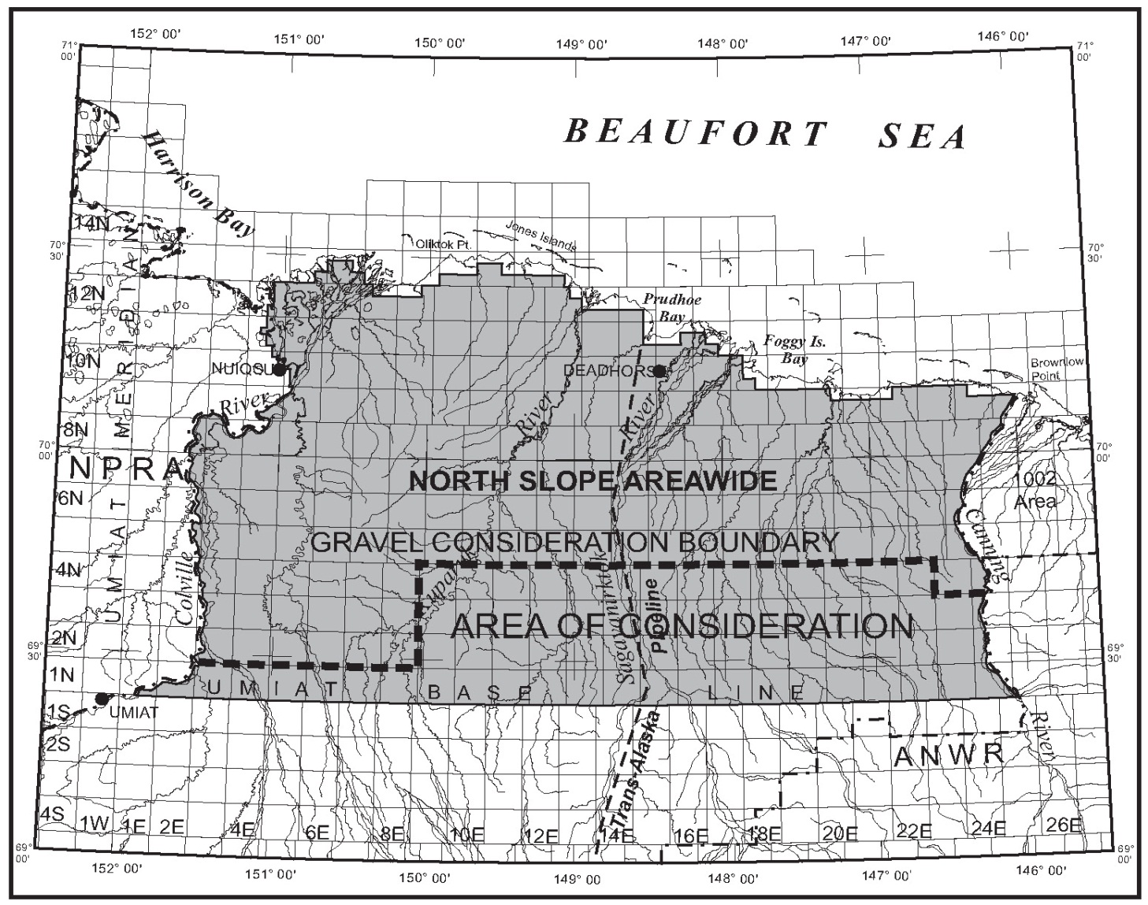  Figure 7.1: Gravel Consideration Boundary  Beginning at the NPR-A boundary, from the northeast corner of T 1N, R 2E,  - east to the northwest corner of T 1N, R 9E, then  - north to the northwest corner of T 4N, R 9E, then  - east to the northwest corner of T 4N, R 23E, then  - south to the southwest corner of T 4N, R 23E, and then  - east along the top of T 3N to the ANWR boundary. | A.5.a.
Figure 7.1: Gravel Consideration Boundary
Beginning at the NPR-A boundary, from the northeast corner of T 1N, R 2E,
- east to the northwest corner of T 1N, R 9E, then
- north to the northwest corner of T 4N, R 9E, then
- east to the northwest corner of T 4N, R 23E, then
- south to the southwest corner of T 4N, R 23E, and then
- east along the top of T 3N to the ANWR boundary.

b. Public access to, or use of, the lease area may not be restricted except within the immediate vicinity of drill sites, buildings, and other related facilities. Areas of restricted access must be identified in the plan of operations. Lease facilities and operations shall not be located so as to block access to or along navigable or public waters as defined in AS 38.05. | A.5.b.

6. Prehistoric, Historic, and Archeological Sites
a. Prior to the construction or placement of any structure, road, or facility resulting from exploration, development, or production activities, the lessee must conduct an inventory of prehistoric, historic, and archeological sites within the area affected by an activity. The inventory must include consideration of literature provided by the NSB, nearby communities, Native organizations, and local residents; documentation of oral history regarding prehistoric and historic uses of such sites; evidence of consultation with the Alaska Heritage Resources Survey and the National Register of Historic Places; and site surveys. The inventory must also include a detailed analysis of the effects that might result from the activity. | A.6.a.
b. The inventory of prehistoric, historic, and archeological sites must be submitted to the Director, and to SHPO who will coordinate with the NSB for review and comment. If a prehistoric, historic, or archeological site or area could be adversely affected by a lease activity, the Director, after consultation with SHPO and the NSB, will direct the lessee as to the course of action to take to avoid or minimize adverse effects. | A.6.b.
c. If a site, structure, or object of prehistoric, historic, or archaeological significance is discovered during lease operations, the lessee must report the discovery to the Director as soon as possible. The lessee must make reasonable efforts to preserve and protect the discovered site, structure, or object from damage until the Director, after consultation with the SHPO and the NSB, has directed the lessee as to the course of action to take for its preservation. | A.6.c.

7. Local Hire, Communication, and Training
a. Lessees are encouraged to employ local and Alaska residents and contractors, to the extent they are available and qualified, for work performed in the lease area. Lessees shall submit, as part of the plan of operations, a proposal detailing the means by which the lessee will comply with the measure. The proposal must include a description of the operator’s plans for partnering with local communities to recruit, hire and train local and Alaska residents and contractors. The lessee is encouraged, in formulating this proposal, to coordinate with employment and training services offered by the State of Alaska and local communities to train and recruit employees from local communities. | A.7.a.
b. A plan of operations application must describe the lessee’s past and prospective efforts to communicate with local communities and interested local community groups. | A.7.b.
c. A plan of operations application must include a training program for all personnel including contractors and subcontractors. The program must be designed to inform each person working on the project of environmental, social, and cultural concerns that relate to that person’s job. The program must use methods to ensure that personnel understand and use techniques necessary to preserve geological, archeological, and biological resources. In addition, the program must be designed to help personnel increase their sensitivity and understanding of community values, customs, and lifestyles in areas where they will be operating. | A.7.c.
8. Definitions
a. In this document:
i. “Facilities” means any structure, equipment, or improvement to the surface, whether temporary or permanent, including, but not limited to, roads, pads, pits, pipelines, power lines, generators, utilities, airstrips, wells, compressors, drill rigs, camps and buildings;
ii. “Important wetlands” means those wetlands that are of high value to fish, waterfowl, and shorebirds because of their unique characteristics or scarcity in the region or that have been determined to function at a high level using the hydrogeomorphic approach;
iii. “Minimize” means to reduce adverse impacts to the smallest amount, extent, duration, size, or degree reasonable in light of the environmental, social, or economic costs of further reduction;
iv. “Plan of operations” means a lease Plan of operations under 11 AAC 83.158 and a unit Plan of operations under 11 AAC 83.346;
v. “Practicable” means feasible in light of overall project purposes after considering cost, existing technology, and logistics of compliance with the standard;
vi. “Secondary containment” means an impermeable diked area or portable impermeable containment structure capable of containing 110 percent of the volume of the largest independent container plus 12 inches of freeboard. Double walled tanks do not qualify as Secondary Containment unless an exception is granted for a particular tank.
vii. “Temporary” means no more than 12 months.

