The following instructions are for manually importing .csv files into Microsoft Access and Excel 2016 (may be applicable to other versions). It is also possible to automate this process and import multiple files using a scripting language like PowerShell, or Visual Basic for Applications (VBA).

Import .csv Files Into Access Database (2016)

- In Microsoft Access, click the External Data tab, then New Data Source -> From File -> Text File.

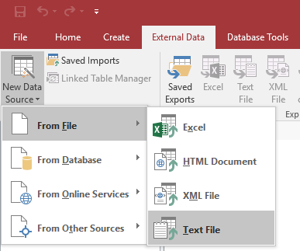

- In the window that opens, click Browse and select a .csv file to import, then click OK.

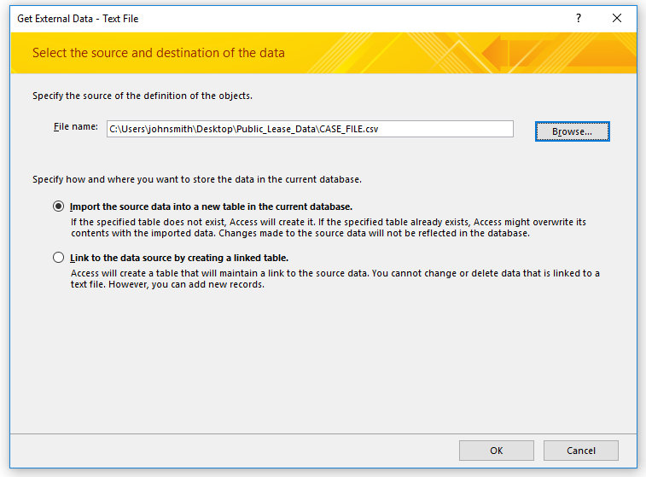

- In the next window, keep the default Delimited option selected, and click Next.
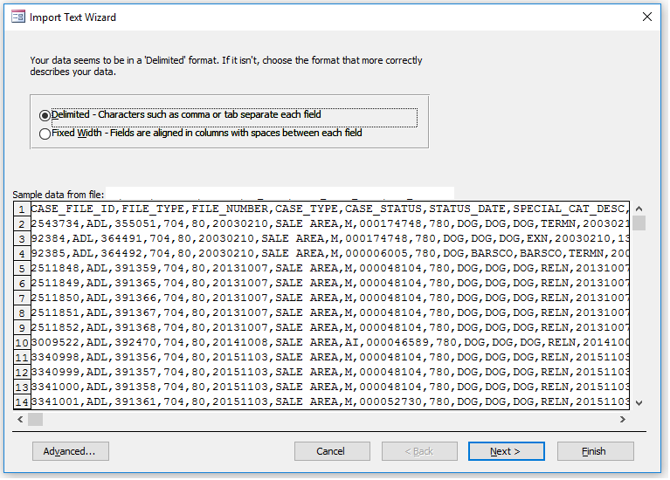
- Keep the default option of Comma selected, choose “ (double-quote) from the Text Qualifier drop-down list, select the First Row Contains Field Names checkbox. Click Finish.
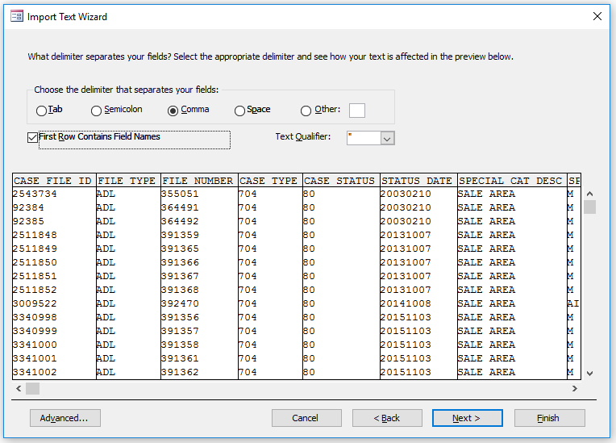

Import .csv Files Into Excel Workbook (2016)

- In Microsoft Excel, click the Data tab, click From Text/CSV, and select a .csv file to import.
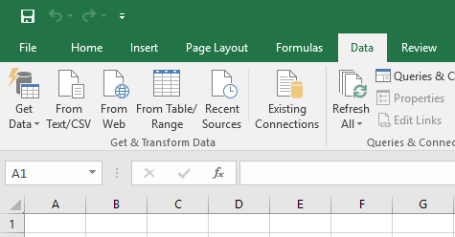
- In the next window, select “Based on entire dataset” from the Data Type Detection drop-down (this may take some time). Click Load.
